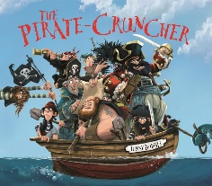

English:
Our texts for the term will be ‘The Pirate Cruncher’ by Jonny Duddle and the ‘Clean Up’ by Nathan Bryon.
- Daily phonics/spelling lessons
- Reading skills taught daily
- Active learning building oracy
- Grammar rules taught explicitly
- Write a narrative based on ‘The Pirate Cruncher’ (with a focus on setting).
- Write a set of instructions on how we can help keep our beaches clean, inspired by the book ‘Clean Up’.
RE:
We will be learning more about Sikhism this term and about why Sikhs admire their Gurus.
Design Technology:
This term we will be learning all about structures. Our end product will be making a strong and stable chair for Baby Bear. To be able to do this, we need to:
-identify man-made and natural structures
-identify the features of a stable chair
-design a stable chair which will be able to hold weight

their own simple mode
PSHE: This term our focus is ‘Relationships’.
We will be exploring different families, what it means to be a happy family and how we can ensure our friendships are strong. We will be learning about who we trust and what a good relationship looks like.

Maths:
- Calculating change from 50p and £1.
- Creating tally charts and using them to create pictograms.
- Interpreting and constructing pictograms and using them to answer questions.
- Interpreting and constructing block diagrams.
- Measuring and comparing capacity using ml and l.
- Ordering capacity using <, > and =.
- Measuring temperature.
Value of the term:
Patience

Year Two Curriculum Overview
Term 5 2024/2025
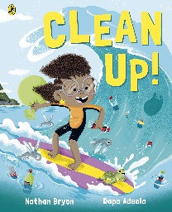
Science:
In Science we will begin our Plants focus. This term we will begin to explore:
- The difference between garden and wild plants.
- The names of a variety of common plants and trees.
- The difference between a bulb and a seed.

Music:
We will go on a musical safari; using instruments with contrasting dynamics (volume) to represent animals, learning call and response with instruments by copying sound patterns and progressing to creating and performing their own animal-based call and response.
Computing:
- Online safety
- Information Technology: Digital Music
Geography:
- To know where Africa is on the world map and the names of some countries in Africa.
- Research features of a contrasting location (country in Africa).
- Compare 2 different locations (UK/location in Africa).
- Present information about a place (Africa).

