**Physical Development:**

**Physical Development**  **This term we will be learning to:** Squiggle whilst you wiggle - Large up and down movements. Use obstacle course (steps, balancing beams, jumping hoops). Climb up/ walk across/ jump off climbing equipment with support. Exploring mark making in different media, (chalk, pencils, pens, paint sticks) -large movements – circular, up and down.

**Personal, Social and Emotional Development:**

**Jigsaw PSED Being Me This term we will be learning about:** Who is me? How am I feeling today? Being at nursery Gentle hands Our rights Our responsibilities

**Communication and Language This term we will be learning to:** Understand more complex language. Listen to others in one to one or small groups. Join in with repeated refrains and anticipate key events and phrases in rhyme and stories.Use language to share experiences, feelings and thoughts. Use more complex sentences to link thoughts. Build up vocabulary.



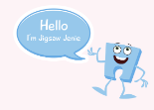

**Nursery Curriculum Overview**

**Term 1 2025/2026**

**Expressive Arts and Design:**

**Focus Artist:** Van Gough (Stary Night)

We will be learning to: Recognise colours/ choose colours for a purpose. Use thick paint brushes. Mark make thick and thin lines. Draw faces.

Sing a range of songs/rhymes



**This Term’s Value: Respect**



**Maths:**

**This term in maths, we will be learning to:**

Count in 1s to 3 (2 year olds) Count in 1s to 5 (pre-schoolers) Use fingers to represent amounts to 3/5. Compare amounts using the words ‘more’ and ‘few’. Sing simple counting songs. Use and understand the words ‘in’ and ‘on’. Use language in everyday contexts to show the passing of time. Name some 3d shapes. Use informal language to describe 3d shapes.

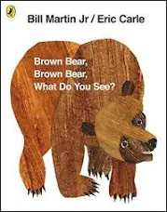

**Literacy:**

**This term, our focus stories are:**  We’re Going on a Bear Hunt Goldilocks and the Three Bears That’s Not my Teddy Brown Brown Bear What do you see?

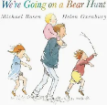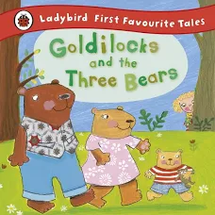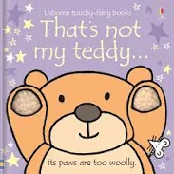

**This term, our focus nursery rhymes are:** Twinkle Twinkle Little Star Jack and Jill Teddy Bear Teddy Bear Turn Around 1,2,3,4,5 Once I caught a Fish Alive

We will be learning to develop our phonological awareness by playing listening games.

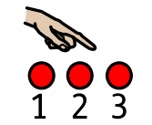

**Understanding the World:**

**We will be learning about:** Ourselves and our families.

.