Friday 12th September 2025

Dear Parent/Carers,

Welcome to Skylarks. We hope you all had a lovely summer break and that your children are looking forward to starting their learning adventure in Reception. We have had a fantastic start to the new school year, the children have settled very well and have been busily exploring their new classroom and have had the happiest possible start to school life.

**Literacy**

This term we will be focusing on the following books:

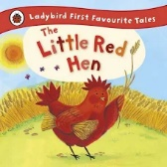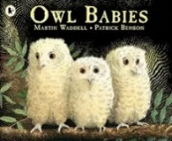

**Topic – It’s Good to Be Me**

This term will be finding out about ourselves and our families. We will be recognising similarities and differences between each other. We will be learning about different parts of the body. In art will be looking at famous self-portraits and drawing ourselves.

To support our learning these are some of the books that we will be reading:

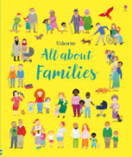

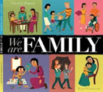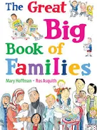

This term’s curriculum web contains more details about what else children will be learning in Term 1.

**Reminders**

* Please ensure that your child brings their water bottle to school every day. In line with the EYFS framework we ask that these contain **water only**.
* Please send your child to school with a spare set of clothes which can be kept in school and be used in the event that your child has an accident. This needs to be in the draw string bag provided. Please ensure the bag is named.
* Please ensure that all items of clothing are named.
* Please do not bring any toys into school as things can get lost or broken

**PE**

Appropriate indoor and outdoor PE kit should be worn every Thursday for PE lessons. Please refer to our uniform policy to ensure your child has the correct PE kit. All children must wear the correct coloured school t-shirt on PE days. A message will be sent home via Arbor if your child is not wearing the correct PE uniform.

**Book Bags**

Book bags need to be in school every day as the children read on different days of the week. Book bags will be kept in school on a Thursday so that books can be changed ready to be sent home on Friday. Please do not put drinks bottles in book bags as books are getting damaged. Any damaged or lost books will result in you being invoiced £5.00 to cover the cost of replacing the book.

**Wow Slips**

These slips are designed to share wow moments from home. This term there will be a basket of these slips placed just by the door, please help yourselves. We will also send some home in your child’s book bag. Wow Slips can be filled in and added to your child’s learning journey.

**Communication**

Please remember to check your child’s book bag regularly for letters. This term will we will continue to keep you up dated with what children have been doing in Reception via the weekly Sway newsletter which is easily accessible on a mobile device. Thank you to all of you who have signed up to Class Dojo. Please remember to check it regularly as we will use it to ask for things like photographs linked to our learning.

**Homework**

As we start our phonics programme every child will be allocated a foundation for phonics reading book, these books encourage children to talk, listen and expand their vocabulary. They offer the opportunity to build and secure a strong foundation for success for learning to read with phonics. The books contain inside-cover guidance, which is designed to help you talk with your child about the book.

Next week we will be sending home a reading for pleasure book. This book is a picture book chosen by your child and can be shared throughout the week. This is not a reading book linked to our phonics scheme, but one which you can enjoy reading and sharing with your child.

Once we have started our phonic lessons your child will be given a phonics homework book which will contain activities to support what we have been learning in class that week.

Maths homework will be set weekly using the online Doddle Maths platform. Once we have set the children up a login will be stuck in the front cover of their reading record.

**Diary Dates**

Reception curriculum information meeting Thursday 18th September 3.15-3.45

Reception stay and play/learning journey sharing event Friday 10th October 2.15-2.45.

More details to follow nearer the time.

I hope you have all the information that you need for the term ahead. If you have any questions or queries, please do not hesitate to speak to me at either the beginning or end of the school day.

Yours faithfully,

Miss Morgan

Reception Teacher/Early Years Lead