Teacher in Charge: Carla Friday
Southchurch High School
Curriculum – Art

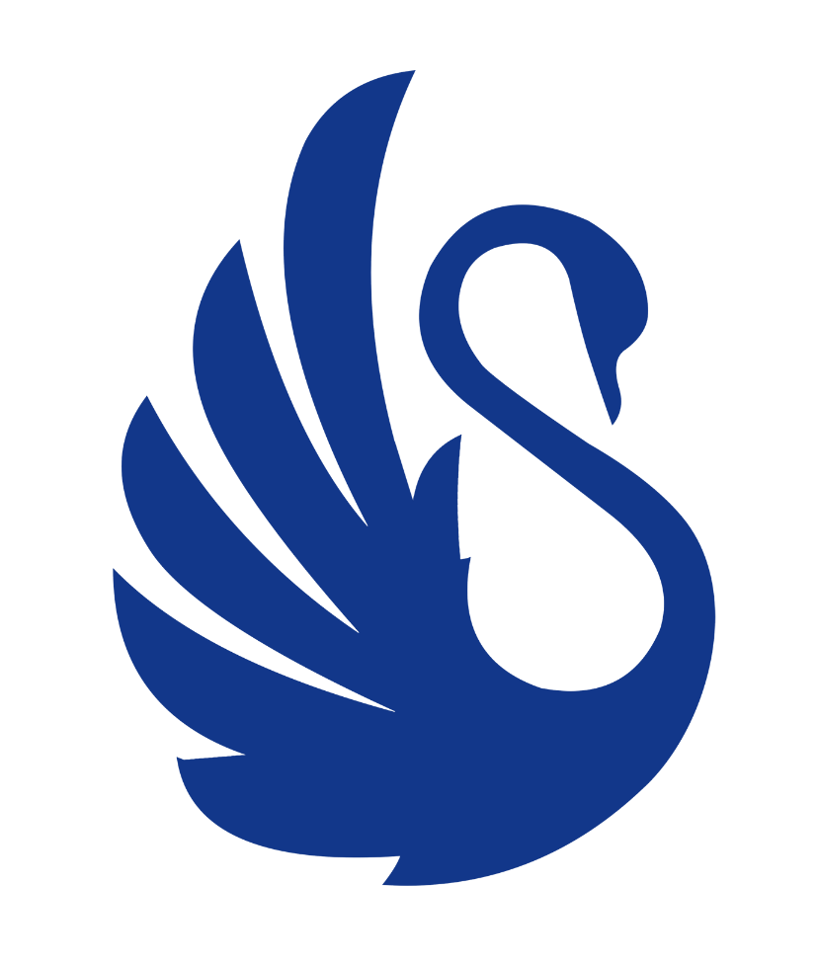

CURRICULUM MAP
Year Group | Half-term 1 | Half-term 2 | Half-term 3 | Half-term 4 | Half-term 5 | Half-term 6
Year 7 | Natural Forms and Shells | Natural forms  Noel Badges Pugh Shells | Under the sea | Under the sea | Fragments of identity | Fragments of identity
Year 8 | Animals  Native America | Animals  Native America | Landscapes | Landscapes | Bugs  Tiny Giants | Bugs  Tiny Giants
Year 9 | Day of  the Dead | Skulls | Nature's Pallette | Nature's  Pallette | Built  perspectives | Built  perspectives
Year 10 | INTRODUCTION PHASE  opportunities to explore and investigate different ways of working in response to key aspects of the Art, craft and design title  Themes might include:  - natural world  - structure  - close up |  | DEVELOPMENT PHASE (Component 1)  Students are given the opportunity to respond to a theme or starting in a personal way using an art, craft or design approach and building on the foundation knowledge, understanding and skills developed in the introductory phase  Themes might include:  - Human condition  - Reuse, reinvent, recycle  - Texture  - Our world. |  | DEVELOPMENT PHASE (Component 1)  Students are given the opportunity to respond to a theme or starting in a personal way using an art, craft or design approach and building on the foundation knowledge, understanding and skills developed in the introductory phase  Themes might include:  - Human condition  - Reuse, reinvent, recycle  - Texture  - Our world.
Year 11 | SUSTAINED PHASE (Component 1)  In this phase students move increasingly from dependence to independence as they work on a self-selected starting point for a sustained project.  Themes might include:  - Events  - Adornment  - Memories  - Layers. |  | EXTERNALLY SET ASSIGNMENT (Component 2)  Students must respond to one of seven starting points provided on the paper. |  | Year 11 Art Exam

