Special educational needs (SEN) information report Southchurch High School



Approved by: | Mrs Airoll, Headteacher
Last reviewed on: | October 2025
Next review due by: | September 2026

Contents
Page No
1. What types of SEND does the school provide for?......................................................................... 3
2. Which staff will support my child, and what training have they had?.............................................. 3
3. What should I do if I think my child has SEND? ............................................................................. 6
4. How will the school know if my child needs SEND support?........................................................... 6
5. How will the school measure my child’s progress? ......................................................................... 8
6. How will I be involved in decisions made about my child’s education? .......................................... 8
7. How will my child be involved in decisions made about their education?........................................ 9
8. How will the school adapt its teaching for my child?........................................................................ 9
9. How will the school evaluate whether the support in place is helping my child?............................ 10
10. How will the school resources be secured for my child? ............................................................... 11
11. How will the school make sure my child is included in activities alongside students who don’t
have SEND? .................................................................................................................................. 11
12. How does the school support students with disabilities? ............................................................... 11
13. How will the school support my child’s mental health and emotional and social development? ................................................................................................................................ 11
14. What support will be available for my child as they transition between classes or settings
or in preparing for adulthood?....................................................................................................... 11
15. What support is in place for looked-after and previously looked-after children with SEND?.......... 12
16. What should I do if I have a complaint about my child’s SEND support?....................................... 12
17. What support is available for me and my family? .......................................................................... 13
18. Glossary ........................................................................................................................................ 13

Dear Parents/Carers

The aim of this information report is to explain how we implement our SEND policy. In other words, we want to show you how special educational needs support works in our school. If you want to know more about our arrangements for SEND, read our SEND policy. You can find it on our website:

Southchurch High School » SPECIAL EDUCATIONAL NEEDS & DISABILITIES (SEND)

NOTE: If there are any terms, we have used in this information report that you are unsure of, you can look them up in the Glossary at the end of the report.

- What types of SEN does the school provide for?

Our school provides for students with the following needs:

AREA OF NEED | CONDITION
Communication and interaction | Autism Spectrum Disorder (ASD)
Communication and interaction | Speech and language difficulties
Cognition and Learning | Specific learning difficulties, including dyslexia, dyspraxia, dyscalculia
Cognition and Learning | Moderate Learning difficulties
Social, Emotional and Mental Health | Attention Deficit Hyperactivity Disorder (ADHD)
Social, Emotional and Mental Health | Attention Deficit Disorder (ADD)
Sensory and/or physical | Hearing impairment
Sensory and/or physical | Visual impairment
Sensory and/or physical | Physical impairment

2. Which staff will support my child, and what training have they had SENDCos

We currently have 2 SENDCos at Southchurch High School.

SENDCo


Mrs Grover
Mrs Grover is a qualified SENDCo and has a Masters in Education with proficiency in Special Education Needs. Mrs Grover also has a Music degree. Mrs Grover trained as a primary school teacher and joined the school in January 2023.

Deputy SENDCo


Mrs Friday
Mrs Friday is a qualified SENDCo and Art teacher, having previously been a Head of Department. Mrs Friday joined the school in September 2023.

SEND Administrator

Mrs Beeney
Mrs Beeney joined the school September 2022 and assists the SEND Department with the day-to-day administration. Mrs Beeney is undertaking an apprenticeship to become an Assistant SENDCo.

Subject Teachers
All our teachers receive in-house SEND training and are supported by the SENDCos to meet the needs of students who have SEND.

Learning Support Assistants (LSAs)
We have a team of LSA’s, who are trained to deliver SEND provision. They support both in class and with interventions.

External Agencies and experts
Sometimes we need extra help to offer our students the support they need. Whenever necessary we will work with external support services to meet the needs of our students with SEND and to support their families. These include:

- Speech and Language Therapists
- Educational Psychologists
- Occupational Therapists
- Specialist Teachers
- GPs or Paediatricians
- School Nurses
- Child and Adolescent Mental Health Services (CAMHs)
- Education Welfare Officers
- Social Services and other local authority (LA) provided support services
- Voluntary sector organisations

3. What should I do if I think my child has SEN?
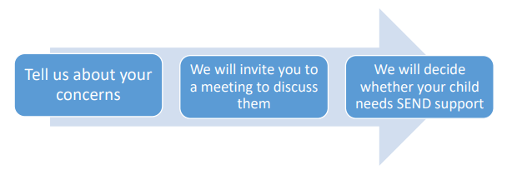
If you think your child might have SEND, the first person you should tell is your child’s Head of Year. You can do this by leaving a brief message on the portal on the school website. They will pass the message on to our SEND Team, who will be in contact to discuss your concerns. | We will meet with you to discuss your concerns and try to get a better understanding of what your child’s strengths and difficulties are. Together we will decide what outcomes to seek for your child and agree on next steps. We will make a note of what has been discussed and add this to your child’s record. | If we decide that your child needs SEND support, we will notify you and your child will be added to the school’s SEND register.

4. How will the school know if my child needs SEN support?

All our class teachers are aware of SEND and are on the lookout for any students who aren’t making the expected level of progress in their schoolwork or socially.

If the teacher notices that a student is falling behind, they try to find out if the student has any gaps in their learning. If they can find a gap, they will give the student extra tuition to try to fill it. Students who do not have SEND usually make progress quickly once the gap in their learning is filled.

If the student is still struggling to make expected progress, the teacher will begin the school SEND referral process.

Southchurch SEND IDENTIFICATION AND PROVISION PATHWAY
Graduated Response: Assess, Plan, Do, Review

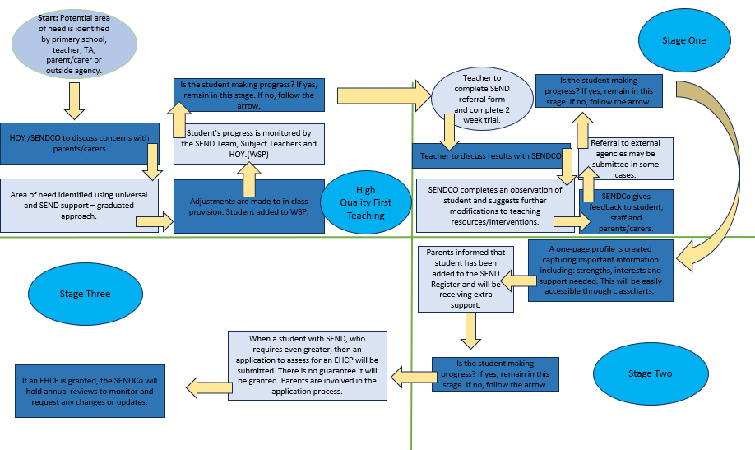

5. How will the school measure my child’s progress?

We will follow the ‘graduated approach’ to meeting your child’s SEND needs. The graduated approach is a 4-part cycle of assess, plan, do, review
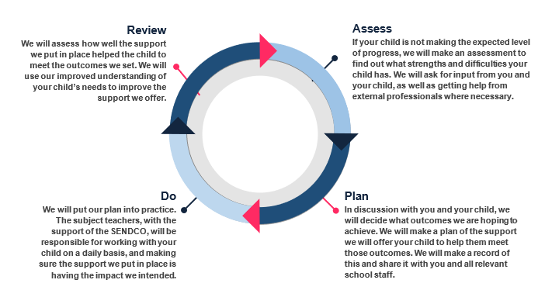
As part of the planning stage of the graduated approach, we will set outcomes that we want to see your child achieve.

Whenever we run an intervention with your child, we will assess them before the intervention begins. This is known as a ‘baseline assessment’. We do this so we can see how much impact the intervention has on your child’s progress.

We will track your child’s progress towards the outcomes we set overtime and improve our offer as we learn what your child responds to best.

This process will be continual. If the review shows a student has made progress, they may no longer need the additional provision made through SEND support. For others, the cycle will continue, and the school’s targets, strategies and provisions will be revisited and refined.

6. How will I be involved in decisions made about my child’s education?

We will provide termly reports on your child's progress. Your child’s SENDCo will meet you at 3 points across the school year to:

- Set clear outcomes for your child’s progress;
- Review progress towards those outcomes;
- Discuss the support we will put in place to help your child make that progress; and
- Identify what we will do, what we will ask you to do, and what we will ask your child to do.

We know that you’re the expert when it comes to your child’s needs and aspirations. So, we want to make sure you have a full understanding of how we are trying to meet your child’s needs, so that you can provide insight into what you think would work best for your child.

We also want to hear from you as much as possible so that we can build a better picture of how the SEND support we are providing is impacting your child outside of school.

If your child’s needs or aspirations change at any time, please let us know right away so we can keep our provision as relevant as possible.

After any discussion we will make a record of any outcomes, actions and support that have been agreed. This record will be shared with all relevant staff, and you will be given a copy.

If you have concerns that arise between these meetings, please contact your child’s Head of Year.

7. How will my child be involved in decisions made about their education?

The level of involvement will depend on your child’s age and level of competence. We recognise that no 2 children are the same, so we will decide on a case-by-case basis, with your input. We may seek your child’s views by asking them to:

- Attend meetings to discuss their progress and outcomes;
- Prepare a presentation, written statement, video, drawing, etc;
- Discuss their views with a member of staff who can act as a representative during the meeting; and
- Complete a survey.

8. How will the school adapt its teaching for my child?
Your child’s teachers are responsible and accountable for the progress and development of all the students in their class.

High-quality teaching is our first step in responding to your child’s needs. We will make sure that your child has access to a broad and balanced curriculum in every year they are at our school. We will adapt how we teach to suit the way the student works best. There is no '1 size fits all’ approach to adapting the curriculum, we work on a case-by case basis to make sure the adaptations we make are meaningful to your child.

These adaptations include:

- Scaffolding our curriculum to make sure all students are able to access it,
- Adapting our teaching, for example, giving longer processing times, pre-teaching of key vocabulary, reading instructions aloud, etc.
- Adapting our resources and staffing
- Using recommended aids, such as laptops, coloured overlays, visual timetables, larger font, etc.
- Teaching assistants will support students within their subjects, promoting resilience and independence as well as giving academic support.

Area of need | Condition | How we support students
Communication and interaction | Autism Spectrum disorder (ASD) | Visual timetables  Social stories
Communication and interaction | Speech and language difficulties | Speech and language therapy
Cognition and learning | Specific learning difficulties, including dyslexia, dyspraxia and dyscalculia | Writing slope  Coloured overlays  Graphic organisers  Boxed information
Social, emotional and mental health | ADHD, ADD | Check lists  Now and Next boards  Choice boards  Standing desks  Brain breaks
Social, emotional and mental health | Adverse childhood experiences and/or mental health issues | Nurture groups  Mentoring  Counselling
Sensory and/or physical | Hearing impairment | Advice taken from hearing impairment advisory teacher
Sensory and/or physical | Visual impairment | Advice taken from visual impairment advisory teacher
Sensory and/or physical | Multi-sensory impairment | Ear defenders  Low level lighting  Silent transition between lessons  Early lunch pass
Sensory and/or physical | Physical impairment | Adjustable desks  Standing frames  Walking frames  Disabled toilets  EVAC chairs  Accessible mini-bus  Accessible lift  Adapted equipment

These interventions are part of our contribution to Southend-on-Sea City Council’s local offer.

9. How will the school evaluate whether the support in place is helping my child?

We will evaluate the effectiveness of provision for your child by:

- Reviewing their progress towards their goals each term;
- Reviewing the impact of interventions after 6 weeks and again at 12 weeks;
- Using student questionnaires;
- Monitoring by the SEND Team;
- Using provision maps to measure progress; and
- Holding an annual review (if they have an education, health and care (EHC) plan).

10. How will the school’s resources be secured for my child?

- It may be that your child’s needs mean we need to secure:
- Extra equipment or facilities
- More teaching assistant hours
- Further training for our staff
- External specialist expertise
- If that’s the case, we will consult with external agencies to get recommendations on what will best help your child access their learning.
- The school will cover up to £6,000 of any necessary costs. If funding is needed beyond this, we will seek it from our local authority.

11. How will the school make sure my child is included in activities alongside students who do not have SEND?

All of our extra-curricular activities and school visits are available to all our students, including before and after-school clubs.

All students are encouraged to go on our school trips, including our residential trips.

All students are encouraged to take part in sports day/school plays/special workshops/work experience etc.

No student is ever excluded from taking part in these activities because of their SEN or disability and we will make whatever reasonable adjustments are needed to make sure they can be included.

12. How does the school support students with disabilities?

Information can be found in the Accessibility Plan on the school website.

13. How will the school support my child’s mental health, and emotional and social development?

We provide support for students to progress in their emotional and social development in the following ways: whole school approaches such as proactive and reactive assemblies, SMSC sessions in tutor time, PSHE lessons and bespoke events with outside agencies. Should it be required, students may receive individual interventions with a focus on their mental wellbeing.

14. What support will be available for my child as they transition between classes or settings, or in preparing for adulthood?

Between schools
When your child is moving on from our school, we will ask you and your child what information you want us to share with the new setting.

Between Phases
The SENDCO of the primary school meets with our SENDCO to discuss the needs of the incoming students near the end of the summer term.

We arrange meetings with the parents/carers of incoming students to discuss how we can best welcome their child into our community.

We hold additional transition days for SEND students.

Moving to adulthood
We provide all our students with appropriate advice on paths into work or further education.

We work with the student to help them achieve their ambitions, which can include goals in higher education, employment, independent living and participation in society.

15. What support is in place for looked-after and previously looked-after children with SEND?



Our dedicated teacher for looked after and previously looked after children is Miss Murray.

Miss Murray will work with the SEND Team, to make sure that all teachers understand how a looked-after or previously looked-after student’s circumstances and their SEND might interact, and what the implications are for teaching and learning.

Children who are looked-after or previously looked-after will be supported much in the same way as any other child who has SEND. However, looked-after students will also have a personal education plan (PEP). We will make sure that the PEP and any SEND support plans or EHC plans are consistent and complement one another.

16. What should I do if I have a complaint about my child’s SEN support?

Complaints about SEND provision in our school should be made to the SENDco in the first instance. They will then be referred to the school’s Complaints Policy.

If you are not satisfied with the school’s response, you can escalate the complaint. In some circumstances, this right also applies to the student themselves.

To see a full explanation of suitable avenues for complaint, see pages 246 and 247 of the SEND Code of Practice.

If you feel that our school has discriminated against your child because of their SEND, you have the right to make a discrimination claim to the first-tier SEND tribunal. To find out how to make such a claim, you should visit: https://www.gov.uk/complain-about-school/disability-discrimination

You can make a claim about alleged discrimination regarding:

- Admission;
- Exclusion;
- Provision of education and associated services; and
- Making reasonable adjustments, including the provision of auxiliary aids and services.

Before going to a SEND tribunal, you can go through processes called disagreement resolution or mediation, where you try to resolve your disagreement before it reaches the tribunal.

Details can be found on the Southend-on-Sea City Council website.

17. What support is available for me and my family?

If you have questions about SEND, or are you struggling to cope, please get in touch to let us know. We want to support you, your child and your family.

To see what support is available to you locally, have a look at the Southend-on-Sea City Council local offer. Southend-on-Sea City Council publishes information about the local offer on their website:
SEND Local Offer – Livewell Southend

18. Glossary

- Access arrangements – special arrangements to allow students with SEN to access assessments or exams.
- Annual review – an annual meeting to review the provision in a student’s EHC plan.
- Area of need – the 4 areas of need describe different types of needs a student with SEN can have. The 4 areas are communication and interaction; cognition and learning; physical and/or sensory; and social, emotional and mental health needs.
- CAMHS – child and adolescent mental health services.
- Adaptive teaching – when teachers adapt how they teach in response to a student’s needs.
- EHC needs assessment – the needs assessment is the first step on the way to securing an EHC plan. The local authority will do an assessment to decide whether a child needs an EHC plan.
- EHC plan – an education, health and care (EHC) plan is a legally-binding document that sets out a child’s needs and the provision that will be put in place to meet their needs.
- First-tier tribunal / SEND tribunal – a court where you can appeal against the local authority’s decisions about EHC needs assessments or plans and against discrimination by a school or local authority due to SEN.
- Graduated approach – an approach to providing SEN support in which the school provides support in successive cycles of assessing the student’s needs, planning the provision, implementing the plan, and reviewing the impact of the action on the student.
- Intervention – a short-term, targeted approach to teaching a student with a specific outcome in mind.
- Local offer – information provided by the local authority that explains what services and support are on offer for students with SEN in the local area.
- Outcome – target for improvement for students with SEN. These targets don't necessarily have to be related to academic attainment.
- Reasonable adjustments – changes that the school must make to remove or reduce any disadvantages caused by a child’s disability.
- SENDCO – the special educational needs co-ordinator.
- SEN – special educational needs.
- SEND – special educational needs and disabilities.
- SEND Code of Practice – the statutory guidance that schools must follow to support children with SEND.
- SEND information report – a report that schools must publish on their website, that explains how the school supports students with SEN.
- SEN support – special educational provision that meets the needs of students with SEN.
- Transition – when a student moves between years, phases, schools or institutions or life stages.

