Computing Intent, Implementation & Impact Statement
At Southwold School we believe in the unlimited potential of every child. As a result of this, we have carefully designed a curriculum which is underpinned by 5 Golden Threads.
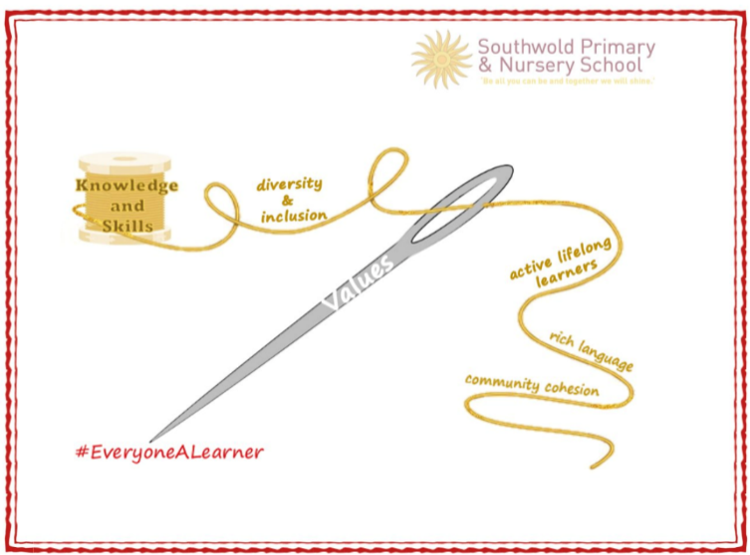
We have carefully chosen our Golden Threads because they are unique to our school context and setting:
- Knowledge and skills: It is our intent that our pupils will develop mastery across the curriculum as a result of a carefully sequenced curriculum which builds progressively on knowledge and skills.
- Rich language: Our intent is for all children to acquire knowledge, develop their vocabulary and have tools to communicate their ideas and learning effectively, both orally and in writing. To do this, our curriculum is planned to include high quality texts, real life and hands on experiences and creating a range of opportunities for all children to be immersed in and engaging with language.
- Active lifelong learners: Our intent is for every child to be a passionate and active learner, underpinned by our value of ‘Excellence’. We provide children with real-life experiences and use AfL strategies within lessons to encourage them to be active learners, who take pride in and can talk about their work and learning.
- Diversity and inclusion: Our intent is for all children of our children to grow up to develop into citizens who are well-rounded, take care of themselves, other people and the world they live in, and who grow to be the best version of themselves as individuals. Our school celebrates inclusion and diversity – all members of our community are made to feel welcome, and we use our curriculum to teach children about issues relating to diversity and inclusion. We also ensure that the needs of our learners are met so that they can fulfil their potential.
- Community cohesion: Maintaining strong links with our community are important. Within our curriculum offer, including our hidden curriculum, we find opportunities for children to work with and support causes in the community – these include visits to school and supporting local charities.
Our Values: Our intent is for all children to embrace and develop a shared set of ACHIEVE Values: Ambition, Collaboration, Honesty, Inclusivity, Environmental care, Valiance and Excellence, which underpin everything we do. This will encourage our children to be the best version of themselves and strive to achieve potential in an ever-changing and modern world.

Intent for our Computing Curriculum:
At Southwold School, our Golden Threads underpin our curriculum intent enabling our pupils to achieve the following in Computing:
- Develop necessary skills to use computational thinking to understand and change the world.
- Be proficient in online safety to ensure they are aware and practice being safe online and at home by using our SMART rules and 4Rs: Respect, Responsibility, Reasoning & Resilience.
- To make connections in their learning and to know more, remember more and do more each year leading to academic success and enjoyment in this subject;
- Develop skills in order to acquire, apply and transfer their knowledge across topics.
- To converse with confidence orally and in creating in a range of contexts using subject specific vocabulary.

In line with the National Curriculum, at Southwold School, we ensure that all children are equipped with the necessary skills to use computational thinking and creativity to understand and change the world. Our goal is to give our children a rich range of experiences in computing and online safety to ensure they have the tools to become proficient in these areas, with the ambition of developing lifelong learners who are prepared for further education and future employment.

Implementation:
The National Curriculum is the starting point of our curriculum design. It has been used to drive our curriculum design, in order to ensure the aims of the National Curriculum are met, and it has been used to inform the choices we have made about the content that we teach at Southwold School.
At our school, we ensure that the objectives of the National Curriculum are achieved through the delivery of our own broad, balanced and progressive curriculum. As a school, we use and the NCCE’s framework to ensure each lesson is sequential and progressive while also adapting the learning and resources to the needs of the children. This ensures that our children are engaged, suitably challenged and the learning is built upon prior attainment. From EYFS to Year 6, we cover the three key strands of Computer Science, Digital Literacy and Information Technology. As a school, to support our implementation, we have broken down these areas into smaller units of learning - Networks and Systems, Media, Data and Information Handling and Programming.
In Computing, children develop their age-appropriate computing vocabulary and skills in order to communicate, create and problem solve effectively. We embed key vocabulary throughout lessons using verbal repetition, actions, and sentence stems. Children’s previous knowledge and language acquisition in computing and online safety is assessed by teachers as part of normal classroom procedure, through pupil work, class discussions and questioning. This allows teachers to accurately pitch lessons and ensure that children are appropriately challenged and supported at all times.

Although we recognise the incredible opportunities the online world offers, we also understand the potential online dangers associated with technology and accessing the internet and for this reason, online safety is a key component of our provision. We ensure that all children are provided with the tools to use technology in a safe and responsible manner whilst still exploring the opportunities it offers. Online Safety is taught regularly as an introductory activity for all Computing lessons as a little and often approach alongside everyday discussions that affect the children. This ensures that the profile of online safety is continually high throughout the school. To ensure our children are safe online, we cover eight strands of the Online Safety curriculum that is provided by the Education for a Connected World framework (Project Evolve) which include;1. Self-image and Identity 2. Online relationships 3. Online reputation 4. Online bullying 5. Managing online information 6. Health, wellbeing and lifestyle 7. Privacy and security 8. Copyright and ownership.
As a result of regular online safety teaching, children develop the school’s ACHIEVE values through their respectful usage of software and hardware while being responsible for their actions online. Furthermore, as a school, we have regular online safety assemblies, attend National Online Safety Assemblies and enjoy taking part in Internet Safety Days where children share what they have learned, compete in competitions and embrace the opportunity to work alongside parents in the classroom.

Impact
Our intended impact is that by the time our pupils leave Southwold School, they will have developed:
- A broad range of tools and understanding that enables children to be safe and responsible digital citizens in society.
- A range of skills that can be applied using various known and unfamiliar hardware and software that involves the fundamental principles of computer science, including logic, algorithms, data representation, and communication.
- A wide range of computational vocabulary that enables every children to problem solve and communicate in a digital world;
- A range of skills that enables to them to problem solve and demonstrate curiosity and inquisitiveness.
- Computation skills and critical thinking skills develop their own digital creations and problem solve (de-bug).
- Ability to be responsible, competent and creative users of information and technology.

