Design and Technology Intent, Implementation & Impact Statement
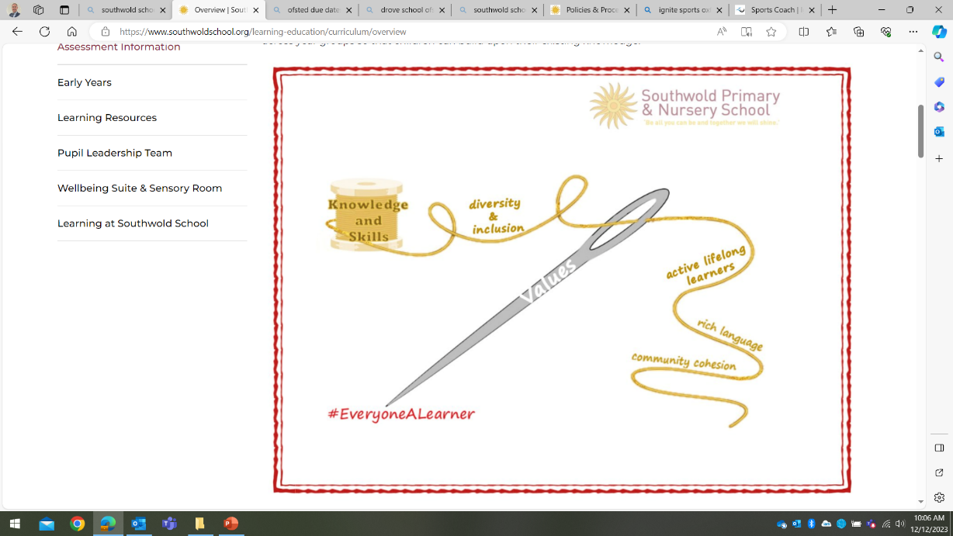
At Southwold School we believe in the unlimited potential of every child. As a result of this, we have carefully designed a curriculum which is underpinned by 5 Golden Threads.

We have carefully chosen our Golden Threads because they are unique to our school context and setting:
- Knowledge and skills: It is our intent that our pupils will develop mastery across the curriculum as a result of a carefully sequenced curriculum which builds progressively on knowledge and skills.
- Rich language: Our intent is for all children to acquire knowledge, develop their vocabulary and have tools to communicate their ideas and learning effectively, both orally and in writing. To do this, our curriculum is planned to include high quality texts, real life and hands on experiences and creating a range of opportunities for all children to be immersed in and engaging with language.
- Active lifelong learners: Our intent is for every child to be a passionate and active learner, underpinned by our value of ‘Excellence’. We provide children with real-life experiences and use AfL strategies within lessons to encourage them to be active learners, who take pride in and can talk about their work and learning.
- Diversity and inclusion: Our intent is for all children of our children to grow up to develop into citizens who are well-rounded, take care of themselves, other people and the world they live in, and who grow to be the best version of themselves as individuals. Our school celebrates inclusion and diversity – all members of our community are made to feel welcome, and we use our curriculum to teach children about issues relating to diversity and inclusion. We also ensure that the needs of our learners are met so that they can fulfil their potential.
- Community cohesion: Maintaining strong links with our community are important. Within our curriculum offer, including our hidden curriculum, we find opportunities for children to work with and support causes in the community – these include visits to school and supporting local charities.
Our Values: Our intent is for all children to embrace and develop a shared set of ACHIEVE Values: Ambition, Collaboration, Honesty, Inclusivity, Environmental care, Valiance and Excellence, which underpin everything we do. This will encourage our children to be the best version of themselves and strive to achieve potential in an ever-changing and modern world.

Intent for our Design and Technology Curriculum:
At Southwold, our Golden Threads underpin our curriculum intent enabling our pupils to achieve the following in design and technology.
- Develop their own sense of belonging as part of a community when learning about the work of designers and products that are significant to them.
- Develop a line of enquiry, asking and answering questions.
- Have knowledge of a range of design and technology skills, inclusive of materials, components, controls and structures which they can practice and apply to create their own products.
- Develop an understanding of how design and technology impacts people and the world in which they live.
- To make links and extend learning across other areas of study and within other aspects of our curriculum.
- To use subject specific vocabulary with confidence, both orally and through focused activities such as planning and evaluating.
- To evaluate their own products and the products of others.

Our intent is to allow our pupils the experiences required to understand design concepts by acting as designers, builders, carpenters and seamstresses and working to find out about the skills, methods and products designers have and. Therefore, we aim to offer opportunities for pupils to develop their understanding using a variety of experiences, sources, visitors and products which encourage them to acquire knowledge and develop an understanding with subject rich vocabulary.

Implementation:
The National Curriculum is the starting point of our curriculum design. It has been used to drive our curriculum design, to ensure the aims of the National Curriculum are met, and it has been used to inform the choices we have made about the content that we teach at Southwold School.
Each year group focuses on a different design skill, which is built upon as they progress through the school. Each year group has an opportunity to focus on different design elements. We have planned cross curricular links within our curriculum design, where appropriate, to make links and apply design and technology skills. For example, when focussing on structuring and building war bunkers, pupils will be learning about World War II.
To support the implementation of our curriculum, we have developed a skills progression document that demonstrates a progression of the skills that need to be taught across each year group. Each skill area has clear progression planned for across each year group, developing on the previous year’s skills. These are used to inform, plan and assess in design and technology:
- Food technology
- Mechanical systems
- Textiles
- Electrical systems
- Structures
- Digital world
The use of subject specific vocabulary will be planned for and modelled by teachers within lessons. Vocabulary obtained from these lessons will be made available for pupils to refer to throughout the topic displays or on word mats.
Wherever possible, teachers will plan opportunities for learning design and technology within trips and our local area. It is important at Southwold for pupils to be exposed to these experiences to develop their curiosity, deepen their understanding of design concepts and apply this in lessons and other contexts. Teachers are also encouraged to introduce the various replicas and high-quality models we have available in the school to encourage pupils to engage in an enquiry-based approach through levels of questioning:
- What do I already know? – What do you notice?
- What can I infer? – Based on previous knowledge.
- What do I want to know?
- How will I find out?
Pupils are encouraged to observe these sources and use them to evaluate, motivate and inspire their own product.

Impact
Our intended impact is that by the time our pupils leave Southwold School, they will have developed:
- A wide range of knowledge about designers and design skills ranging from local to global products.
- A secure understanding of how products may have developed overtime.
- Critical thinking skills to develop their own technology enquires using a range of questions to develop their understanding of planning, products and designing.
- An ability to support and evaluate the work of others using a wide range of knowledge and evidence.
- A respect for aspects of design and technology and the range of social, cultural, religious and ethnic diversity, in Britain and the wider world, and how this has changed or influenced present day designs and technology.
- An interest in design and technology and an enthusiastic approach to learning, which develops their curiosity.

