**OUR ONLINE SAFETY CURRICULUM**

**Term 1: Our online safety theme this term is ‘Self-Image and Identity.’ We will be exploring how our offline and online identities are shaped and how media impacts on gender, stereotypes, and our emotions. We will discuss our own identities and how people represent themselves in different ways online whether this is real or edited and how this can affect our own behaviour**.

ProjectEvolve

**To support this, you could try to use Purple Mash’s ‘Mashcam’ and see how you look as an astronaut or chef!**

**This term we will be focusing on the ‘S’ in our online safety SMART rules.**

Talk to your child about what they understand this to represent. What do they know?

**It has been National Coding Week!**

**The focus this year is Artifical Intelligence. We talked about the pros and cons of using AI and how it is already being used today.**

**We tried using this AI app** <https://www.autodraw.com/> **to see how pattern and coding recognition helps create drawings.**

**Here are some AI generated drawings created.**

**Raw Drawing AI Drawing**

**Here are some AI generated drawings created.**

**Raw Drawing AI Drawing**





**Some tips about technology from NOS…**

Please ensure you have signed your Acceptable User Agreement on ParentMail. This agreement states how we expect children to behave in order to help them stay safe online.

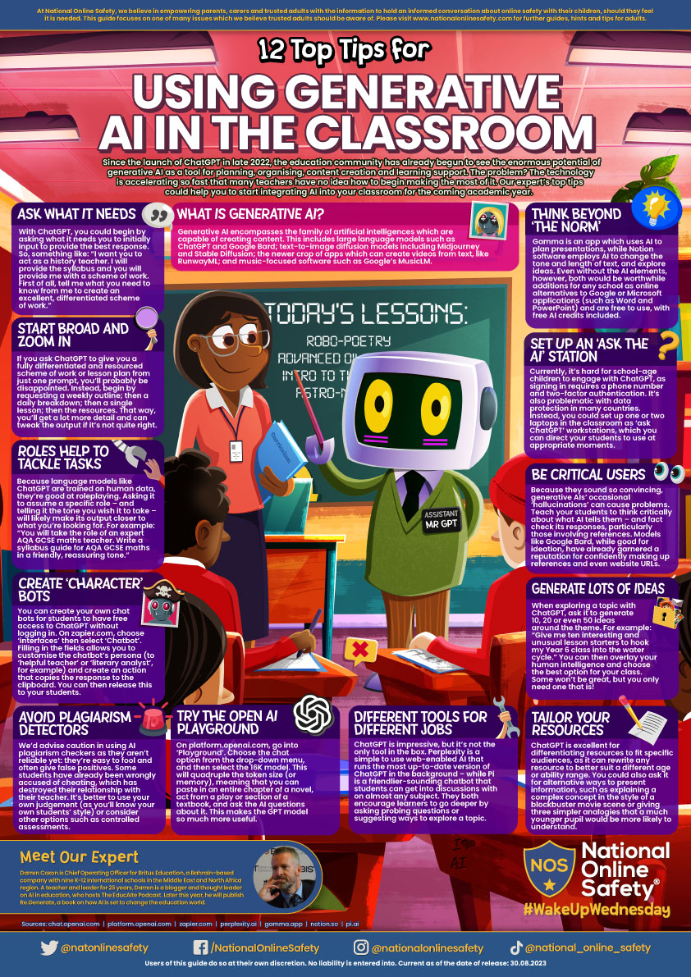

# A white circle with a blue background Description automatically generatedhas launched a new 4-7s website and guide for parents & carers

Featuring characters and messages from the CEOP Education [Jessie & Friends resource](https://www.thinkuknow.co.uk/professionals/resources/jessie-and-friends/), the [new 4-7s website](https://www.thinkuknow.co.uk/4_7/) helps children to develop the skills and knowledge they need to stay safer online.

Designed for children to visit with their parents, carers or other supervising adults, users complete ‘badges’ where they help the characters, Jessie, Tia and Mo, to identify when to ‘Tell a Grown Up’ (TAG) in different situations online.

Each badge asks a series of questions, aimed at helping children to recognise worrying or frightening situations online. These topics were chosen by professionals as being the most valuable. Answering each question correctly earns a star. When children have answered all the questions in a badge and collected three stars, they will get a certificate to download or print and colour in.

The four badges children can play are:

* Watching Videos
* Sharing Pictures (6-7 year olds only)
* Online Gaming (6-7 year olds only)
* Chatting Online (6-7 year olds only)

