OUR ONLINE SAFETY CURRICULUM
Term 1: Our online safety theme this term is ‘Privacy and security.’ We will be exploring simple strategies for creating strong passwords and keeping them safe. We will discuss why it’s a good idea to only share information with people you trust, describe how connected devices can collect and share information with others, describe strategies to keep personal information private depending on context. We will explain that the internet is never fully private and is monitored. Plus, that some online services seek consent to store your information as well as knowing how to respond appropriately to this. We will give children the skills of knowing how to increase privacy on apps and in settings to keep them safe.
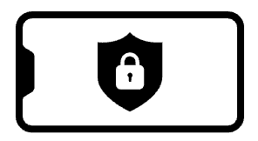
ProjectEvolve

To support this, you could
check your child’s device settings with them and discuss.

This term we will be focusing on the ‘S’ in our online safety SMART rules.
Talk to your child about what they understand this to represent. What do they know?
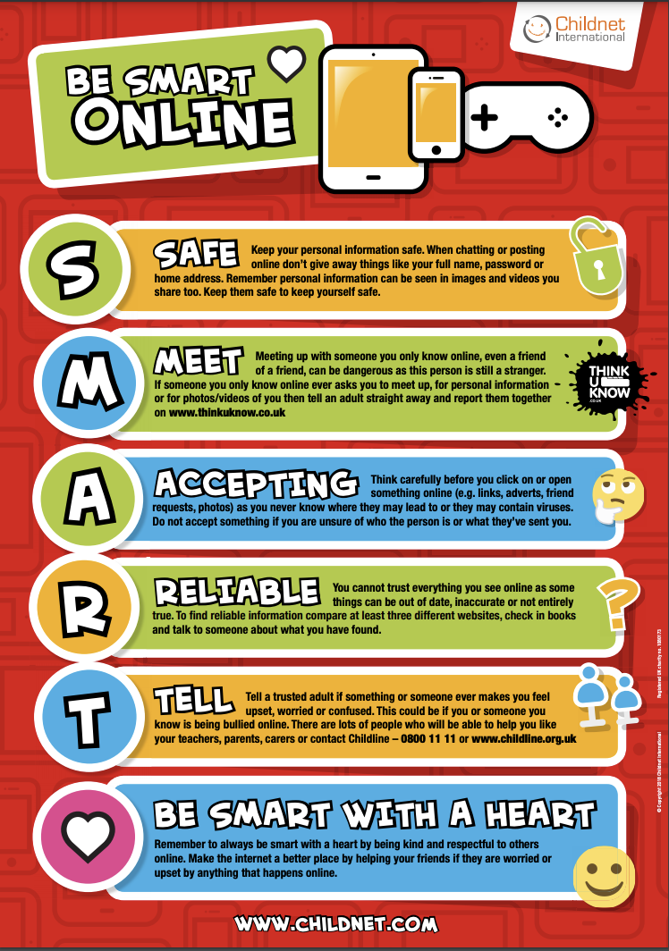
Tap into new video quality controls in the YouTube Kids app

Your guide to everything YouTube Kids, including new features, content, and more. Click on the links below,,,

Cartooning  Club | Video quality  controls | Reading  Spotlight

Some tips about technology from NOS…
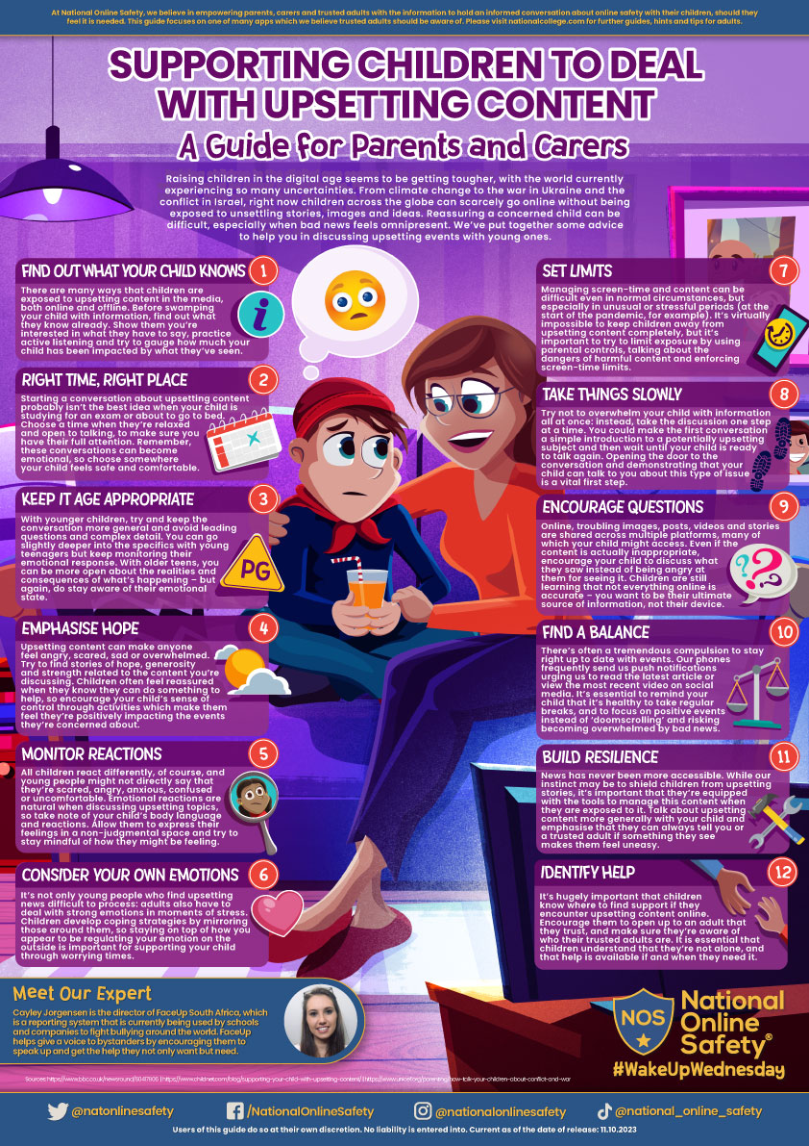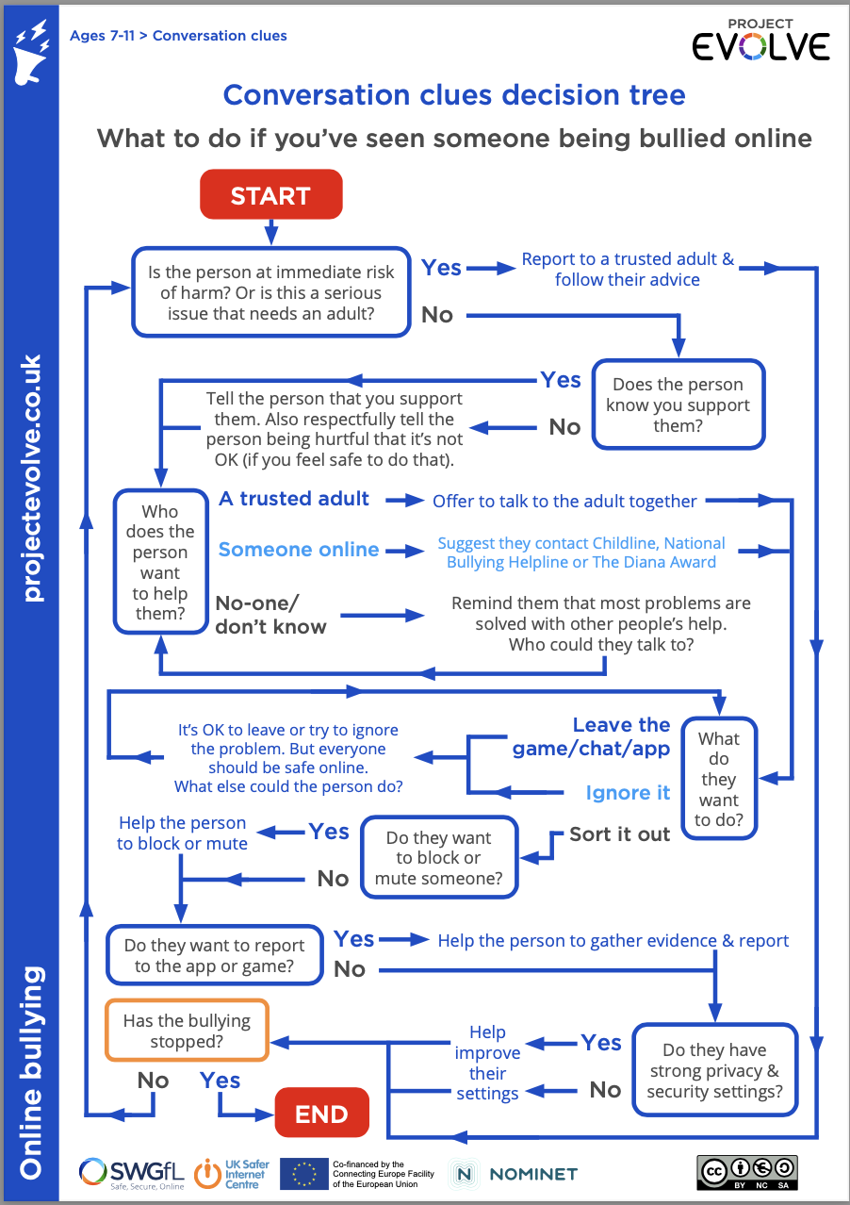
Reporting
If you are worried about something you or your child has seen online, you can use these helplines or click the 'report' button.​
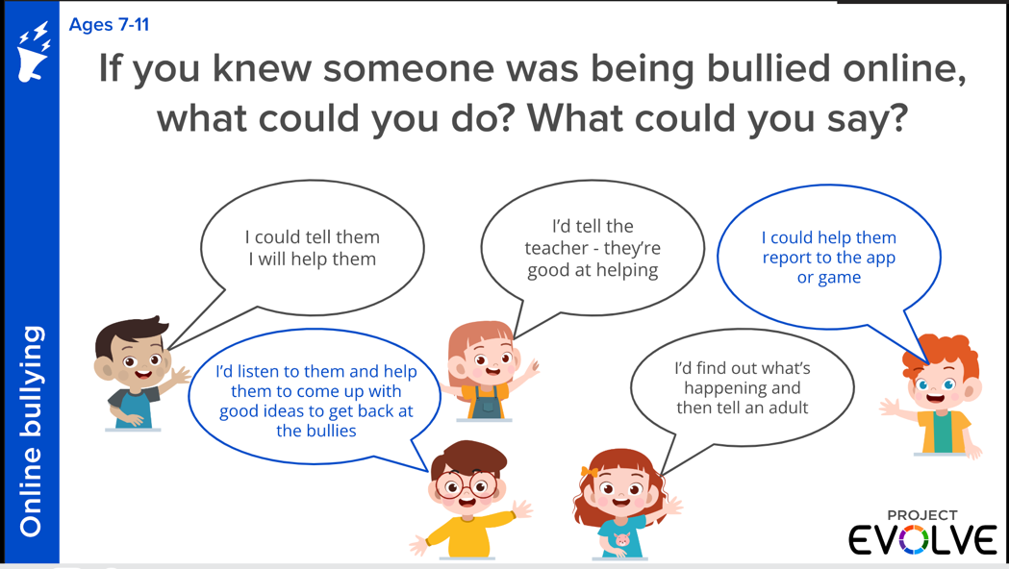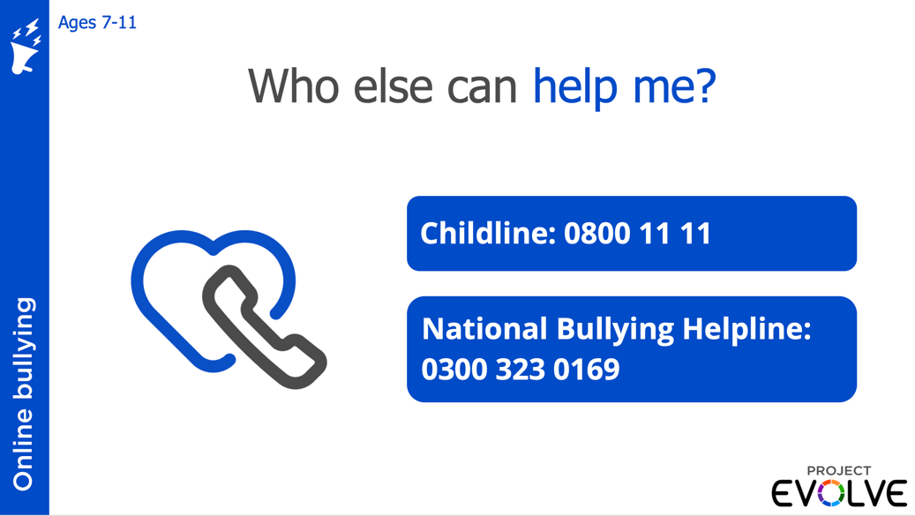
​
​
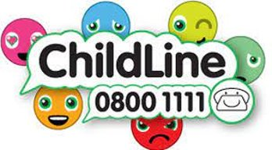 for free and confidential advice​
0808 800 5000
to report and remove harmful online content​ https://saferinternet.org.uk/
for advice on making a report about online abuse​ https://www.ceop.police.uk/Safety-Centre/
https://report.ncsc.gov.uk/your-details
https://www.cybersmile.org/advice-help/gaming/in-game-resources
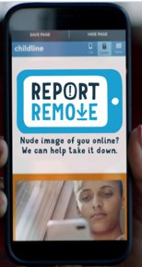 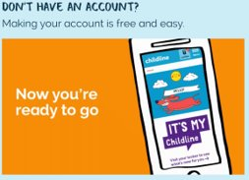 https://www.childline.org.uk/login/

