**This term we will be focusing on the ‘T’ in our online safety SMART rules.**

Talk to your child about what they understand this to represent. What do they know?

**OUR ONLINE SAFETY CURRICULUM**

**Term 2: Our online safety theme this term is ‘Online Bullying.’ We will be discus and describe appropriate ways to behave towards other people and why this is important. In classes, we will think carefully about how we speak to others online through chats and posts, as this might affect other people and their perception of us. We will discuss different ways bullying can happen and what that could look like but most importantly how we can prevent these situations escalating by getting help. We will explore strategies for effective reporting and intervention and how bullying and other aggressive behaviour relates to legislation.**

ProjectEvolve

**To support this, you could talk to your child about the similarities and differences between themselves and others. Reminding them to celebrate those differences. Maybe they could draw a picture of themselves, and another family member then discuss the things that are the same and different.**

**We will be celebrating…**

**An new era for internet safety is coming!**

The Online Safety Bill is receiving Royal Assent which means that many of provisions and laws will be implemented in two months time:

* ‘’the Act makes social media companies keep the internet safe for children and give adults more choice over what they see online’’.
* ‘’Ofcom will immediately begin work on tackling illegal content and protecting children’s safety’’.

This new Bill ‘allows children and adults more control over the content they see online, and for stronger action to be taken against online harm.’

Find out more using this link:[**https://saferinternet.org.uk/blog/online-safety-bill-becomes-law**](https://saferinternet.org.uk/blog/online-safety-bill-becomes-law)

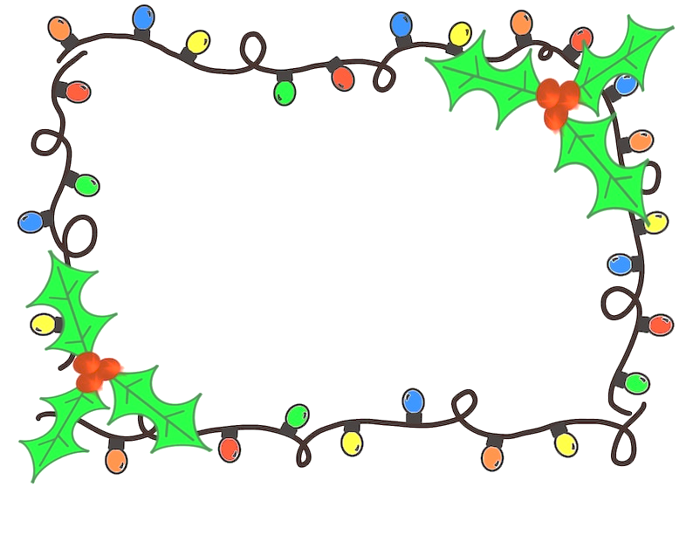

**The PurpleMash Christmas Card competition will be open on Monday 6th November.**

**We will update you with more details next week!**

**Some tips about technology from NOS…**

