EYFS/ KS1 Learner

Acceptable Use Agreement

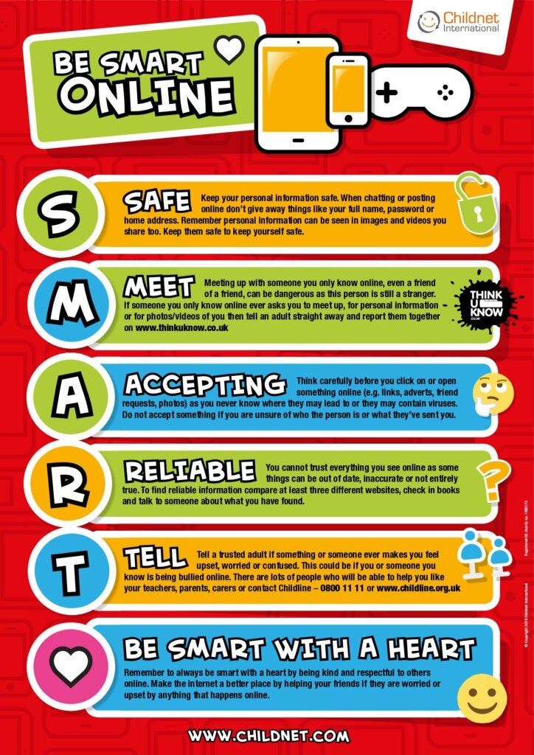

I will follow these rules to stay safe online:
- I will only use the computers or tablets when an adult has said I can.
- I will only use activities that an adult has allowed me to use e.g. websites that are for children my age.
- I will take care of computers, tablets, and other equipment.
- I will be polite if I talk with others online.
- I will not share personal information about myself or others online (e.g., full name, age, address, email address, telephone numbers, school).
- I will never talk to or meet an online stranger.
- I will not take or share photos or videos of myself or others online.
- I will ask for help from an adult if I am not sure what to do or if I think I have done something wrong.
- I will tell an adult if I see something that upsets me.
- I know that my school can see what I do on the computers and online.
- I will use the SMART rules to help keep me safe online.
- If I break the rules, I might not be allowed to use a computer/tablet.

Class signatures

