Geography Intent, Implementation & Impact Statement
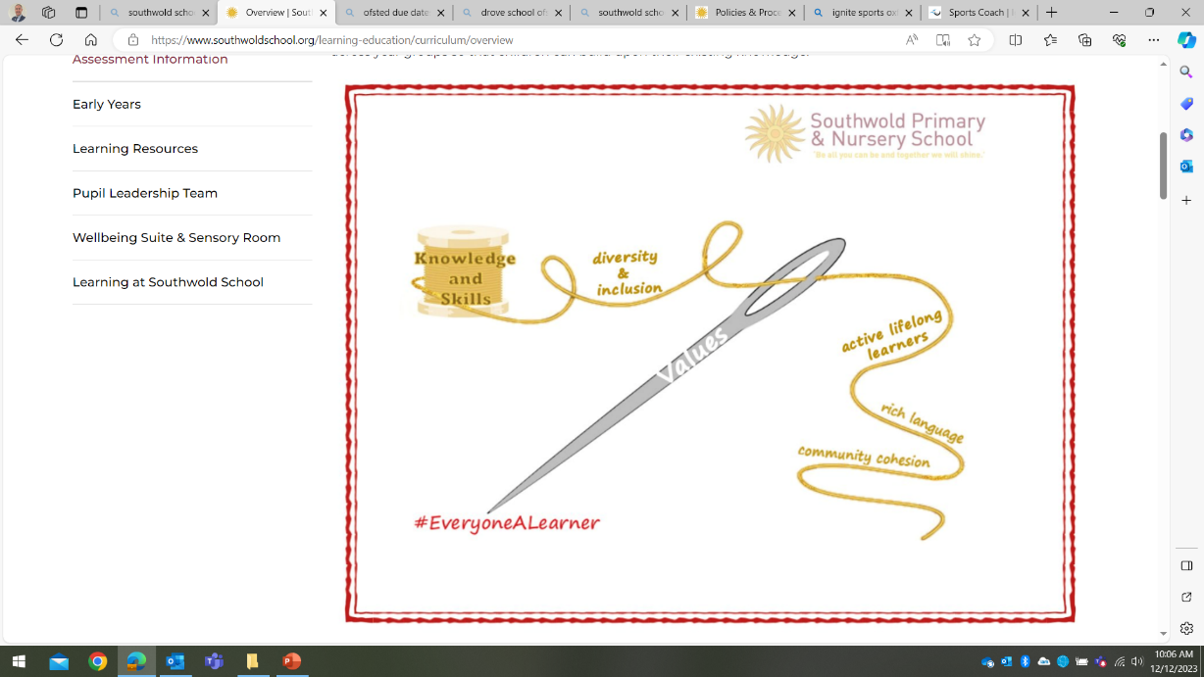
At Southwold School we believe in the unlimited potential of every child. As a result of this, we have carefully designed a curriculum which is underpinned by 5 Golden Threads.

We have carefully chosen our Golden Threads because they are unique to our school context and setting:
- Knowledge and skills: It is our intent that our pupils will develop mastery across the curriculum as a result of a carefully sequenced curriculum which builds progressively on knowledge and skills.
- Rich language: Our intent is for all children to acquire knowledge, develop their vocabulary and have tools to communicate their ideas and learning effectively, both orally and in writing. To do this, our curriculum is planned to include high quality texts, real life and hands on experiences and creating a range of opportunities for all children to be immersed in and engaging with language.
- Active lifelong learners: Our intent is for every child to be a passionate and active learner, underpinned by our value of ‘Excellence’. We provide children with real-life experiences and use AfL strategies within lessons to encourage them to be active learners, who take pride in and can talk about their work and learning.
- Diversity and inclusion: Our intent is for all children of our children to grow up to develop into citizens who are well-rounded, take care of themselves, other people and the world they live in, and who grow to be the best version of themselves as individuals. Our school celebrates inclusion and diversity – all members of our community are made to feel welcome, and we use our curriculum to teach children about issues relating to diversity and inclusion. We also ensure that the needs of our learners are met so that they can fulfil their potential.
- Community cohesion: Maintaining strong links with our community are important. Within our curriculum offer, including our hidden curriculum, we find opportunities for children to work with and support causes in the community – these include visits to school and supporting local charities.
Our Values: Our intent is for all children to embrace and develop a shared set of ACHIEVE Values: Ambition, Collaboration, Honesty, Inclusivity, Environmental care, Valiance and Excellence, which underpin everything we do. This will encourage our children to be the best version of themselves and strive to achieve potential in an ever-changing and modern world.

Intent for our Geography Curriculum:
At Southwold School, our Golden Threads underpin our curriculum intent enabling our pupils to achieve the following in Geography:
- Be curious about the world around them and understand this influences our lives today, develop their own sense of belonging based on gaining a better understanding of the geographical significance of the place in which they live. ​
- Ask questions about their locality, other countries and the world, develop research skills and evaluate material to inform opinions. ​
- Increase children’s knowledge of other cultures and in doing so, teach a respect and understanding of what it means to be a positive citizen to be part of a multicultural society.
- Have knowledge of their local community, the world, some of its countries and the people and communities that have developed in them.
- Understand how natural processes affect the world, people and communities.
- To make connections in their learning and to know more, remember more and do more each year leading to academic success and enjoyment in this subject. ​
- Develop skills to acquire, apply and transfer their knowledge.
- Develop geographical skills including how to use, draw and interpret maps of different scales and the vocabulary necessary to carry out effective geographical enquiry. ​
- To converse with confidence orally and in writing in a range of contexts using subject specific vocabulary.
- Encourage a commitment to sustainable development and appreciation of what global citizenship means.

Curriculum Intent
At Southwold, we understand the importance of Geography and how life is different in other areas. We aim to give children the opportunity to explore and develop respect and understanding for the area they live in and the people that live in it. We want pupils to be able to understand the importance of being part of a community within Bicester and develop a respect of different ways of life and experience other cultures and areas in different countries.
We aim to produce a balanced and well thought out curriculum, based on the National Curriculum document, which is progressive and outlines the intended geographical skills and areas of focus. We understand that knowledge is important for children, however we also place equal importance on the geographical skills and focus on how these skills can transfer into other geographical concepts and areas of learning. We intend to offer different opportunities to develop and progress pupils’ geographical skills through cross curricular activities, so that pupils can understand that geographical concepts extend further across various subjects and can apply to our way of life.
Our intent is to enable our pupils the experiences required to understand geographical concepts by acting as geographers and working to find out about the areas and world around them. Therefore, we aim to offer opportunities for pupils to develop their understanding using a variety of experiences and sources which encourage them to acquire knowledge and develop an understanding with subject rich vocabulary.
Implementation
Using the National Curriculum as a starting point, we have developed a progression of topics that develop across the school through our curriculum map for each year group.
Our children are taught about the world they live in – climates, environments, continents and more!
Wherever possible, teachers will plan opportunities for learning geography through trips to the local area or to areas surrounding Bicester. It is important at Southwold for pupils to be exposed to these experiences to develop their curiosity, deepen their understanding of fieldwork and apply this within the classroom or to different contexts.
Within our curriculum, we have developed a skills document that demonstrates a progression of the skills that need to be taught across each year group. Each area of the skills required progress across each year group, developing on the previous year’s skills. These skill areas are as follows:
- Locational knowledge
- Place knowledge
- Human and Physical Geography
- Collect, analyse and communicate with a range of data (through experiences of fieldwork)
- Interpret a range of sources (maps, diagrams, aerial photographs, etc.)
- Communicate geographical information (maps, numerical and quantitative skills, etc.)
These are used to inform, plan and assess in Geography, with each skill progressing alongside the pupils.

Impact
By the time the children at Southwold leave our school they should have developed:
- Secure locational knowledge, with an ability to locate countries, the equator, hemispheres, the tropics, and the significance of latitude and longitude
- Secure knowledge of the counties and cities of the United Kingdom and other capital cities that have been studied from around the world
- A robust understanding of human and physical geography from a wide range of studies of different countries
- Extensive geographical based vocabulary from different areas of study
- A secure ability to interpret a range of sources including data on graphs and maps, atlases, globes and other platforms to support the location of country or areas within a country
- Secure use of various geographical tools, skills and techniques to support fieldwork to observe, measure, record and present information reliably
- An ability to reach conclusions with a reasonable argument in which to communicate findings
- A natural curiosity of the world around them with an ability to express opinions on current issues in society and the environment i.e. renewable energy

