Geography Intent, Implementation & Impact Statement
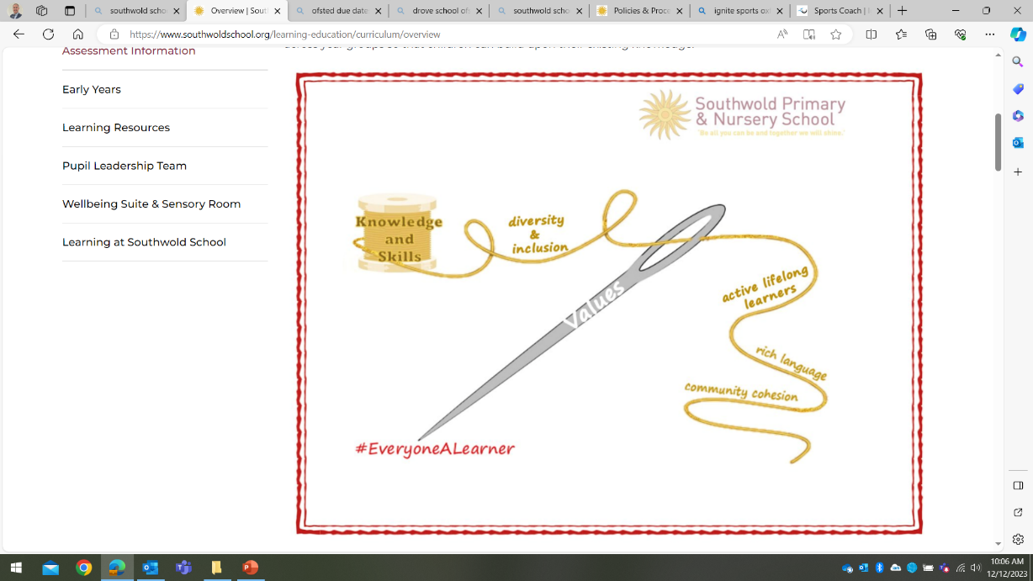
At Southwold School we believe in the unlimited potential of every child. As a result of this, we have carefully designed a curriculum which is underpinned by 5 Golden Threads.

We have carefully chosen our Golden Threads because they are unique to our school context and setting:
- Knowledge and skills: It is our intent that our pupils will develop mastery across the curriculum as a result of a carefully sequenced curriculum which builds progressively on knowledge and skills.
- Rich language: Our intent is for all children to acquire knowledge, develop their vocabulary and have tools to communicate their ideas and learning effectively, both orally and in writing. To do this, our curriculum is planned to include high quality texts, real life and hands on experiences and creating a range of opportunities for all children to be immersed in and engaging with language.
- Active lifelong learners: Our intent is for every child to be a passionate and active learner, underpinned by our value of ‘Excellence’. We provide children with real-life experiences and use AfL strategies within lessons to encourage them to be active learners, who take pride in and can talk about their work and learning.
- Diversity and inclusion: Our intent is for all children of our children to grow up to develop into citizens who are well-rounded, take care of themselves, other people and the world they live in, and who grow to be the best version of themselves as individuals. Our school celebrates inclusion and diversity – all members of our community are made to feel welcome, and we use our curriculum to teach children about issues relating to diversity and inclusion. We also ensure that the needs of our learners are met so that they can fulfil their potential.
- Community cohesion: Maintaining strong links with our community are important. Within our curriculum offer, including our hidden curriculum, we find opportunities for children to work with and support causes in the community – these include visits to school and supporting local charities.
Our Values: Our intent is for all children to embrace and develop a shared set of ACHIEVE Values: Ambition, Collaboration, Honesty, Inclusivity, Environmental care, Valiance and Excellence, which underpin everything we do. This will encourage our children to be the best version of themselves and strive to achieve potential in an ever-changing and modern world.

Intent for our History Curriculum:
At Southwold School, our Golden Threads underpin our curriculum intent enabling our pupils to achieve the following in history:
- Develop their own sense of belonging as part of a community when learning about the history of places and people of significance to them
- Develop a line of enquiry, asking and answering questions
- Instill a curiosity and understanding of key historical events throughout history, in the UK and around the world. ​
- Develop an understanding of how history has impacted our lives in the present day
- To make links and extend learning across other periods of study and within other aspects of our curriculum
- A fully comprehensive and empathetic view of historical events in which they experience aspects of history in a variety of ways
- Develop a knowledge of chronology within which the children can organise their understanding of the past.
- Understand how the past was different from the present and that people of other times and places may have had different values and attitudes from ours.
- Develop an interest in the past and an appreciation of human achievements and aspirations.
- Develop skills to acquire, apply and transfer their knowledge into different areas of study.
- To subject specific vocabulary with confidence, both orally and through focused activities such as writing

Our intent is to allow our pupils the experiences required to understand historical concepts by acting as historians and working to find out about the people, events and different periods of study. Therefore, we aim to offer opportunities for pupils to develop their understanding using a variety of experiences, sources, visitors and artefacts which encourage them to acquire knowledge and develop an understanding with subject rich vocabulary. Southwold School is located within Oxfordshire, within a county of rich local history. Visits to local places of historical importance and relevance are planned for.

Implementation:
The National Curriculum is the starting point of our curriculum design. It has been used to drive our curriculum design, to ensure the aims of the National Curriculum are met, and it has been used to inform the choices we have made about the content that we teach at Southwold School.
Each year group focuses on a different period of history, which is built upon as they progress through the school. Each year group has an opportunity to focus on various historical figures, events and periods in history. We have planned cross curricular links within our curriculum design, where appropriate, to make links and apply historical knowledge and skills. This way, knowledge is transferrable.
Within our curriculum, we have developed a skills document that demonstrates a progression of the skills that need to be taught across each year group. Each skill area has clear progression planned for across each year group, developing on the previous year’s skills. These are used to inform, plan and assess in history:
- Chronological knowledge/ understanding (understanding periods of time and where they are placed in history)
- Historical terms (Vocabulary)
- Historical enquiry (Using evidence and communicating ideas)
- Interpretations of history (Using sources of information)
- Continuity and change
- Cause and consequence
- Similarities and differences
- Significance (Recognising people and events of significant importance)
The use of subject specific vocabulary and historical terms will be planned for and modelled by teachers within lessons. Vocabulary obtained from these lessons will be made available for pupils to refer to throughout the topic displays or within knowledge organisers. Alongside this, pupils will be exposed to the use of a timeline, which will be continuously added to and developed throughout the school year for pupils to refer to.
Wherever possible, teachers will plan opportunities for learning history through trips to the local area, historical sites or museums. It is important at Southwold for pupils to be exposed to these experiences to develop their curiosity, deepen their understanding of historical concepts and apply this in history lessons and other contexts. Teachers are also encouraged to introduce the various replicas and artefacts we have available in the school to encourage pupils to engage in an enquiry-based approach through levels of questioning:
- What do I already know? – What do you notice?
- What can I infer? – Based on previous knowledge.
- What do I want to know?
- How will I find out?
Pupils are encouraged to observe these primary and secondary sources, identifying if they are reliable, rich and relevant to the topic they are focussing on.
Impact
Our intended impact is that by the time our pupils leave Southwold School, they will have developed:
- A wide range of knowledge about historical events, people, situations and periods, ranging from local to world history, and how our history of knowledge has been developed over time
- A secure chronological understanding of historical events and periods from around the world in which they can compare, place accurately in a timeline and identify trends over time
- Critical thinking skills to develop their own historical enquires using a range of questions to develop their understanding of change, cause and significance
- An ability to support, challenge and evaluate other’s opinions using a wide range of evidence, selecting information to form responses and challenging sources of information, and their validity, to organise information purposefully
- A respect for aspects of history and the range of social, cultural, religious and ethnic diversity, in Britain and the wider world, and how this has changed or influenced present day
- An interest in history and an enthusiastic approach to learning, which develops their curiosity of the past and historical enquiry process

