MFL Intent, Implementation & Impact Statement
At Southwold School we believe in the unlimited potential of every child. As a result of this, we have carefully designed a curriculum which is underpinned by 5 Golden Threads.
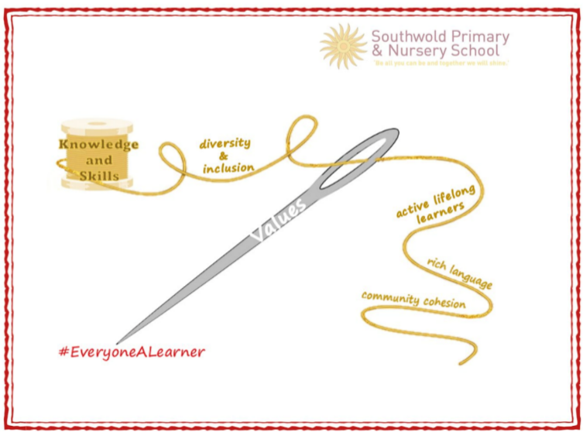
We have carefully chosen our Golden Threads because they are unique to our school context and setting:
- Knowledge and skills: It is our intent that our pupils will develop mastery across the curriculum as a result of a carefully sequenced curriculum which builds progressively on knowledge and skills.
- Rich language: Our intent is for all children to acquire knowledge, develop their vocabulary and have tools to communicate their ideas and learning effectively, both orally and in writing. To do this, our curriculum is planned to include high quality texts, real life and hands on experiences and creating a range of opportunities for all children to be immersed in and engaging with language.
- Active lifelong learners: Our intent is for every child to be a passionate and active learner, underpinned by our value of ‘Excellence’. We provide children with real-life experiences and use AfL strategies within lessons to encourage them to be active learners, who take pride in and can talk about their work and learning.
- Diversity and inclusion: Our intent is for all children of our children to grow up to develop into citizens who are well-rounded, take care of themselves, other people and the world they live in, and who grow to be the best version of themselves as individuals. Our school celebrates inclusion and diversity – all members of our community are made to feel welcome, and we use our curriculum to teach children about issues relating to diversity and inclusion. We also ensure that the needs of our learners are met so that they can fulfil their potential.
- Community cohesion: Maintaining strong links with our community are important. Within our curriculum offer, including our hidden curriculum, we find opportunities for children to work with and support causes in the community – these include visits to school and supporting local charities.
Our Values: Our intent is for all children to embrace and develop a shared set of ACHIEVE Values: Ambition, Collaboration, Honesty, Inclusivity, Environmental care, Valiance and Excellence, which underpin everything we do. This will encourage our children to be the best version of themselves and strive to achieve potential in an ever-changing and modern world.

Intent for our MFL Curriculum:
At Southwold School, our Golden Threads underpin our curriculum intent enabling our pupils to achieve the following in MFL:
- To provide children in Key Stage 2 with a foundation in French
- Value different cultures and languages
- Motivate and foster pupils’ curiosity to deepen their understanding of the world
- Develop pupils’ understanding of ‘the three pillars’ (phonics, grammar and vocabulary) of language learning in French
- Develop language skills in order to acquire, apply and transfer to other languages
- Enable pupils to express their ideas and thoughts in another language
- To make connections in their learning and to know more and remember more each year leading to enjoyment in this subject
Southwold School is located in an area of rich diversity of language and culture. It is our intent to allow our pupils the experience required in order to understand what it is to learn to communicate in another language as language learners. Therefore, we aim to offer opportunities for pupils to develop their understanding through the four strands of language skills – speaking, listening, reading and writing – which encourage them to acquire knowledge and the confidence to learn about the architect of language.
Implementation:
The National Curriculum is the starting point of our curriculum design. It has been used to drive our curriculum design, to ensure the aims of the National Curriculum are met, and it has been used to inform the choices we have made about the content that we teach at Southwold School.
French is taught through a careful sequence of lessons based on ‘Language Angels,’ developing the skills and confidence to apply it in real-life situations and prepare pupils for life in a modern world. Each Key Stage 2-year group have a weekly lesson that provides opportunities to develop the language, through vocabulary, writing and speaking experiences.
Learning is sequenced with regular opportunities to revisit and build upon prior knowledge to support deeper understanding, and to encourage children to apply their knowledge. Where appropriate, cross- curricular links are made to make learning experiences more meaningful and to give context to the knowledge acquired and skills taught. For example, in Year 3, the children learn about France for their geography topic. Key vocabulary in French is displayed to support learning and to scaffold responses from the children. As a staff, we strive to encourage a passion for language learning and continue to develop each child’s personal values to prepare them for their future lives.

Impact
Our intended impact is that by the time our pupils leave Southwold School, they will have developed:
- A secure foundation of learning in French so that children can converse at a basic level
- An ability to express their ideas and thoughts in another language
- Knowledge of what makes up learning a language (the architect)
- The language skills to apply and transfer to other languages
- Respect and value for the diversity of languages in the world
- An excitement and confidence to learn other languages

