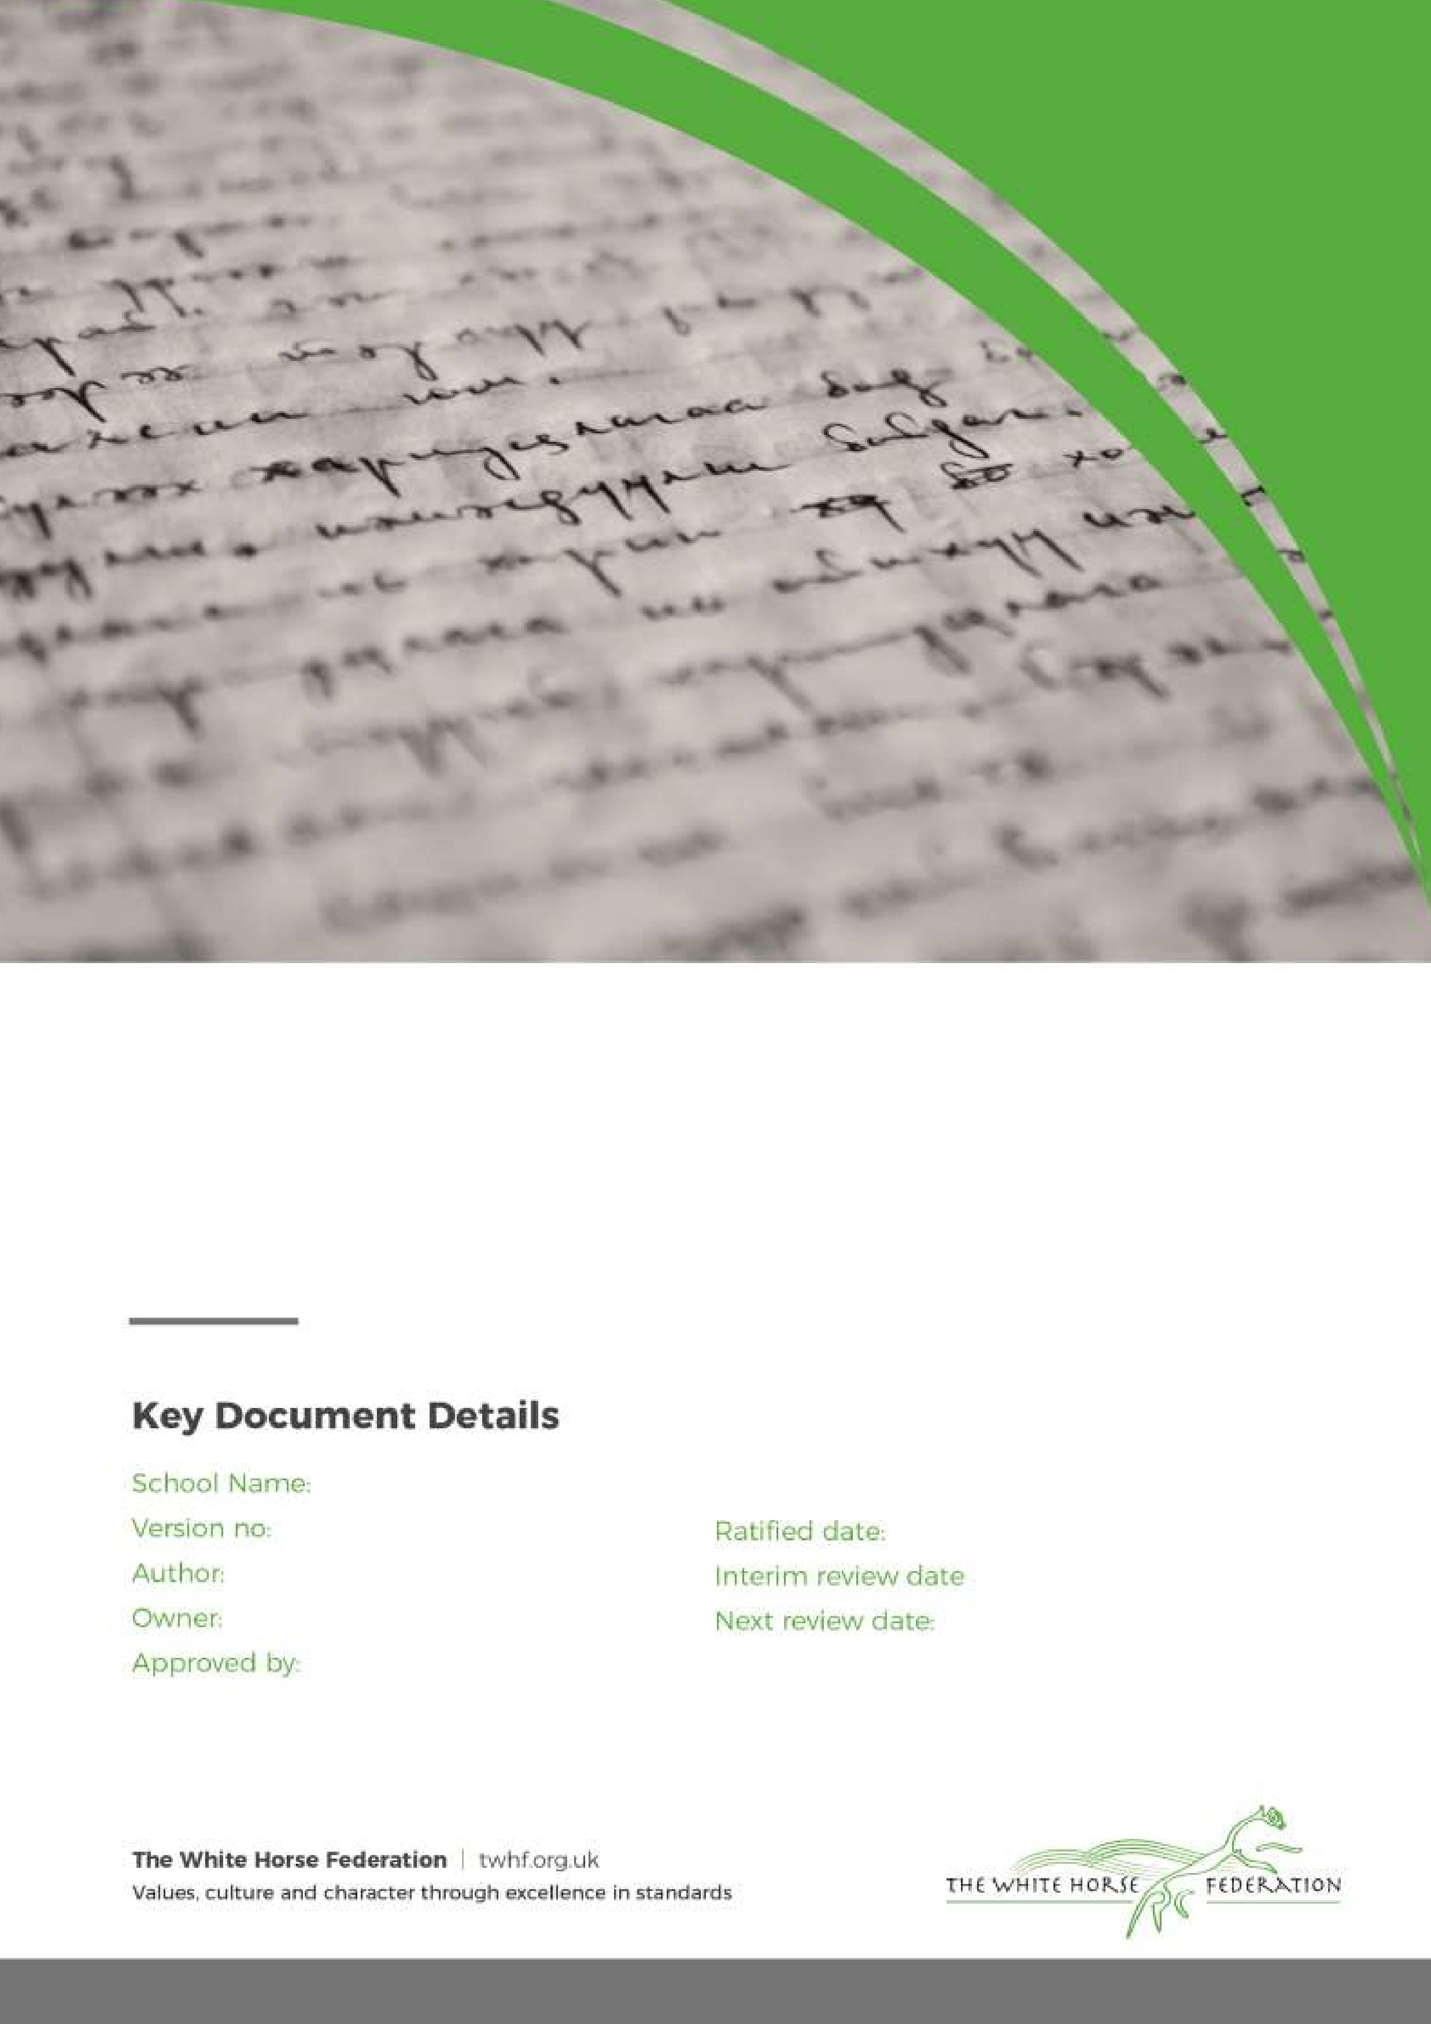

Marking & Feedback Policy

1

L Graham

Headteacher

Headteacher

February 2024

n/a

September 2025

Gagle Brook School & Southwold School

Marking & Feedback Policy

Rationale:
The purpose of this policy is to support school improvement and the raising of standards for all our pupils.

This policy intends to:
- Make clear our vision of the role of Marking and Feedback as a key and integral form of Assessment of Learning and Assessment for Learning at Gagle Brook School and Southwold School
- Make clear the expectations for Marking and Feedback

Our Values:
Our ACHIEVE Values underpin our collective work to ensure that children achieve their full potential. Our Marking & Feedback Policy is underpinned by these values ensuring that our children achieve their full potential in their outcomes, evident in their workbooks and data.

Our principles for Marking & Feedback as a form of Assessment:
At Gagle Brook School and Southwold School, assessment means continually evaluating pupils’ knowledge, skills and understanding, establishing what pupils can do and what their next learning steps should be. Assessment is at the heart of the learning process. It provides valuable evidence to guide and improve teaching and learning. Alongside this, it offers an opportunity for pupils to demonstrate and review their progress. It is an integral part of our relentlessly ambitious, high expectations culture.

We are committed to:
- Seeking and interpreting evidence of pupils’ learning to decide where learners currently are, where they need to go next and how best to get there.

- Using assessment, day-to-day, in the classroom to raise pupils’ achievement and their aspirations. We believe that pupils will improve most if they understand the aim of learning, where they are in relation to this aim and how they can achieve the aim (or close the gap in their knowledge).

- Providing pupils with clear, precise and easily comprehensible feedback that demonstrates a growth mindset, in oral and written forms. We will always expect pupils to engage with this feedback and ask them to respond to it where appropriate. The quality and value of teachers’ feedback will be evaluated by how great an impact it has on pupils’ future progress.

- Involving pupils at all times in an ongoing self-improvement process and assisting them to understand that the continual quest to improve oneself is a crucial life skill. Assessment feedback should recognise success of pupils and inspire ever greater effort and a belief that, through commitment, hard work and practice more can be achieved.

- Continually tracking the performance of pupils during a lesson and over time, and using this information in three ways:
- to ensure that all pupils are suitably challenged
- to provide additional learning support for those who are currently finding learning more difficult
- to benchmark pupils against Age Related Expectations

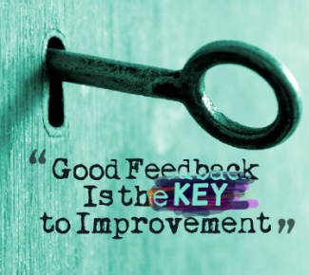

Marking and Feedback:
Research shows that high quality feedback is the most important factor in pupil learning. Our staff body is committed to providing relevant and timely feedback to pupils, both orally and written. We mark to show pupils that we value their work and to motivate them, celebrating their success, diagnosing areas for development and evaluating how well the learning has been understood. We see marking and feedback as a process of creating dialogue with the learner, through which feedback can be exchanged and questions asked; the learner must be actively involved in the process. Finally, we mark to point a way forward, and to help us to inform our planning and set targets for individual pupils.

Aims of Marking & Feedback:
We aim to:
- Provide consistency and continuity in Feedback and Marking throughout the school so that children have a clear understanding of teacher expectations.
- Use Feedback/Marking as a tool for formative on going assessment.
- Improve standards by encouraging children to give their best and improve on their last piece of work through response to marking & feedback (e.g. self-editing / correction of spellings).
- Develop children’s self-esteem through praise and valuing their achievements.
- Create a dialogue which will aid progression.
- Provide a consistent approach to marking which is evident across the school.

Principles of effective feedback/marking:
Good feedback/marking or annotation of children’s work should:
- Be positive, motivating and constructive.
- Be at the child’s level of comprehension.
- When written comments are given, writing in handwriting that is legible and a model for the child.
- Positively affect the child’s progress to aid their next step of learning.

The purpose of AfL is to provide feedback in such a way that learning will improve as a result. Feedback will always be constructive and sensitive. Feedback will comment on the work rather than the child. Although there may be occasions when it is useful to reflect on the child’s attitudes, this should be done verbally during or after the lesson.

All teachers will adhere to the above principles and will:

- Provide regular feedback.
- Provide time in lessons to review work from previous lessons as necessary.
- Adjust planning in the light of marking.
- Make learning questions explicit.
- Involve children in the process from an early stage (as part of formative assessment).
- Allow specific time for the children to read, reflect and respond to marking.
- Use children’s work as exemplars (what a good one looks like) (Use of the visualiser to show good examples of children’s learning and steps for improvement).

Expectations of Marking:
Marking must be proportionate, meaningful, manageable and motivating and the teacher is best place to decide what is needed for each piece of work.

Marking of Reading, Science & Non-Core curriculum areas:
- All work in pupil books must be acknowledged and used to inform planning for the next lesson. For Reading, Science and non-core curriculum areas, as a minimum, the date and title should be checked, mistakes within the content of a pupil’s work corrected, and spellings of key topic-related vocabulary corrected.

- The main focus of the marking should be against the Learning Question (how fully did the children meet the LQ?).

- Teachers mark using a blue pen and pink highlighter. Children will edit / self-assess and respond to marking in purple pen.

Marking of English Writing & Mathematics:
- Marking of English Writing and Mathematics is expected to be in more depth than other curriculum areas, following the guidance set out in this policy.

English Writing:
- The main focus of the marking should be against the Learning Question (how fully did the children meet the LQ?). Teachers will either highlight the LQ pink or tick once when a child has met the LQ.

- A minimum of one written comment will be provided to children, evident in books each week. This must move the children forward in their learning. For example: ‘Remember to use the conjunctions, and, but and so.’ Children should be able to articulate areas of their written work that they are working to develop.

- Children must adhere to presentation guidance, which will be evident in the front of each book. E.g. children will neatly write the date and LQ, or a copy will be provided for them to stick into books.

- Teachers use a pink highlighter to highlight evidence within a child’s work that they either have a) shown evidence of securing the learning question/application of the taught skill; b) shown evidence of age-related curriculum skills (useful in Phase 3 writes).

- Within written work, teachers should ensure that grammatical and punctuation errors are recognised and addressed, with examples of missing punctuation inserted (e.g. use of commas and full stops) and grammatical areas identified either within the text or within the margin (using marking codes), as determined by the teacher as to what is most helpful to a pupil. Teachers may not identify all errors, as may request that children self-edit their work in light of feedback, although some corrections by the teacher should be evident, as appropriate.

- Teachers will either correct a child’s spelling for them within the text, or use the ‘Sp’ symbol in the margin, underlining the misspelt word, to remind a pupil to self-edit their work. If a child has made more than 5 spelling incorrections, a maximum of 5 should be corrected. Teachers will set spelling corrections to complete for each piece of work (set in the margin, with children asked to rewrite the correct spelling 5 times per word – if spelling mistakes have been made).

- Pupils will be taught to self-edit their work from Year 2 upwards (the exception to this will be if a child has a particular barrier to learning which prevents them from doing this independently, in which case the teacher will use their professional judgement to decide what will best support the individual pupil). All self-editing is done using purple pen.

- The marking code included within this Policy should be followed.

Mathematics:

- The main focus of the marking should be against the Learning Question (how fully did the children meet the LQ?). Teachers will either highlight the LQ pink or tick once when a child has met the LQ.

- Marking of mathematics work is through a combination of teacher marking and self-assessment. Ticks will be used to indicate a correct calculation/answer and dots to indicate an incorrect calculation/answer.

- Teachers may feel that it is appropriate to set a consolidation (further practise) question for a pupil, if they have found the work challenging. Pupils will be expected to respond to this in purple pen.

- Incorrect number formation should be corrected and set for a child to practise.

- It must be evident that the teacher has checked each child’s work for accuracy and misconceptions (e.g. tick/highlight of learning question) even if self-assessment has been utilised. Any incorrectly self-assessed work should be identified by the teacher to inform accurate and ongoing assessment of learning.

Oral Feedback:
- This is the most regular and interactive form of feedback.
- Focus on being constructive and informative to help pupils take the next steps in their learning.
- Can be direct (targeted at pupils/individuals) or indirect (whole class can listen and reflect on what is said).
- It is an opportunity to model the language pupils can use when responding or giving feedback to others.

Self-assessment/Editing:
Self-assessment and editing is encouraged from Year 2 upwards. Editing pens can be used by the children for editing as appropriate. Purple pens are used by children for editing.
It is expected that when self-assessment is used, there is evidence that the teacher has still checked the child’s work.

Peer assessment:
- Peer assessment MUST be taught and should be modelled regularly.
- Peer assessment with learning partners should be positive and given verbally, not written on the work.
- Children can evaluate their own work against success criteria and on occasions can be involved in shared marking of work.
- This is not meant to replace teacher marking and feedback, but is important for encouraging children to become more independent and responsible for their own learning as well as a strategy for children to demonstrate their understanding of the Learning Question.

Expectations of Presentation:
One of our ACHIEVE Values is ‘Excellence’. It is therefore expected that all pupils take pride in their work and show ‘excellence’ through the presentation of it.

General guidance for good presentation includes:
- Using a ruler to underline dates and titles
- Sticking sheets/success criteria neatly and straight into books (sheets trimmed and not hanging out)
- Not wasting pages
- Use of sharp pencil
- No scribbling out – use of pencil and ruler to cross out mistakes
- Setting work out for Maths Story & Real Story
- Neat handwriting in line with school guidance and use of pen in Years 5 and 6 (licence can be given in Year 4)
- Teacher handwriting to model high expectations

Pupil books and recorded observations of pupils have the LOUDEST VOICE! It is important that they are well presented and show pride in the quality, quantity and presentation of all work.

Monitoring Marking & Feedback to assess for impact:
In order to assess the quality of marking and feedback and its subsequent impact on pupil progress, marking will be reviewed through:
- Termly formal book looks – these will be conducted by the SLT and alongside core subject leaders, with written feedback provided to staff. This will feed into triangulated evidence for Performance Management, linking to the Teachers’ Standards 2012.
- ‘Work watch’ – targeted pupils will be selected to bring their book to share with a member of SLT every 1-2 weeks. The children’s presentation and work will be reviewed with them.
- Pupil Progress Meetings – teaching staff will be expected to bring pupil books to PPM meetings to evidence progress.
- Subject Leader audits – Subject Leaders may request to look at pupil books to assess curriculum coverage, progress, quality of feedback and presentation.
- TWHF audits – Colleagues from TWHF may request to review books as part of Trust audits.

Marking Code Guidance:

EYFS teaching & learning Pedagogical Documentation
How will we document progress and achievement in Reception?
In early years education, pedagogical documentation refers to ‘making thinking and learning visible’.
Why? We document to share, to understand, and to be understood.
So what? It provides a reflective process for teachers which informs our teaching; raises questions for us and provides next steps.

Baseline File:
- Nursery End of year expectation (TWHF)
- Transition document and notes from home and nursery visits.
- Pencil grip picture
- Scissor hold picture
- Math dice assessment.
- Speech and Language screening assessment. e.g Wellcomm

Progress file:
- Child Initiated writing x1 per term
- 2x pictures of scissor control in the year and cuttings
- SSM story observation – 1 per child per term
- 1x High quality observation cross curricular – to give us overall information about children’s learning. (Recorded on online LJ, Keynote on i-pad, or paper LJ)
- Intervention progress. E.g., S&L, Phonics, math, PSED, pencil grip
(This might be held by Senco or in a different file in school)
- Tick sheets for weekly maths activities to inform Ready to Progress Criteria.

Class Visual Pedagogical Documentation

Wow Space/Proud Wall
1 x child-initiated wow photo
1x draw a man/ self per term
1x art/creation work per term
Name progression x3 (Sept, Jan, May)

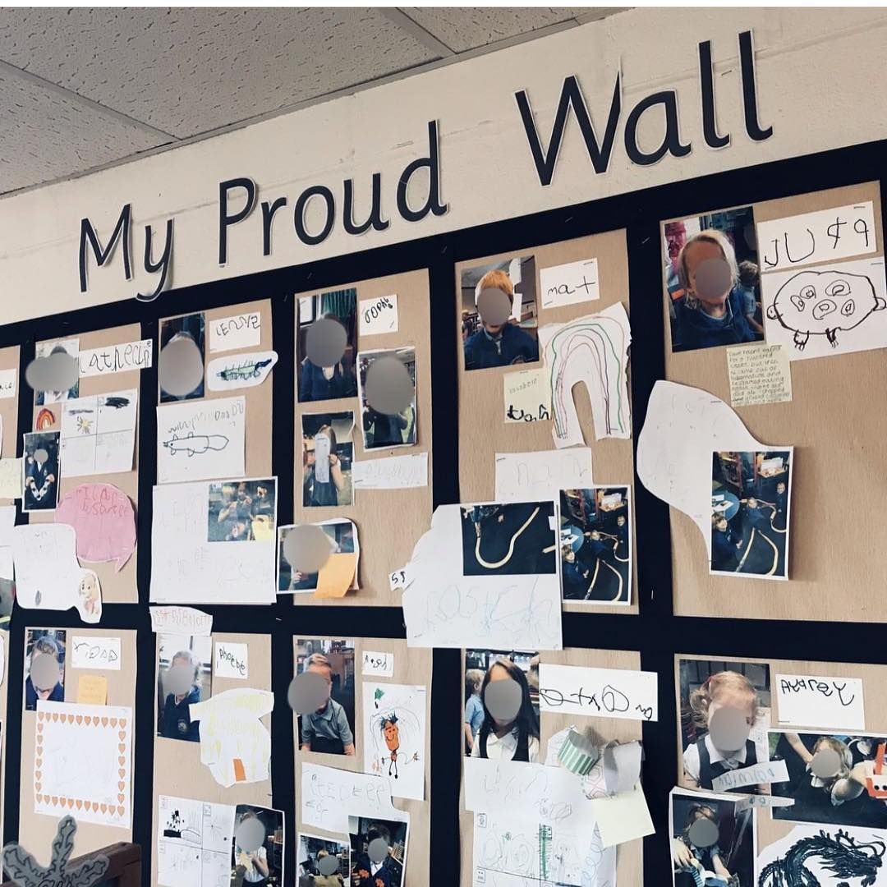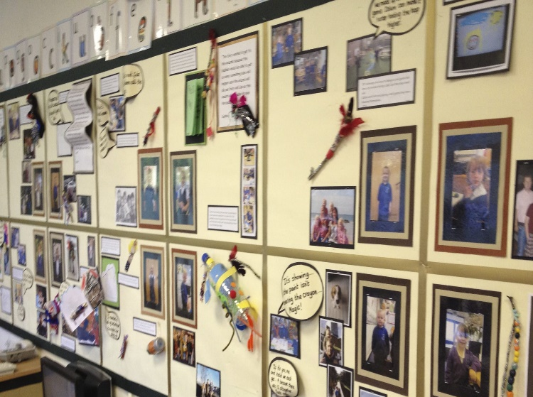

UtW Learning Display/Floor book
This will contain photographs and speech bubbles to depict the learning experiences & enhancements provided term by term. (See Seend)

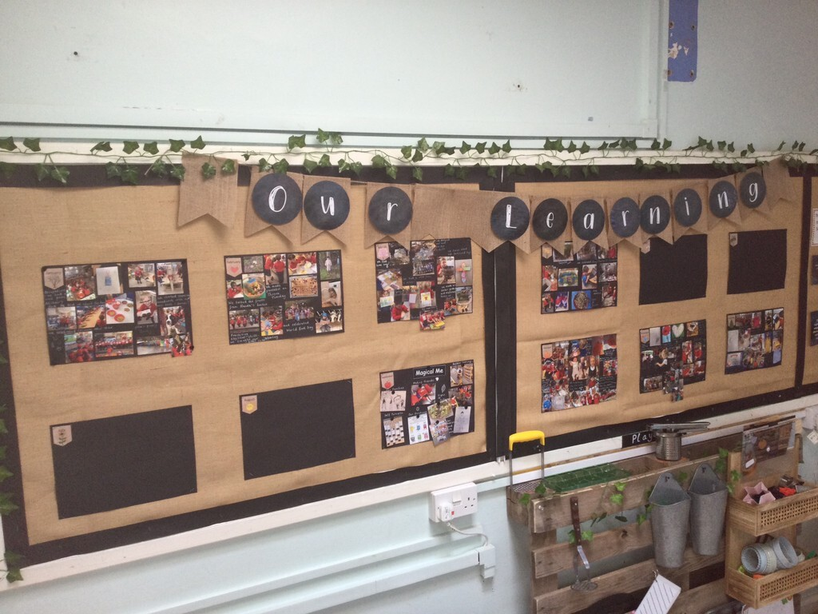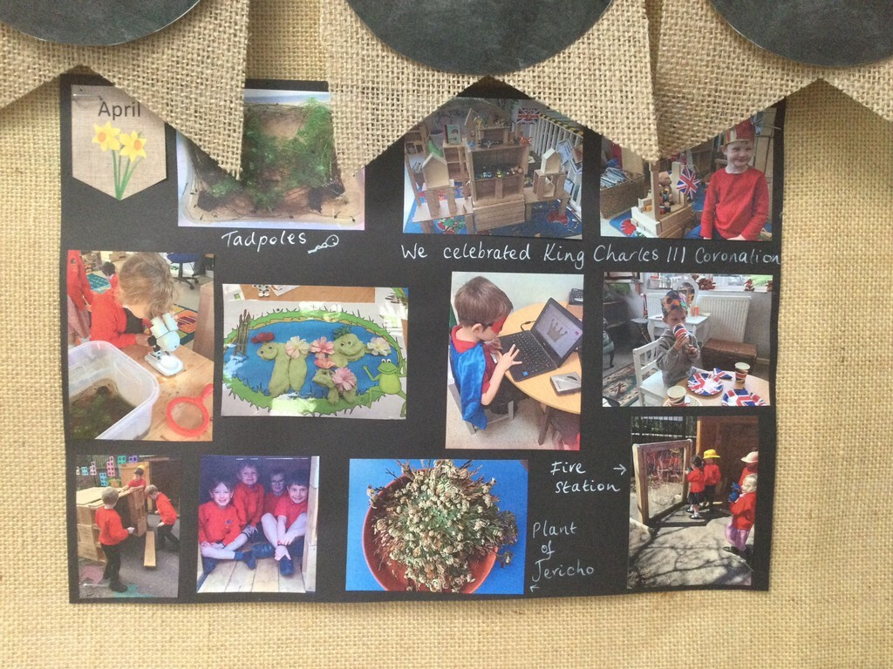

Math in Action Display
This will have photographs of child initiated, small group math learning, sentence stems and brief explanations of subject content.
It can be created as we learn each week.

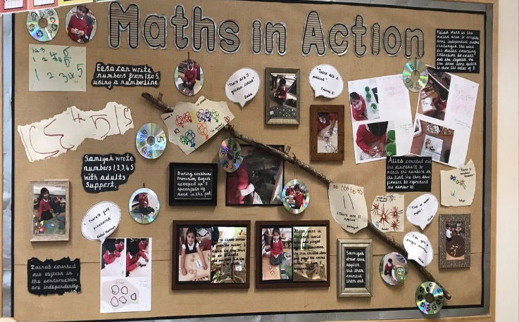

Other

- PSHE Display: Jigsaw Mind map and quotes from children.
- Values Displays
- WOW moments and whole class activities recorded in online platform to inform parents.

