Music Intent, Implementation & Impact Statement
At Southwold School we believe in the unlimited potential of every child. As a result of this, we have carefully designed a curriculum which is underpinned by 5 Golden Threads.
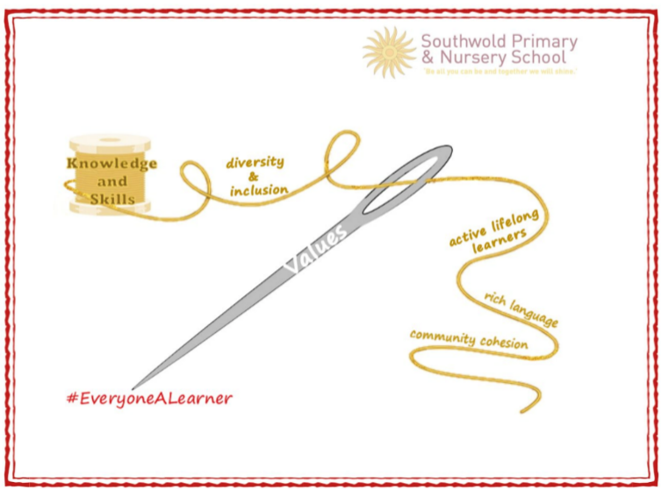

We have carefully chosen our Golden Threads because they are unique to our school context and setting:
- Knowledge and skills: It is our intent that our pupils will develop mastery across the curriculum as a result of a carefully sequenced curriculum which builds progressively on knowledge and skills.
- Rich language: Our intent is for all children to acquire knowledge, develop their vocabulary and have tools to communicate their ideas and learning effectively, both orally and in writing. To do this, our curriculum is planned to include high quality texts, real life and hands on experiences and creating a range of opportunities for all children to be immersed in and engaging with language.
- Active lifelong learners: Our intent is for every child to be a passionate and active learner, underpinned by our value of ‘Excellence’. We provide children with real-life experiences and use AfL strategies within lessons to encourage them to be active learners, who take pride in and can talk about their work and learning.
- Diversity and inclusion: Our intent is for all children of our children to grow up to develop into citizens who are well-rounded, take care of themselves, other people and the world they live in, and who grow to be the best version of themselves as individuals. Our school celebrates inclusion and diversity – all members of our community are made to feel welcome, and we use our curriculum to teach children about issues relating to diversity and inclusion. We also ensure that the needs of our learners are met so that they can fulfil their potential.
- Community cohesion: Maintaining strong links with our community are important. Within our curriculum offer, including our hidden curriculum, we find opportunities for children to work with and support causes in the community – these include visits to school and supporting local charities.
Our Values: Our intent is for all children to embrace and develop a shared set of ACHIEVE Values: Ambition, Collaboration, Honesty, Inclusivity, Environmental care, Valiance and Excellence, which underpin everything we do. This will encourage our children to be the best version of themselves and strive to achieve potential in an ever-changing and modern world.

Intent for our Music Curriculum:
At Southwold School, our Golden Threads underpin our curriculum intent enabling our pupils to achieve the following in Music:
- To be curious about different music genres and how they are composed and performed.
- To learn how to play a range of instruments.
- Use our school values to work cooperatively and persevere when activities challenge them.
- To make connections in their learning and to know more, remember more and do more each year. leading to academic success and enjoyment in music.
- Develop skills to acquire, apply and transfer their knowledge. ​

At Southwold, we intend our music curriculum to be a way of celebrating our diverse school community. We aspire to offer a range of opportunities to sing a variety of multicultural songs, listen to inspirational composers, participate in music sessions delivered by Oxford Music Service, and compose pieces of music that reflect the mastery of music that all children have developed through accessing a planned and structured curriculum. We are committed to ensuring that children understand the value and importance of music and can transfer their musical skills knowledge and experiences into their wider community. As a school we intend to develop every child’s self-confidence and social development that will support them in their future, and as such we believe that Music offers all children an opportunity to express their creativity and inspire self-confidence through practical experiences leading to various musical performances and activities.
Implementation:
The National Curriculum is the starting point of our curriculum design. It has been used to drive our curriculum design, to ensure the aims of the National Curriculum are met, and it has been used to inform the choices we have made about the content that we teach at Southwold School.
The implementation of the Music Curriculum at our school is through a combination of class teachers and music specialists from Oxford Music Service delivering sessions. Specialists from Oxford Music Service are utilised as they provide vital subject knowledge, musical experiences, road shows and teaching of specialised musical instruments. We teach the National Curriculum through the Charanga scheme of work which offers a range of differentiated activities to allow every child an opportunity to access the music curriculum and celebrate the diversity of our school community. We are committed to providing a range of musical experiences, offering awe and wonder for the children, which celebrate the different cultures and heritage within our school and wider community. We present a variety of learning stimuli to ensure the curriculum is accessible to all. At Southwold School, musical vocabulary is built upon from Nursery through to Year 6 through movement, pictorial representations and written / oral language of musical terminology and notations. This helps to develop the skills to be able to read and understand how to perform a basic musical composition. In addition to their classroom music sessions, and experiences, children are exposed to a range of music through singing lessons and activities where children procure the rewards of singing in unison and harmony and are taught to consider the elements of music required for performances such as tone, tempo, pitch, along with enhancing their ability to listen, respect and cooperate with each other.
Impact
Our intended impact is that by the time our pupils leave Southwold School, they will have developed:
- Their own opinions of different music genres and how they are composed and performed by listening and analysing different music types.
- To have challenged themselves to create and perform different genres of music.
- Develop skills to acquire, apply and transfer their knowledge ​across different musical instruments and genres.
- An appreciation for music and how it makes us feel and how it represents different cultures and other parts of the world.

