 | Pre-School Provision
 |  | Term 1 | Term 2 | Term 3 | Term 4 | Term 5 | Term 6
 | Key dates
RICH | Story Focus | Nursery Rhymes  Goldilocks and the Three Bears  We’re Going on a Bear Hunt  Brown Bear, Brown Bear | The Enormous Turnip  We’re Going on a Leaf Hunt  Pumpkin Soup | The Three Little Pigs  Little Red Riding Hood  Mr Wolf’s Pancakes | Chicken Licken  Ugly Duckling  Farmer Duck | The Three Billy Goats Gruff  The Little Red Hen  Farmyard Hullabaloo | The Very Hungry Caterpillar  Cinderella  Train Ride
 |  | 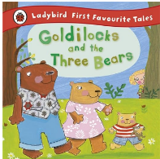  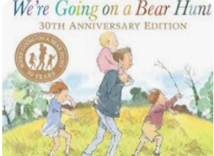  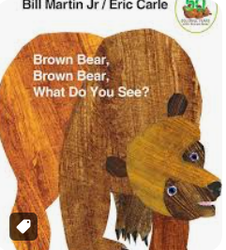 | 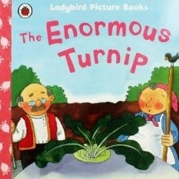  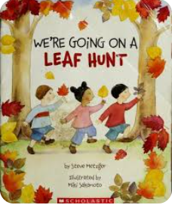  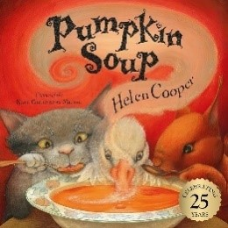 | 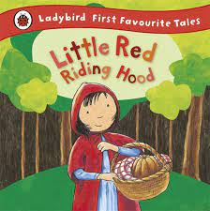  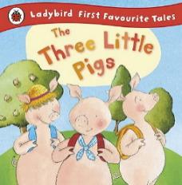  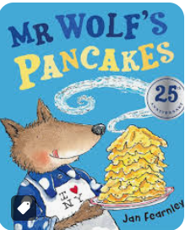 | 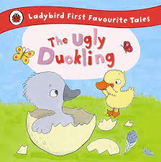  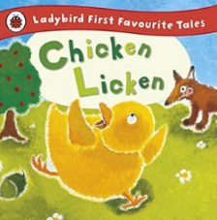  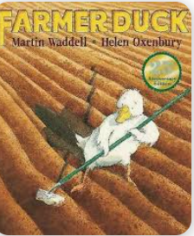 | 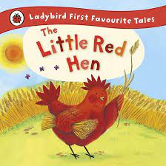  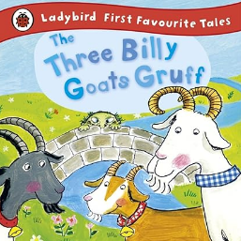  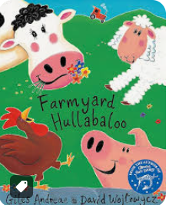 | 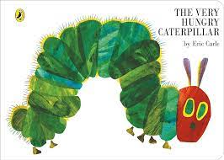  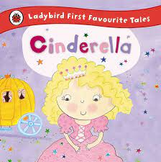  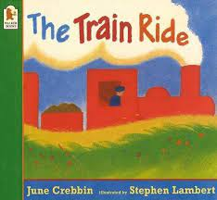
 | Nursery Rhyme Focus | Twinkle Twinkle  Jack and Jill | Baa Baa Black Sheep  Dingle Dangle Scarecrow | Incy Wincy Spider  Hot Cross Buns | Humpty Dumpty  Mary had a Little Lamb | I Hear Thunder  Hey Diddle, Diddle | Hickory Dickory Dock  Grand Old Duke of York
 |  | Twinkle Twinkle Little Star - CBeebies - BBC   | Baa Baa Black Sheep: BSL Signed Nursery Rhymes | CBeebies (youtube.com)  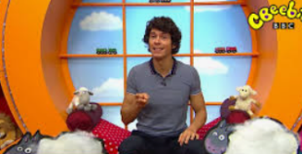 | Wind The Bobbin Up | The Baby Club (youtube.com)  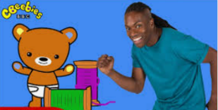 | Humpty Dumpty sat on a wall - BBC Teach   | CBeebies: Something Special - I Hear Thunder - Nursery Rhyme - YouTube   | 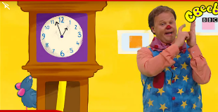CBeebies: Something Special - Hickory Dickory Dock - Nursery Rhyme (youtube.com)
 |  | 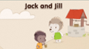Jack and Jill - BBC Teach | 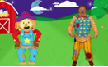Dingle Dangle Scarecrow - CBeebies - BBC | 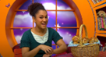Hot Cross Buns: BSL Signed Nursery Rhymes | CBeebies (youtube.com) | 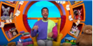CBeebies - CBeebies House Songs, CBeebies House - Mary Had A Little Lamb nursery rhyme (bbc.co.uk) | Hey Diddle Diddle - CBeebies - BBC  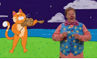 | The grand old Duke of York - BBC Teach  
 | Oracy focus | Join in with repeated phrases in Goldilocks and the Three Bears and We’re Going on a Bear Hunt.  Text Map: Twinkle Twinkle | Join in with repeated phrases in the Enormous Turnip.  Text Map: Baa Baa Black Sheep | Act out the story of the Little Red Riding Hood and The Three Little Pigs using props and masks.  Text Map: Incy Wincy Spider  Text Map: What LRR says to the wolf (What big ears you have...) The Three Little Pigs | Act out the story of the Chicken Licken using props and masks.  Text Map: Humpty Dumpty  Text Map: Chicken Licken | Orally retell the story of The Billy Goats Gruff in a beginning, middle and end format.  Text Map: I Hear Thunder  Text Map: Three Billy Goats Gruff, Little Red Hen | Orally retell the story of The Hungry Caterpillar, remembering as many foods as possible, in a beginning, middle and end format.  Text Map: Hickory Dickory Dock  Text Map: The Very Hungry Caterpillar
 | Writing focus – MUST be used alongside Getting Ready to Write. This simply talks about types of marks. | - Random scribbling – Some meaning may be applied to this.  -Lines made to show writing will be different to their drawings.  - It will look like horizontal / vertical lines / circular marks. |  | - Scribble writing - Children will be ascribing meaning to their marks.  - Movement of writing will follow a left to right motion on the page.  - There will be a range of vertical, horizontal and circular lines and an attempt at using diagonal line. |  | - A wider variety of marks will be used to show writing.  - Bouncy patterns, zig zag, circular, horizontal  - Movement of writing will follow a left to right motion on the page.  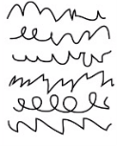 | - Name writing (or attempt to)  - Symbols produced to complete their name, these may or may not be correctly formed.  - A range of vertical, horizontal, circular and diagonal marks.  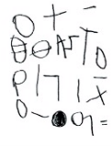
Nourish | Book Talk | - Hugless Douglas Goes to Little School  - Goldilocks  - We're Going on a Bear Hunt  - Brown Bear, Brown Bear  - Same, Same but Different  - Oh Dear | - Let’s celebrate Diwali  - The Enormous Turnip  - We’re Going on a Leaf Hunt  - Pumpkin soup  - The Scarecrow Who Didn’t Scare  - We’re Going on an Elf Hunt  - Owl’s first Christmas  - Babushka | - The Three Little Pigs  - Little Red Riding Hood  - Mr Wolf’s Pancakes  - Dim Sum for Everyone  - Oodles of Noodles  - So Much  -The Children who Loved Books | - Chicken Licken  - Ugly Duckling  - Farmer Duck  - Hooray for Hoppy  - The Odd Egg  - We’re Going on an Egg Hunt  - Five Little Chicks | - The Three Billy Goats Gruff  - The Little Red Hen  - Farmyard Hullabaloo  -Titch  - Jasper’s Beanstalk  - Mad About Minibeasts  - Monkey puzzle?  - | - The Very Hungry Caterpillar  - Cinderella  - Train Ride  - Tiny Seed  - Ugly Bug Ball  - Pass the Jam, Jim!
 | Songs and Rhymes | Little Miss Muffet | Pease Pudding  Little Jack Horner | Dr Foster  Pat-a-Cake (said as clapping rhyme) | Jack be Nimble | Five Little Peas in a Pea Pod Pressed  Rain, Rain Go Away  Dr Foster | If You Should Meet a Crocodile  Little Arabella Millar
 | Basket of Books: Themes | Tales  - The Magic Porridge Pot  - Goldilocks and the Three Crocodiles  Bears  - My Friend Bear (big and small link)  - The Little Mouse, The Red Ripe Strawberry and the Big Hungry Bear  - Bear Snores  - All Things Bears  - Peace at Last  - Whatever Next  - Can’t You Sleep Little Bear?  - Let’s Go Home Little Bear  Diversity Books  - We are family  - Together we can  - Who are you?  - My village rhymes  from around the  world  - Same, same but  different  - Through the eyes of  me  PSED | Tales  -The Enormous Watermelon  Autumn  - We’re Going on a Leaf Hunt  - Leaf Man  Christmas  - We’re Going on an Elf Hunt  - First Christmas  - Babushka  - Owl’s First Christmas  - First Festivals - Christmas  Diwali  - Let's celebrate Diwali  - Deepal's Diwali  - First Festivals – Diwali  Harvest  Diversity Books  - So Much  PSED | Farm – pigs  - The Pig in the Pond  - Tom’s Tail  - Blow your nose big bad wolf  Lunar New Year  - Oodles of Noodles  - Goldy Luck and the Three Pandas  - Dragons in the city  - Dim sum for everyone  - First Festivals – Lunar New Year  Diversity Books  PSED  - The Koala who Could | Ugly Duckling link  - The Crocodile Who Didn’t Like Water  - The Odd Egg  Farm – chicks/ducks  - Farmer Duck  - It’s Quacking Time  - Five Little Chicks  - Rosie’s Walk  Spring  - Hooray for Hoppy  Easter  - We’re Going on an Egg Hunt  - The Golden Egg  - First Festivals – Easter  Diversity Books  PSED  - Kind | Farm - general  - What If?  - I Love Animals  - Click, Clack Moo  Growing  - Titch  - Mad about Minibeasts  - Jasper’s Beanstalk  - Snail Trail  - Pip and posy the friendly snail  - Dandelion Seed  Diversity Books  - Hats of Faith  PSED  - What it means to be kind | Eric Carle books  - The Tiny Seed  - Mixed-Up Chameleon  - From Head to Toe  - Polar Bear, Polar Bear  - Panda Bear, Panda Bear  - Baby Bear, Baby Bear  Seaside/Summer  - Splash! by Jane Hissey  Picnics  - Pass the Jam, Jim!  Journeys  Diversity Books  PSED

Physical Development
(Gross Motor Skills and Fine Motor Skills)
Physical activity is vital in children’s all-round development, enabling them to pursue happy, healthy and active lives. Gross and fine motor experiences develop incrementally throughout early childhood, starting with sensory explorations and the development of a child’s strength, co-ordination and positional awareness through tummy time, crawling and play movement with both objects and adults. By creating games and providing opportunities for play both indoors and outdoors, adults can support children to develop their core strength, stability, balance, spatial awareness, co-ordination and agility. Gross motor skills provide the foundation for developing healthy bodies and social and emotional wellbeing. Fine motor control and precision helps with hand-eye co-ordination which is later linked to early literacy. Repeated and varied opportunities to explore and play with small world activities, puzzles, arts and crafts and the practise of using small tools, with feedback and support from adults, allow children to develop proficiency, control and confidence.
 | Term 1 | Term 2 | Term 3 | Term 4 | Term 5 | Term 6
Adult Led Sessions  Fine Motor | Dough Gym / Funky Fingers
Adult Led Sessions  Gross Motor | Squiggle While You Wiggle
Knowledge and Skills
What do we want the children to learn and know?
Me as an active child | I can use wheeled toys with increasing skill | I hold my pencil with my thumb and all my fingers | I am showing increasing control in holding and using a range of tools | I am showing a preference for a dominant hand | I can run with spatial awareness | I can grasp and release with two hands to throw and catch a ball, beanbag or object
Enhanced provisions | Playdough – buttons & googly eyes et for creating faces & people | paintbrushes, sponges and other tools for painting | brushes & cloths for car / bike washing | garden tools for digging | natural resources (transient art)  Leaf or flower clay impressions | fruit and veg for cutting and printing
Ongoing continuous Provision (third teacher) | Bikes and scooters, tyres, planks of wood, large loose parts, chalk for large scale mark making  play dough & tools, small items with tweezers, paper clips, peg boards, geo boards, threading with beads and pasta, gloop, foam, pegs

Personal, Social and Emotional Development
(Self Regulation, Managing Self, Building Relationships)
Children’s personal, social and emotional development (PSED) is crucial for children to lead healthy and happy lives, and is fundamental to their cognitive development. Underpinning their personal development are the important attachments that shape their social world. Strong, warm and supportive relationships with adults enable children to learn how to understand their own feelings and those of others. Children should be supported to manage emotions, develop a positive sense of self, set themselves simple goals, have confidence in their own abilities, to persist and wait for what they want and direct attention as necessary. Through adult modelling and guidance, they will learn how to look after their bodies, including healthy eating, and manage personal needs independently. Through supported interaction with other children, they learn how to make good friendships, co-operate and resolve conflicts peaceably. These attributes will provide a secure platform from which children can achieve at school and in later life.
 | Term 1 | Term 2 | Term 3 | Term 4 | Term 5 | Term 6
Adult Led Sessions  (Jigsaw)  What do we want the children to learn and know? | Being me in my world | Celebrating Difference in including anti bullying | Dreams and Goals | Healthy me | Relationships | Changing me
Knowledge and Skills
What do we want the children to learn and know?
Me as an individual member of our class and society | I know my own name and becoming aware of my abilities | I am developing an understanding of and show interests in gender, ethnicity and ability | I am making choices and showing autonomy through asserting my ideas | I am learning that actions have consequences | Through play, I am trying out different behaviours | I am showing a sense of belonging through being involved in daily tasks

