Oracy Intent, Implementation & Impact Statement
At Southwold School we believe in the unlimited potential of every child. As a result of this, we have carefully designed a curriculum which is underpinned by 5 Golden Threads.
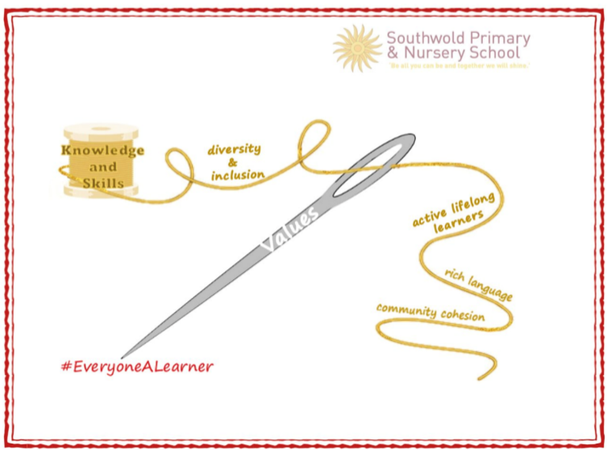
We have carefully chosen our Golden Threads because they are unique to our school context and setting:
- Knowledge and skills: It is our intent that our pupils will develop mastery across the curriculum as a result of a carefully sequenced curriculum which builds progressively on knowledge and skills.
- Rich language: Our intent is for all children to acquire knowledge, develop their vocabulary and have tools to communicate their ideas and learn effectively, both orally and in writing. To do this, our curriculum is planned to include high quality texts, real life and hands-on experiences, and create a range of opportunities for all children to be immersed in and engaging with language.
- Active lifelong learners: Our intent is for every child to be a passionate and active learner, underpinned by our value of ‘Excellence’. We provide children with real-life experiences and use AfL strategies within lessons to encourage them to be active learners, who take pride in and can talk about their work and learning.
- Diversity and inclusion: Our intent is for all children of our children to grow up to develop into citizens who are well-rounded, take care of themselves, other people and the world they live in, and who grow to be the best version of themselves as individuals. Our school celebrates inclusion and diversity – all members of our community are made to feel welcome, and we use our curriculum to teach children about issues relating to diversity and inclusion. We also ensure that the needs of our learners are met so that they can fulfil their potential.
- Community cohesion: Maintaining strong links with our community are important. Within our curriculum offer, including our hidden curriculum, we find opportunities for children to work with and support causes in the community – these include visits to school and supporting local charities.
Our Values: Our intent is for all children to embrace and develop a shared set of ACHIEVE Values: Ambition, Collaboration, Honesty, Inclusivity, Environmental care, Valiance and Excellence, which underpin everything we do. This will encourage our children to be the best version of themselves and strive to achieve potential in an ever-changing and modern world.

Intent for oracy:
At Southwold School, our Golden Threads underpin our curriculum intent enabling our pupils to develop the spoken language of children through a language rich curriculum to improve their communication and language skills, leading to purposeful talk as a tool to enhance learning opportunities. This is a priority for all school staff, starting in the Early Years from the moment children start Nursery.
Oracy has been identified as a key school development priority to improve outcomes because:
- The vast majority of pupils entering Early Years have a mild or significant language delay as identified within Wellcomm speech and language assessments.
- 29% of pupils have English as an additional language and there are 22 languages spoken within the school. The main languages are English (245), Romanian (22), Polish (18) and Chinese (13).
- The Index Measure of Deprivation shows that most neighbourhoods in Cherwell are more deprived than the Southwold School LSAO. Whilst the level of deprivation in Southwold is relatively low, it has increased. Compared with other local neighbourhoods, Cherwell is more deprived than 84% of them. This is further illustrated by Southwold being within the lower rate of income deprivation affecting children than most neighbourhoods in England, therefore, not all children are exposed to a broad range of vocabulary outside of school.

Implementation:
The school has adopted a clear protocol for oracy which sets out what is expected to be consistently evident in teachers’ practice in all Key Stages. Teachers will plan for children to use a range of oracy strategies included within the school’s protocol within the ‘I do’, ‘We do’ and ‘You do’ sections of the lesson. Teachers use an ‘I do’ section to explicitly teach children through modelling and explanation. To prevent cognitive overload of pupils and to allow for the explicit imparting of knowledge, this section is heavily based in teacher talk. Within this section, adults will model speaking in full sentences and the use of subject-specific stem sentences.
The protocol is set out below:

- Talk Partners:
- A consistent approach to the use of talk partners should be evident in all classrooms.
- The school uses ‘Partner A’ and ‘Partner B’ to name roles within a talk partner pairing.
- Children should be clear on whether they are ‘Partner A’ or ‘Partner B’ at all times. It is at the discretion of teaching staff how often these labels change, but children should know.
- Clear roles will be given to each partner. E.g. Partner A, you are going to tell Partner B … Partner B, you are going to state whether or not you agree / offer an alternative suggestion.
- Children will be encouraged to turn and face each other, maintaining eye contact and positive body language.
- Children should be encouraged to talk using indoor voices enabling them to hear one another.
- After children are facing each other, a pause will be given whilst the teacher gives the stem sentence expected to be used.
- Talk partners are supported with stem sentences which are modelled by the class teacher. Absolute clarity is provided to pupils of what is expected from the conversation before they are given time to talk to their partner.
- At times, the teacher will model the talk partner conversation using stem sentences and another pupil / adult to act as the other partner. This relates to the T&L principle of modelling.
- An appropriate amount of time should be allowed to facilitate purposeful talk.
The above principles of talk partner practice are set out in the dialogue below:
We have just learnt some reasons behind the start of World War 2. In a moment, you are going to talk to your partner and give one reason each.
Turn and face your partner. [pause]
Partner A, you are going to start your sentence with ‘One reason that the war started was …’
Partner B, you are going to add to this using ‘An additional reason it started was …’
You have 45 seconds. Turn and talk.

- Stem sentences and generalisations:
A stem sentence acts as a stem and not a complete sentence. It can be used to fit a range of applications to support pupil talk and contact a part of the sentence that needs to be completed.
e.g.
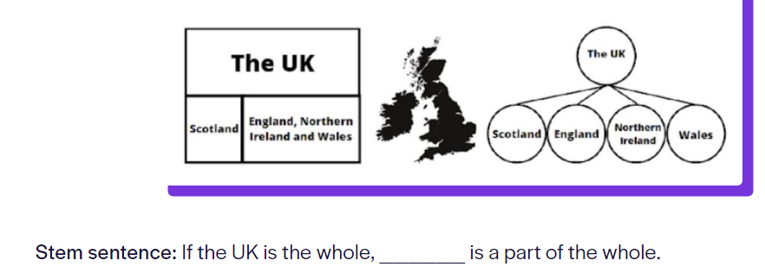
A generalisation, however, is specific to subject knowledge / content.
e.g. Generalisation: a prime number is a number with two factors
Stem sentences should be used to support pupil talk, encouraging them to talk in full sentences and acting as a scaffold to the structure of the conversation.
Generalisations should be used to support pupils to talk about subject specific content, knowledge and facts.

- Speaking in full sentences:
- All children are expected to speak using full sentences and that are grammatically correct, and adults should model this. It is expected that this will be at all points in the school day, not limited solely to lesson time.

- Adults should encourage children to use a stem of a sentence to support them to be able to speak in full sentences.
E.g. Teacher: Why did Chamberlain appease Hitler?
Pupil: Because Britain did not want another war.

Teacher: Why did Chamberlain appease Hitler?
Pupil: Chamberlain appeased Hitler because Britain did not want another war.

- Talk as a means of Assessment of Learning:
- Oracy strategies will enable teachers and support staff to assess children’s understanding of learning within a lesson. These strategies will also be used to ensure all children have an opportunity to think of an answer and engage in the learning.
- Teachers will not use a ‘hands up’ approach as this is not targeted and does not encourage all children to think of and be ready with an answer.
- Lolly-pop sticks will not be used. Teachers may ‘cold call’ pupils through targeted questioning or following a paired discussion.

- Recapping vocabulary:
It is expected that topic vocabulary is recapped at the start of a lesson. In mathematics lessons, vocabulary used within the lesson is introduced at the start of the lesson. Within topic / broader curriculum areas, it is expected that the class teacher will revisit vocabulary learnt in the previous lesson at the very start of the new lesson. Displaying topic-related vocabulary on a working wall / classroom display is also outlined in the school’s Environment Expectations document.

Our oracy curriculum ensures the children have an opportunity practice a variety of types of talk and practise the skills needed for different oracy outcomes:
- exploratory talk
- interactive/negotiation
- recitation
- debate and persuasion
- building understanding
- to inform/teach

Impact
The intended impact of our approach to oracy and strategies for talk is that:
- Children will have regular, planned opportunities to explore ideas through talk and talk about their learning in a purposeful way.
- A clear and consistent approach to the use of talk partners will be evident within teaching and learning across all Key Stages.
- Children will be aware of good habits of talk as a result of a clear protocol which is modelled by school staff and embedded into practice.
- Children will acquire a broader range and understanding of vocabulary.
- Children will talk confidently in full sentences, with stem sentences provided by adults to act as a scaffold and use conjunctions to organise and sequence their ideas.
- Children will deliberately select gestures that support the delivery of ideas.
- Children will ask questions to find out more about a subject and recognise the value of listening to what others say and adapt how they speak in different situations according to the audience, including using Standard English.
- Children will value their own opinions and be able to express them to others.
- Children will begin to reflect on their oracy skills and identify areas of strength and areas to improve.
- Children will respond appropriately to what others say, challenge each other’s opinions and develop their own reasoned arguments.
- Children will be open-minded, value the contribution of others and take account of their views.
- Children will appreciate the diversity of languages, dialects and accents in the school.
- Children will consider the impact of their words on others when giving feedback.
- Children will share learning in an engaging, informative way through formal presentations.
- Children’s wellbeing will be improved as they are more confident at expressing themselves in a clearer way.
- Oracy / talk strategies will be used meaningfully and as an assessment of learning, informing teaching.

