PHSE Intent, Implementation & Impact Statement
At Southwold School we believe in the unlimited potential of every child. As a result of this, we have carefully designed a curriculum which is underpinned by 5 Golden Threads.
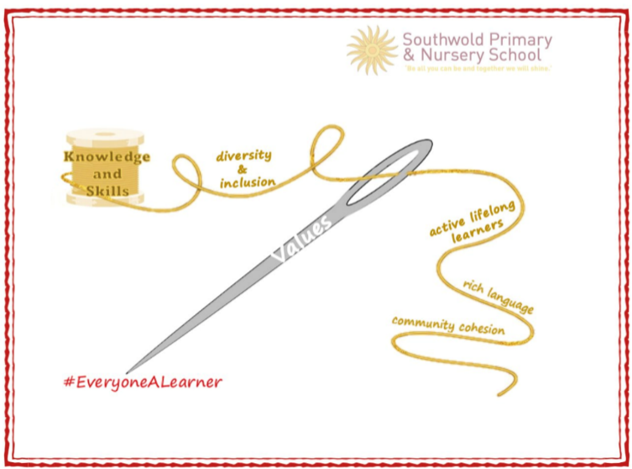

We have carefully chosen our Golden Threads because they are unique to our school context and setting:
- Knowledge and skills: It is our intent that our pupils will develop mastery across the curriculum as a result of a carefully sequenced curriculum which builds progressively on knowledge and skills.
- Rich language: Our intent is for all children to acquire knowledge, develop their vocabulary and have tools to communicate their ideas and learning effectively, both orally and in writing. To do this, our curriculum is planned to include high quality texts, real life and hands on experiences and creating a range of opportunities for all children to be immersed in and engaging with language.
- Active lifelong learners: Our intent is for every child to be a passionate and active learner, underpinned by our value of ‘Excellence’. We provide children with real-life experiences and use AfL strategies within lessons to encourage them to be active learners, who take pride in and can talk about their work and learning.
- Diversity and inclusion: Our intent is for all children of our children to grow up to develop into citizens who are well-rounded, take care of themselves, other people and the world they live in, and who grow to be the best version of themselves as individuals. Our school celebrates inclusion and diversity – all members of our community are made to feel welcome, and we use our curriculum to teach children about issues relating to diversity and inclusion. We also ensure that the needs of our learners are met so that they can fulfil their potential.
- Community cohesion: Maintaining strong links with our community are important. Within our curriculum offer, including our hidden curriculum, we find opportunities for children to work with and support causes in the community – these include visits to school and supporting local charities.

Our Values: Our intent is for all children to embrace and develop a shared set of ACHIEVE Values: Ambition, Collaboration, Honesty, Inclusivity, Environmental care, Valiance and Excellence, which underpin everything we do. This will encourage our children to be the best version of themselves and strive to achieve potential in an ever-changing and modern world.

Intent for our PHSE Curriculum:
At Southwold School, our Golden Threads underpin our curriculum intent enabling our pupils to achieve the following in PHSE:
- To build skills, attitudes, self-esteem, perseverance and confidence;
- To develop an understanding of our diverse school community and to understand and value how they fit into and contribute to the world;
- To confidently express their values, interact with others and express their views and understanding;
- To improve their capacity to learn, their resilience and their emotional well-being and mental health and thereby enhance their life-chances;
- To develop knowledge, skills, and attributes they need to keep themselves healthy and safe and to prepare them for life and work in modern Britain.
- Through the Personal, Social, Health Education (Health and Well-being) curriculum we intend to provide children with learning and experiences that enable them to achieve the above.

Implementation:
The National Curriculum is the starting point of our curriculum design. It has been used to drive our curriculum design, to ensure the aims of the National Curriculum are met, and it has been used to inform the choices we have made about the content that we teach at Southwold School.
At Southwold we follow the PSHE Jigsaw scheme and is taught across the school on a weekly basis. Jigsaw is a whole school approach which provides a spiral and progressive comprehensive PSHE programme in which the statutory elements sit and are embraced.

There are six Puzzles in Jigsaw that are designed to progress in sequence from the start of each academic year:
- Term 1: Being Me in My World
- Term 2: Celebrating Difference (including anti-bullying)
- Term 3: Dreams and Goals
- Term 4: Healthy Me
- Term 5: Relationships
- Term 6: Changing Me (including RHSE Education)

Each Puzzle has six Pieces (lessons) which work towards an ‘end product’. Each Piece has two learning intentions. One is based on specific PSHE learning and the other is based on emotional literacy and social skills development. The whole school works on the same Puzzle at the same time. Each lesson is built upon a Charter which underpins the behaviour and respect that is the basis for each lesson (one is provided within Jigsaw, but children and their teacher can write their own to ensure mutual respect and ownership).
The various teaching and learning activities are engaging and mindful of different learning styles and the need for differentiation and the Early Years (EYFS) planning is aligned to the National Early Years Framework (England).

Impact
Our intended impact is that by the time our pupils leave Southwold School, they will have developed:
- The tools to become active and responsible citizens.
- A keen sense of the importance of Values in their lives.
- A strong sense of moral purpose and understanding.
- Their spiritual, moral, social, cultural, mental and physical development;
- Their academic potential, and will leave school equipped with skills they will need throughout later life;
- Their understanding and ability of how to keep themselves safe.
- A compassionate view of the world and other people.

