Parent/ Carer

Acceptable Use Agreement
Digital technologies have become integral to the lives of children and young people, both within schools and outside school. These technologies provide powerful tools, which open up new opportunities for everyone. They can stimulate discussion, promote creativity, and stimulate awareness of context to promote effective learning. Young people should have an entitlement to safe internet access at all times.

This acceptable use policy is intended to ensure:
- that young people will be responsible users and stay safe while using the internet and other communications technologies for educational, personal, and recreational use.
- that school systems and users are protected from accidental or deliberate misuse that could put the security of the systems and users at risk.
- that parents and carers are aware of the importance of online safety and are involved in the education and guidance of young people with regard to their on-line behaviour.

The school will try to ensure that learners have good access to digital technologies to enhance their learning and will, in return, expect the learners to agree to be responsible users. A copy of the learner acceptable use agreement is attached to this permission form, so that parents/carers will be aware of the school expectations of the young people in their care.
Parents are requested to sign the permission form below to show their support of the school in this important aspect of the school’s work
This form- electronic/printed
Who will have access to this form: Head teacher, HR, Admin
Where this form will be stored: Office, Microsoft storage, Local network storage, Local server
How long this form will be stored for: for the duration of the pupil being on roll.
How this form will be destroyed: Confidential waste or deleted from the system.

Permission Form
As the parent/carer of a pupil at this school, I give permission for my child to have access to the digital technologies at school.
EYFS: I understand that the school has discussed the acceptable use agreement with my child and that they have received, or will receive, online safety education to help them understand the importance of safe use of technology and the internet – both in and out of school.
KS1&KS2: I know that my child has signed an acceptable use agreement and has received, or will receive, online safety education to help them understand the importance of safe use of technology and the internet – both in and out of school.
I understand that the school will take every reasonable precaution, including monitoring and filtering systems, to ensure that young people will be safe when they use the internet and systems. I also understand that the school cannot ultimately be held responsible for the nature and content of materials accessed on the internet and using mobile technologies.
I understand that my child’s activity on the systems will be monitored and that the school will contact me if they have concerns about any possible breaches of the acceptable use agreement.
I will encourage my child to adopt safe use of the internet and digital technologies at home and will inform the school if I have concerns over my child’s online safety.

Parent/Carers: Date:
Learner Name: Class:

EYFS/ KS1 Learner

Acceptable Use Agreement

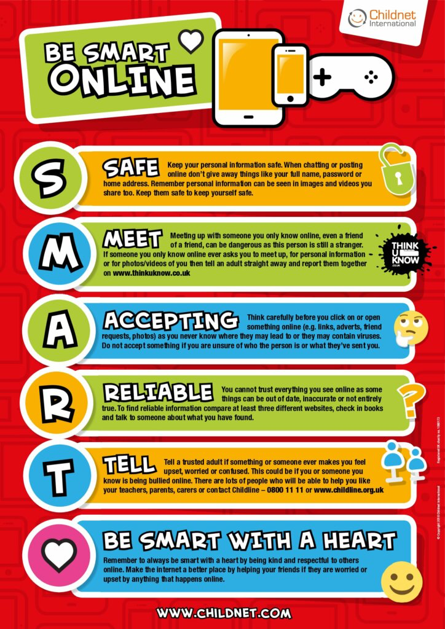

I will follow these rules to stay safe online:
- I will only use the computers or tablets when an adult has said I can.
- I will only use activities that an adult has allowed me to use e.g. websites that are for children my age.
- I will take care of computers, tablets, and other equipment.
- I will be polite if I talk with others online.
- I will not share personal information about myself or others online (e.g., full name, age, address, email address, telephone numbers, school).
- I will never talk to or meet an online stranger.
- I will not take or share photos or videos of myself or others online.
- I will ask for help from an adult if I am not sure what to do or if I think I have done something wrong.
- I will tell an adult if I see something that upsets me.
- I know that my school can see what I do on the computers and online.
- I will use the SMART rules to help keep me safe online.
- If I break the rules, I might not be allowed to use a computer/tablet.

KS2 Learner

Acceptable Use Agreement

We would like you to read, understand and use these rules, to help you and others stay safe and behave responsibly when using the internet and digital technology.

For my own personal safety, I will be SMART online:

- I will keep my username and password safe and secure. I will not share it or write it down.
- I will not share personal information about myself or others when online (e.g., full name, age, address, email address, telephone numbers, school).
- I will be aware of “stranger danger” when I am online. I will never arrange to meet people in real life who I’ve only met online. I will remember that people online might not always be who they say they are.
- I will think carefully before clicking on a link in case it could be a virus.
- When I am using the internet to find information, I should take care to check that the information is accurate and reliable. I understand that the work of others may not be truthful and may be a deliberate attempt to mislead me.
- I will immediately tell an adult or report anything I see online that is inappropriate or makes me feel uncomfortable.

I will look after the devices I use, so that the school and everyone there can be safe:

- I will handle all the devices carefully and only use them if I have permission. I understand that there will be a consequence if anything is deliberately damaged or broken.
- I will try not to alter the settings on any devices or install any software or programmes.
- I will tell an adult if a device is damaged or if anything else goes wrong.
- I will only use the devices to do things that I am allowed to do in school e.g., activities I’ve been asked to do, visit age-appropriate websites.

I know that there are other rules that I need to follow:

- I will think about how my behaviour online might affect other people:
- When online, I will act as I expect others to act toward me.
- I will not copy or use anyone else’s original work or files without their permission.
- Where work is protected by copyright, I will not try to download copies (including music and videos).
- I will be polite and responsible when I communicate with others, and I appreciate that others may have different opinions to me.
- I will not take or share photos/ videos of anyone without their permission.
- I understand that what I do online will be supervised and monitored.
- I will only use my own personal mobile phone in the school if a parent/ carer has completed a mobile phone permission slip. If I am allowed, I must continue to follow all the other school rules.
- I will not use any social media sites in school.
- I understand that if I do not follow these online safety rules, there will be consequences. This could include my parents/ carer being told, loss of access to the school computer/tablets/internet, I may lose privileges and in the event of illegal activities the police will be involved.

Use of Digital/Video Images
The use of digital/video images plays an important part in learning activities. Learners and members of staff may use digital cameras to record evidence of activities in lessons and out of school. These images may then be used in presentations in subsequent lessons.
Images may also be used to celebrate success through their publication in newsletters, on the school website and occasionally in the public media. Where an image is publicly shared by any means, only your child’s first name will be used.
The school will comply with the Data Protection Act and request parent’s/carer’s permission before taking images of members of the school. We will also ensure that when images are published that the young people cannot be identified by the use of their names.
In accordance with guidance from the Information Commissioner’s Office, parents/carers are welcome to take videos and digital images of their children at school events for their own personal use (as such use in not covered by the Data Protection Act). To respect everyone’s privacy and in some cases protection, these images should not be published/made publicly available on social networking sites, nor should parents/carers comment on any activities involving other learners in the digital/video images.
Parents/carers are requested to sign the permission form below to allow the school to take and use images of their children and for the parents/carers to agree.

This form (electronic or printed) | The images
Who will have access to this form.  Head teacher, HR, admin | Images may be published on school; Twitter, Facebook, the schools website, local press, prospectus or brochure etc.
Where this form will be stored. Office, Microsoft storage, Local network storage, Local server | Who will have access to the images. WHF staff and third party operators Schudio
How long this form will be stored for. For the duration of the pupil being on roll. | Where the images will be stored. Office, Microsoft storage, Local network storage, Local server, Schudio server
How this form will be destroyed. Confidential waste or deleted | How long the images will be stored for. For the duration of the pupil being on roll.
 | How the images will be destroyed. Deleted
 | How a request for deletion of the images can be made. Email DPO@twhf.org.uk

Where a child’s image has been used in a prospectus or brochure which has been printed for the purposes of distribution, it may not be possible to remove the image of the child in all copies and this should be taken into account when providing any consent

Digital/Video Images Permission Form

Parent/Carers Name: Learner Name:
As the parent/carer of the above learner, I agree to the school taking digital/video images of my child/children. | Yes/No
I agree to these images being used:
- to support learning activities. | Yes/No
- in publicity that reasonably celebrates success and promotes the work of the school. | Yes/No
Insert statements here that explicitly detail where images are published by the schools | Yes/No
I agree that if I take digital or video images at, or of school events which include images of children, other than my own, I will abide by these guidelines in my use of these images. | Yes/No

Where a child’s image has been used in a prospectus or brochure which has been printed for the purposes of distribution, it may not be possible to remove the image of the child in all copies and this should be taken into account when providing any consent

Signed:
Date:

Use of Cloud Systems Permission Form
The school uses Microsoft Teams for learners and staff. This permission form describes the tools and learner responsibilities for using these services.
The following services are available to each learner as part of the school’s online presence in Microsoft Teams
Using Microsoft Teams and Purple Mash will enable your child to collaboratively create, edit and share files and websites for school related projects and communicate via email with other learners and members of staff. These services are entirely online and available 24/7 from any internet-connected computer.
The school believes that use of the tools significantly adds to your child’s educational experience.
This form (electronic or printed) | The data shared with the service provider
Who will have access to this form. Head teacher, HR, admin | What data will be shared: educational, email
Where this form will be stored. Office, Microsoft storage, Local network storage, Local server | Who will the data will be shared with WHF staff, purple mash,
How long this form will be stored for. . for the duration of the pupil being on roll. | Who will have access to the data. WHF staff, purple mash, pupils,
How this form will be destroyed. Confidential waste or deleted | Where is the data stored. Office, Microsoft storage, Local network storage, Local server
 | How long the data will be stored for. for the duration of the pupil being on roll.
 | How will the data be destroyed. Deleted from system
 | How a request for deletion of the data can be made. Email DPO@twhf.org.uk

Do you consent to your child to having access to this service? | Yes/No

Learner Name: Parent/Carers Name:
Signed: Date:

