RE Intent, Implementation & Impact Statement
At Southwold School we believe in the unlimited potential of every child. As a result of this, we have carefully designed a curriculum which is underpinned by 5 Golden Threads.
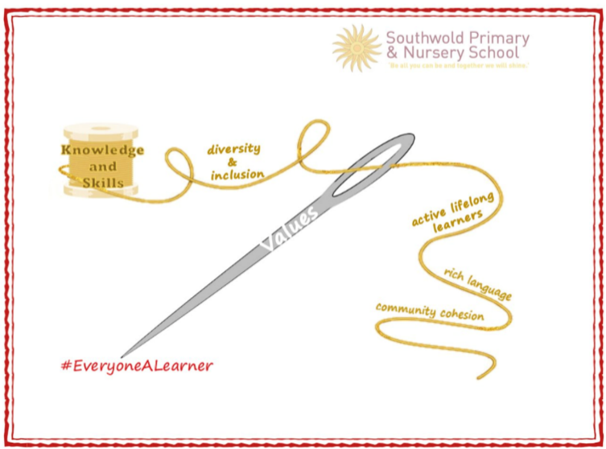
We have carefully chosen our Golden Threads because they are unique to our school context and setting:
- Knowledge and skills: It is our intent that our pupils will develop mastery across the curriculum as a result of a carefully sequenced curriculum which builds progressively on knowledge and skills.
- Rich language: Our intent is for all children to acquire knowledge, develop their vocabulary and have tools to communicate their ideas and learning effectively, both orally and in writing. To do this, our curriculum is planned to include high quality texts, real life and hands on experiences and creating a range of opportunities for all children to be immersed in and engaging with language.
- Active lifelong learners: Our intent is for every child to be a passionate and active learner, underpinned by our value of ‘Excellence’. We provide children with real-life experiences and use AfL strategies within lessons to encourage them to be active learners, who take pride in and can talk about their work and learning.
- Diversity and inclusion: Our intent is for all children of our children to grow up to develop into citizens who are well-rounded, take care of themselves, other people and the world they live in, and who grow to be the best version of themselves as individuals. Our school celebrates inclusion and diversity – all members of our community are made to feel welcome, and we use our curriculum to teach children about issues relating to diversity and inclusion. We also ensure that the needs of our learners are met so that they can fulfil their potential.
- Community cohesion: Maintaining strong links with our community are important. Within our curriculum offer, including our hidden curriculum, we find opportunities for children to work with and support causes in the community – these include visits to school and supporting local charities.
Our Values: Our intent is for all children to embrace and develop a shared set of ACHIEVE Values: Ambition, Collaboration, Honesty, Inclusivity, Environmental care, Valiance and Excellence, which underpin everything we do. This will encourage our children to be the best version of themselves and strive to achieve potential in an ever-changing and modern world.

Intent for our RE Curriculum:
At Southwold School, our Golden Threads underpin our curriculum intent enabling our pupils to achieve the following in RE:
- To engage in enquiring into key questions arising from the study of religion and belief and promote their personal and spiritual development;
- To develop an understanding of religious traditions and to appreciate cultural differences;
- To have respect for other peoples’ views, tolerance and to celebrate diversity;
- To develop critical thinking skills and their knowledge, understanding of, and empathy of people and their beliefs, religious or otherwise.

At Southwold School, our RE teaching reflects worldviews, through an enquiry-based curriculum we intend to educate, inform and allow children to formulate their own thinking.
Our RE curriculum and teaching does not try to persuade but rather to inform and develop the skills with which evaluation can take place

Implementation:
The National Curriculum is the starting point of our curriculum design. It has been used to drive our curriculum design, in order to ensure the aims of the National Curriculum are met, and it has been used to inform the choices we have made about the content that we teach at Southwold School.

At Southwold School, our RE curriculum is based on the Plan Bee RE scheme which builds on the children's growing knowledge and understanding of major world religions, religious communities, religious traditions, festivals, places of worship, and special books. Christianity is taught across every year group alongside other religions including Buddhism, Hinduism, Islam, Judaism and Sikhism.

In the Early Years, RE is taught to enable children to learn about many of the different religious festivals and then children are able to apply their knowledge in child-initiated learning. In Years 1 to 6 RE is taught on a weekly basis through engaging learning experiences that cultivate children's curiosity and build their confidence.

Impact
Our intended impact is that by the time our pupils leave Southwold School, they will have developed:
- The philosophy that they are free to make their own choices and decisions concerning religion and belief.
- A sense of wonder and curiosity about cultures and beliefs within the wider community.
- Their understanding of personal development and their understanding of the wider world.
- Respect, tolerance and sensitivity towards beliefs, faiths and traditions.
- An ability to think about the big questions in life and ways of answering them.
- Skills for preparation for life in a diverse and modern Britain.

