School Uniforms
To ensure all students look smart and best represent Southwold School, we have a number of expectations when it comes to school uniforms.

The Southwold School uniform consists of: | Required | Preferred | Optional
Burgundy or white polo shirt  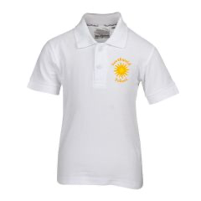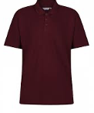 |  | With school logo
Dark grey or black trousers, skirt, pinafore dress or culottes
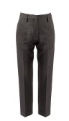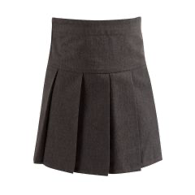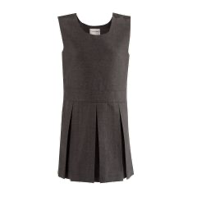
Sensible black footwear (not trainers, flipflops or open toed sandals)

Burgundy sweatshirt or cardigan  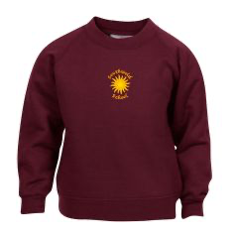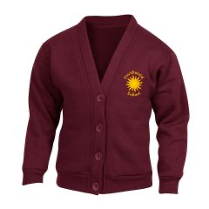 |  | With school logo
Burgundy, red or yellow summer dress with white ankle socks, shorts optional during summer
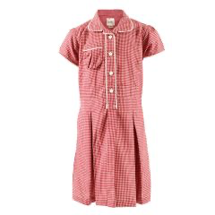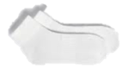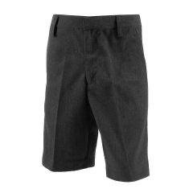

Dark grey or black ankle or below the knee socks/ tights
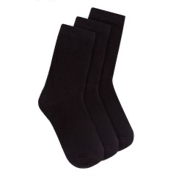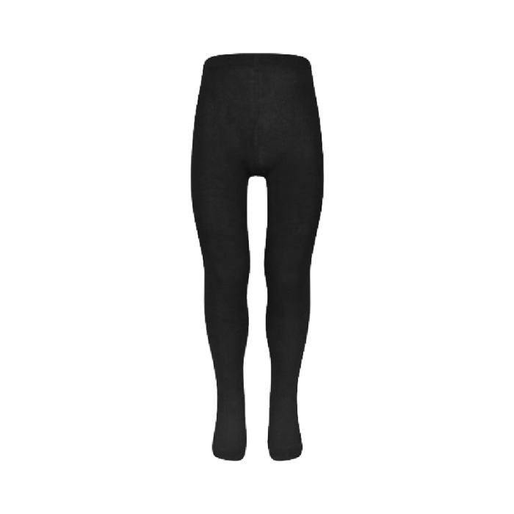
(White in the warmer weather)
Burgundy fleece with school logo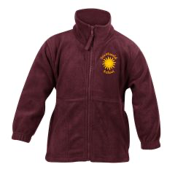
Any colour outdoor jacket (preferably waterproof) | During the Winter and wet months

PE Kit
PE kits should be brought in a suitable named bag. Please label all clothing with your child’s name.

The PE kit consists of: | Required | Preferred
White or burgundy t-shirt
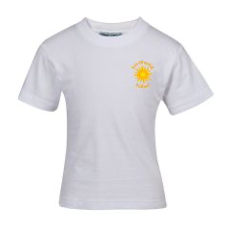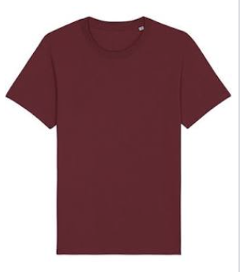
Black shorts
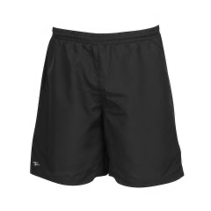
Black tracksuit in winter
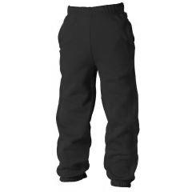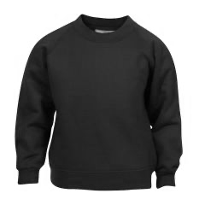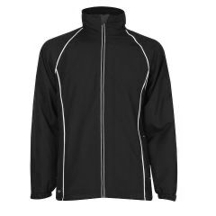
Plimsolls or trainers
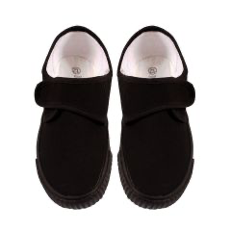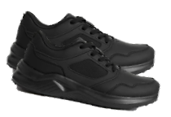

Branded school logo items can be purchased by clicking on the ONLINE SHOP

All other items can be purchased at your preferred retailer.

Additional Notes
Jewellery should be kept to a minimum. It is fine to wear jewellery due to a religious belief. Children are permitted to wear a watch.
Earrings should be small stud earrings. Hoop earrings are not allowed as they are a risk during PE lessons and at playtime.
Hair accessories should be in the school colours.
Nail varnish and makeup are not permitted in school.
Sunhats should be worn outside during sunny day. We recommend a legionnaires cap, so their head and neck are protected. 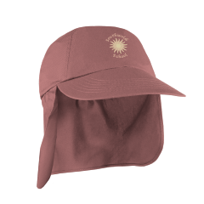
If, for cultural reasons, parents wish their child to wear a particular type of clothing during the school day, this is absolutely fine. Examples include a turban, headscarf, or a PE kit that includes longer-length trousers.

