Science Intent, Implementation & Impact Statement
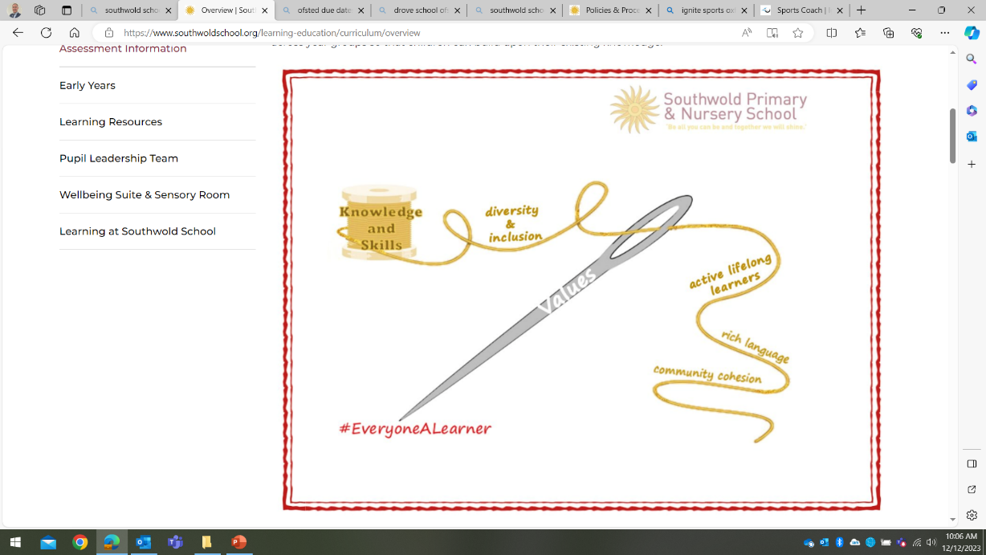
At Southwold School we believe in the unlimited potential of every child. As a result of this, we have carefully designed a curriculum which is underpinned by 5 Golden Threads.

We have carefully chosen our Golden Threads because they are unique to our school context and setting:
- Knowledge and skills: It is our intent that our pupils will develop mastery across the curriculum as a result of a carefully sequenced curriculum which builds progressively on knowledge and skills.
- Rich language: Our intent is for all children to acquire knowledge, develop their vocabulary and have tools to communicate their ideas and learning effectively, both orally and in writing. To do this, our curriculum is planned to include high quality texts, real life and hands on experiences and creating a range of opportunities for all children to be immersed in and engaging with language.
- Active lifelong learners: Our intent is for every child to be a passionate and active learner, underpinned by our value of ‘Excellence’. We provide children with real-life experiences and use AfL strategies within lessons to encourage them to be active learners, who take pride in and can talk about their work and learning.
- Diversity and inclusion: Our intent is for all children of our children to grow up to develop into citizens who are well-rounded, take care of themselves, other people and the world they live in, and who grow to be the best version of themselves as individuals. Our school celebrates inclusion and diversity – all members of our community are made to feel welcome, and we use our curriculum to teach children about issues relating to diversity and inclusion. We also ensure that the needs of our learners are met so that they can fulfil their potential.
- Community cohesion: Maintaining strong links with our community are important. Within our curriculum offer, including our hidden curriculum, we find opportunities for children to work with and support causes in the community – these include visits to school and supporting local charities.
Our Values: Our intent is for all children to embrace and develop a shared set of ACHIEVE Values: Ambition, Collaboration, Honesty, Inclusivity, Environmental care, Valiance and Excellence, which underpin everything we do. This will encourage our children to be the best version of themselves and strive to achieve potential in an ever-changing and modern world.

Intent for our Science Curriculum:
At Southwold School, our Golden Threads underpin our curriculum intent enabling our pupils to achieve the following in Science:
- Be curious and develop a deeper understanding about the world which we live in.
- Develop scientific knowledge and conceptual understanding through the three aspects of science: biology, physics and chemistry.
- Participate in purposeful, practical enquiries which link to the 6 different enquiry types: fair/ comparative testing, research, observation over time, pattern seeking, identifying, grouping and classifying and problem solving.
- Progressively develop their disciplinary knowledge and Working Scientifically skills.
- Make connections in their learning and to know more, remember more and do more each year leading to academic success and enjoyment in this subject.
- Develop understanding of the nature, processes and methods of science through different types of science enquiries that help them to answer scientific questions about the world around them.
- Are equipped with the scientific knowledge required to understand the uses and implications of science today and for the future.
- Converse with confidence orally and in writing, in a range of contexts using subject specific vocabulary.
Our intent is to provide children with a science curriculum which enables them to confidently explore the world around them and have a deeper understanding of the ever-changing world in which they live. We aim to nurture children’s curiosity and motivate children to be inquisitive learners throughout their time at Southwold and beyond. We strive to enhance children’s understanding of the three areas of the science curriculum through real life and hands-on experiences which foster their substantive knowledge, develop their disciplinary knowledge and immerse them in scientific language.

Implementation:
The National Curriculum is the starting point of our curriculum design. It has been used to drive our curriculum design, to ensure the aims of the National Curriculum are met, and it has been used to inform the choices we have made about the content that we teach at Southwold School.
At Southwold, we create a positive attitude towards science learning and develop and embed children’s scientific knowledge, skills and understanding through our carefully sequenced planning across the school. Our whole school approach towards science involves the following:
- In EYFS, a high-quality learning environment encourages and provokes children to develop their understanding of the world. Children in KS1 and KS2 take part in a minimum of 1 hour of science learning per week, which focuses and builds upon the objectives which are set out in the 2014 Science National Curriculum and have been mapped out in our Southwold Curriculum Maps.
- Working Scientifically skills are mapped out in our Science Progression of Skills document. A skill is modelled and taught discretely at the beginning of each science lesson and children are given the opportunity to practice and apply their skills throughout their independent learning. Sentence stems are used to ensure a gradual progression of skills in each year group.
- Children are immersed in subject-specific vocabulary and given sentence stems to develop their oracy within science. Knowledge organisers are used for each unit to provide consistency and progression in scientific language throughout the school.
- Children have the opportunity, to participate in a wide range of purposeful, real life and hands-on experiences which are used alongside high-quality secondary sources to enable children to ask and answer scientific questions.
- Each year, children have the opportunity, to take part in the ‘Festival of Tomorrow’ and take part in workshops with expert scientists.
- Elicitation activities are used to assess children’s previous knowledge and skills and allow teachers to tailor learning to support and challenge all children.
- A TAPS assessment is used during each unit to support the assessment of children’s skills.
- Safe practice is highlighted and modelled in the teaching and learning of science. Children are encouraged to plan and reflect upon personal safety within their practical enquiries.
Impact
Our intended impact is that by the time our pupils leave Southwold School, they will have developed:
- An interest in science and an enthusiastic approach to learning, which develops their curiosity of the world which we live in.
- A secure substantive knowledge and a clear understanding of the key scientific concepts which have been covered in the National Curriculum.
- An understanding of the different enquiry types.
- Their disciplinary knowledge and they have the confidence to apply their Working Scientifically skills to plan, carry out and evaluate scientific enquiries.
- A range of scientific vocabulary which they can use to clearly articulate their understanding of science.

