15th May 2026

Dear Parents and Carers,

From Wednesday to Friday, we welcomed visitors from Challenge Partners. Challenge Partners is an educational charity that brings schools together across England to share expertise, strengthen teaching practice, and improve outcomes for children and young people. Through collaboration and peer review, they support schools in raising standards and promoting continuous improvement. The visit was a valuable experience for everyone involved, and we were pleased to receive overwhelmingly positive feedback. During the three days, visitors observed lessons across the school, and I was proud to see so many examples of high-quality practice throughout the school. In particular, the strong focus on ensuring wellbeing is at the heart of learning, the development of communication skills across the curriculum and engaging and personalised learning experiences tailored to individual pupils and students.

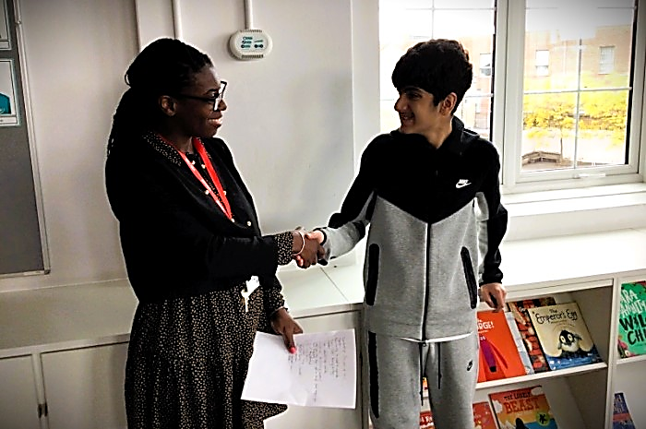

Primary Parents’ coffee morning and afternoon tea
A heartfelt thank you to the parents who attended our recent coffee morning and afternoon tea sessions. These meetings provided a valuable opportunity for us to listen to your views about what is working well and where we can continue to improve.
We greatly value feedback from families — both positive and constructive — as we continually strive to provide the highest quality of care and education for your children.
We look forward to welcoming our secondary parents and carers for afternoon tea next week on Tuesday 19th May at 2:30pm.

Mental Health Awareness Week
This week, we proudly took part in Mental Health Awareness Week, including our “Wear It Green Day” celebration on Friday.
We know that children and young people with SEND can experience higher levels of anxiety and mental health challenges, so it was especially important for us to use this week as an opportunity to promote wellbeing and positive mental health across the school community. Students took part in a range of engaging activities designed to help them understand mental health, recognise ways to support their own wellbeing, and learn strategies for self-care.
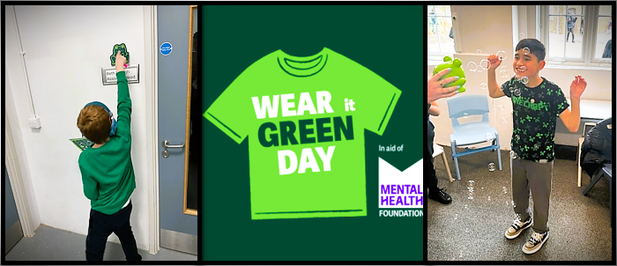
Activities included scavenger hunts, wellbeing quizzes, and creative art-based sessions, all of which were enjoyed enthusiastically by our students. Key Stage 3 students completed the Wellbeing Award for Schools pupil survey during assembly, while Key Stage 4 students explored the positive impact that shared activities and social connections can have on wellbeing.

Young Men’s Group

The Young Men’s Group meets weekly to discuss a range of topics relevant to them at this stage of their lives. It is a great opportunity
to ask tricky questions, share concerns,
and prepare to navigate their next step
and make sure they are ready for the future.

Online safety
Parental Safety Controls - TikTok
This short, jargon-free video walks parents through setting up safety controls on TikTok – a platform parents tell us they find unfamiliar and worrying.
See the TikTok Family Pairing video

Find the Right Words
Virgin Media and Internet Matters have released a wonderful new resource for parents/carers. Called 'Find the Right Words', the video and resources help with some of those difficult conversations about how to keep children safe online.
Link - Find the Right Words.

Looking Ahead
- Parent Afternoon Tea - Secondary classes - Tuesday 19 May, from 2.30 pm
- Circus Sensible – Thursday 21st May
- Last Day of Term – Friday, 22nd May
- School reopens for students – Monday, 1st June
- Year 11 residential – Monday, 1st June – Wednesday, 3rd June

Support and activities for families
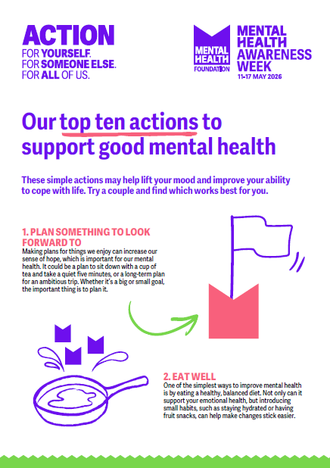

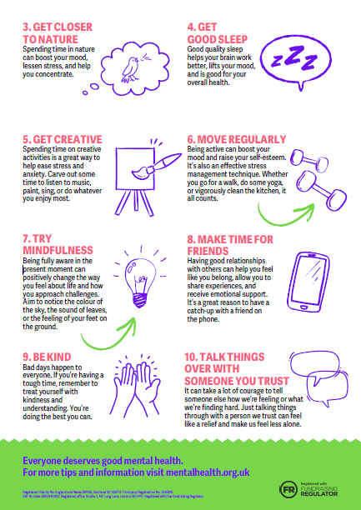


Browse Pace2Be Parenting resources
Parents and carers play an important role in children’s wellbeing. Take a look at our expert-led parenting articles and tips to help your child navigate any challenges they may come across.
Link - parenting smart


A parent’s guide to positive mental wellbeing
Parent or carers of autistic young people can face a number of unique and sometimes difficult challenges.
We know that parents and carers work hard every day for their child’s benefit, ensuring they are happy and healthy. But sometimes pressures can build up and be overwhelming. You might even feel like you are at breaking point.
This is completely understandable and something that lots of parents and carers go through. Spending so much time looking after someone else can often mean, you neglect to look after your own wellbeing. Feeling overwhelmed, desperate and worn out could be a sign that you need to look after yourself.
To best support your family, it is important to look after yourself in a way that is most appropriate for you. Though you may have very little free time, finding ways to look after your own mental wellbeing will benefit you and your family.

Take a moment of pause
In a busy day, try to find a small moment to just breathe. Though it might be difficult to find a quiet space to yourself, breathing strategies can help calm the mind and shift your focus from the stress and worry to the present moment.

Talk to others
Keeping connected with others outside your household can help relieve feelings of isolation or loneliness that parents and carers can sometimes feel. It is important to talk about how you feel. You might want to read about similar experiences through the blogs we share on our online community, Talk about Autism.
Alternatively, you might choose to talk to others as an escape from your usual routines or challenges.

Sleep
Feeling anxious or stressed can affect sleeping patterns. In fact, lack of sleep can make it more difficult to cope with everyday challenges and make stress even worse. There are ways you can support sleeping patterns with enough exercise during the day and a healthy diet.

Finding the positives
Caring for someone bring lots of challenges and rewards. We understand that looking after someone can change your relationship with them and challenge the family dynamic. There will be lots of positives looking after your autistic child or young person, it’s important to notice these things. Reminding yourself of these will help you overcome feelings of frustration. You should also remind yourself of the challenges you’ve come through already.

Be organised
Being organised can help you feel more in control. Keeping stim toys, daily planners or medication details somewhere where you know they will be helpful.

Ask for help
Most parents and carers need more support at some point. This support can be from family, friends or support groups. Some might feel overwhelmed or ashamed at asking for help but there are lots of support networks out there ready to support people when they are looking for information, advice, guidance and emotional support.
For further information and support
NHS mental health support at home during coronavirus.
Mind mental health charity wellbeing support.
Scope disability charity support for parents and carers of disabled people.
The School Run mental health tips for parents of SEN children.

As always, thank you for your continued support. We wish you and your family a restful and enjoyable weekend.

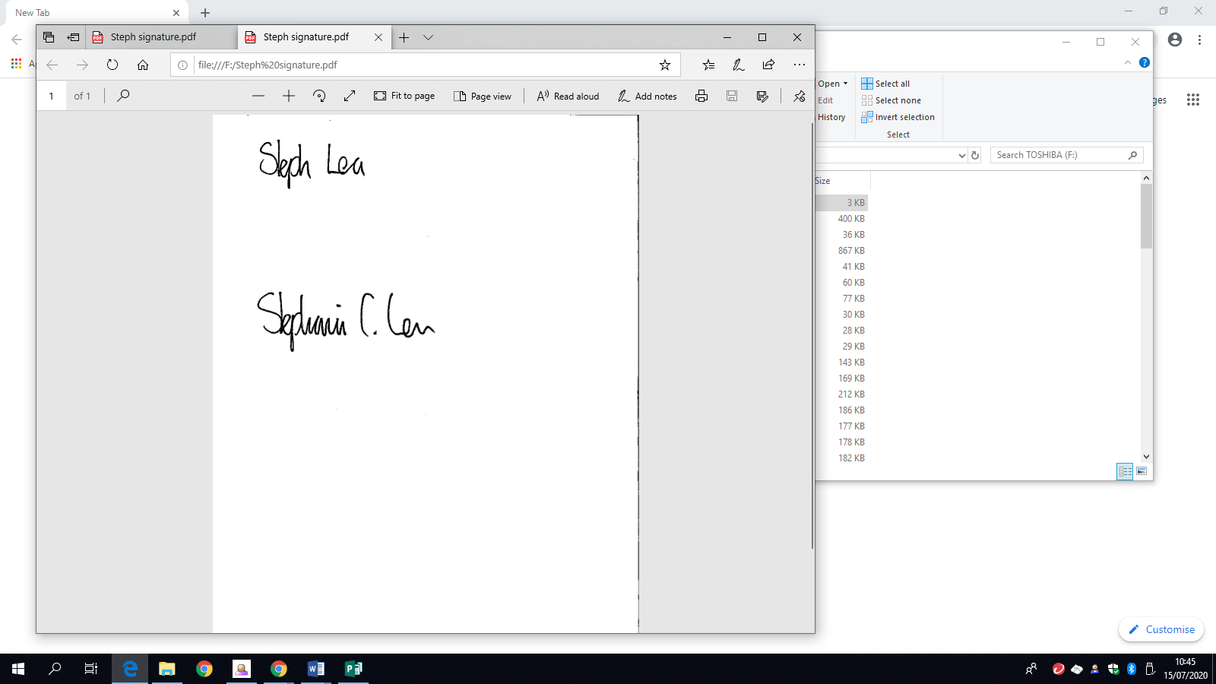

Steph Lea
Executive Headteacher

