17th July 2026
Dear Parents and Carers,

As we come to the end of another successful academic year, we would like to take this opportunity to celebrate the achievements, progress and memorable experiences that have made this year so special. It has been a year filled with learning, laughter and, most importantly, the continued growth of every one of our pupils.
We are incredibly proud of everything our pupils have achieved and would like to thank our dedicated staff, supportive families, governors and community partners who have worked alongside us throughout the year.

Throughout the year we also began working towards the Wellbeing Award for Schools, reinforcing our commitment to placing mental health and emotional wellbeing at the heart of everything we do.

Our pupils have enjoyed an exciting range of personal development opportunities that have brought learning to life. Highlights have included:
- Visits to the Victoria & Albert Museum, Tate Modern, libraries and local community venues.
- Science, animation, music technology and stop-motion workshops.
- Steel pan music performances and hands-on experiences.
- Cricket, cycling, dance, karate, yoga and table cricket competitions.
- Surrey Cricket coaching, Bikeability and independent travel training.
- Careers fairs, workplace visitors and employment-focused activities preparing our older students for adulthood.
These experiences have helped develop communication, independence, confidence, resilience and curiosity while creating lasting memories.

Supporting pupils to become confident and independent young people has remained a central focus throughout the year. Through community visits, leisure centre sessions, library visits, travel training, road safety education and opportunities to make choices, pupils have continued to develop essential life skills that will support them well beyond their time at Spa Camberwell.
Our Student Council has also played an important role in school life, helping to organise events, represent pupil voice and promote wellbeing across the school.

Communication continues to be at the heart of our curriculum. This year pupils have benefited from:
- Reading workshops with families.
- Makaton and communication training for parents.
- Oracy workshops.
- Visits from authors and storytellers.
- World Book Day celebrations.
- Creative writing projects and assemblies.
Together, these experiences have supported pupils' confidence, communication skills and enjoyment of reading.

The wellbeing of our pupils and families remains a high priority. Across the year we celebrated World Mental Health Day, Children's Mental Health Week, Anti-Bullying Week and Children's Mental Health initiatives through engaging activities that promoted kindness, emotional regulation, self-advocacy and resilience. Weekly Happiness Project sessions, sensory regulation opportunities, yoga, mindfulness activities and specialist therapeutic support have continued to help pupils feel calm, confident and ready to learn.

We have loved celebrating the achievements of our pupils throughout the year.
Whether receiving Jack Petchey Awards, Playground Licences, taking part in performances, developing new sporting skills, speaking confidently in assemblies or simply achieving personal milestones, every success has been recognised and celebrated. It has been wonderful to watch pupils grow in confidence, communication, and independence over the course of the year.

Our partnership with families is one of our greatest strengths. Thank you to everyone who has attended coffee mornings, family assemblies, parent workshops, therapist meetings, reading sessions, and training throughout the year. Your engagement makes a real difference to your children's learning and wellbeing.

Our pupils have shown kindness and compassion through a range of community initiatives, including fundraising events, Children in Need, Food Bank collections and environmental projects such as Recycle Week. These experiences help develop empathy, responsibility and a strong sense of belonging within the wider community.

As we reflect on another fantastic year, we are reminded that our greatest achievement is seeing our pupils happy, safe and healthy and making progress in ways that are meaningful to them. Thank you to our families for your continued trust and partnership, and to our dedicated staff whose care, expertise and commitment make Spa Camberwell such a special place.

We wish everyone a restful, enjoyable summer break and look forward to welcoming you back on Thursday, 3rd September for another exciting year of learning, growth and achievement.
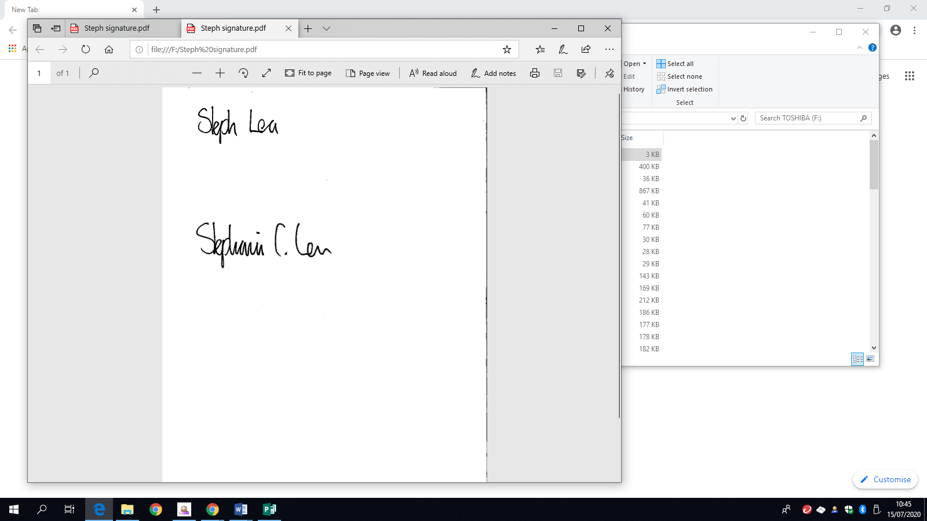

Steph Lea
Executive Headteacher

News and highlights from the week

Visits to the park
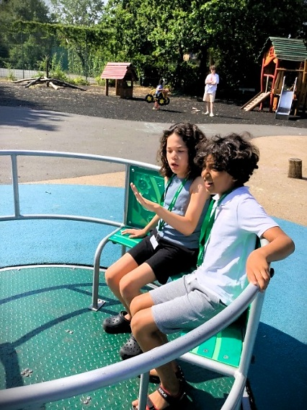
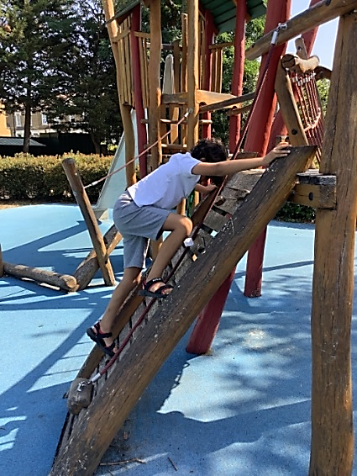
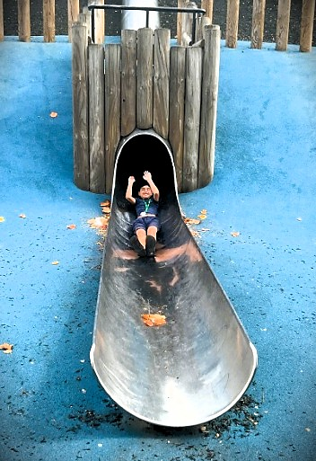

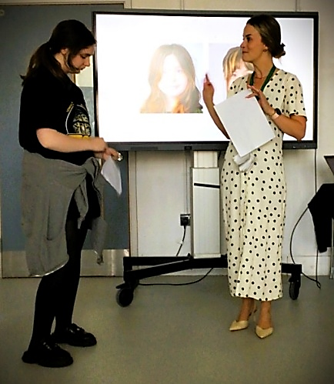
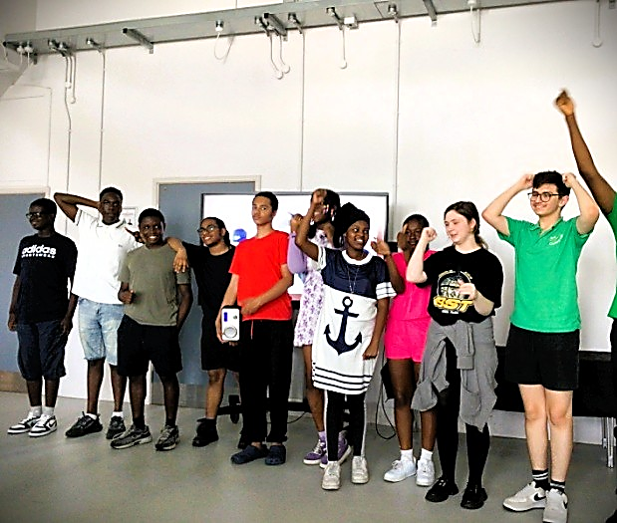
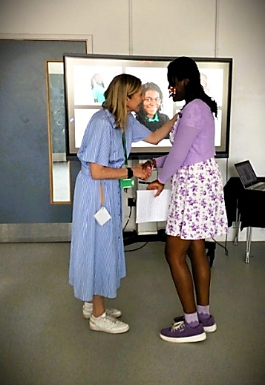
The Year 11 Leavers Event

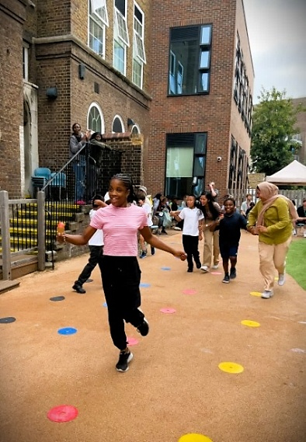
Sports Day
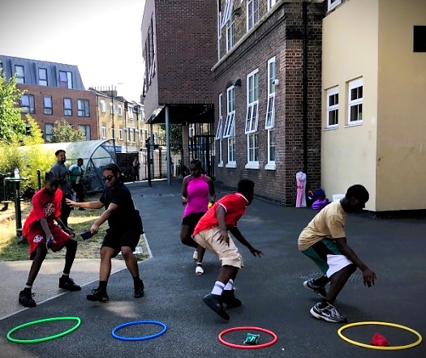
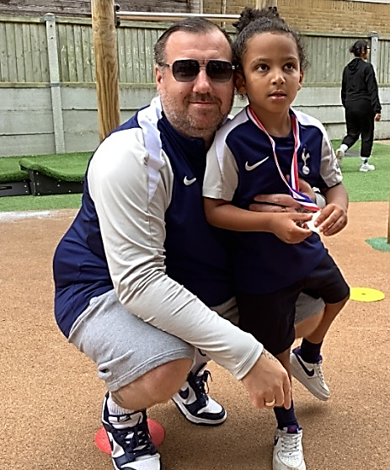

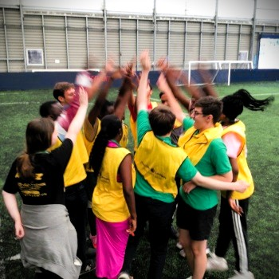
Last session of the Millwall Premier League Inspires Programme
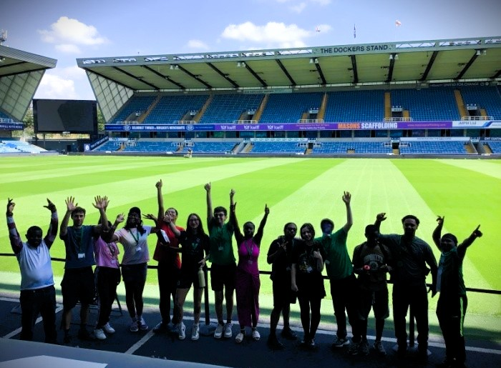

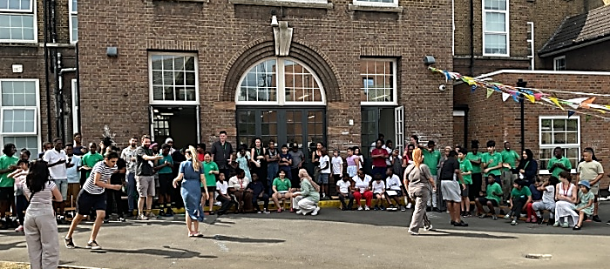
Spa Camberwell Carnival

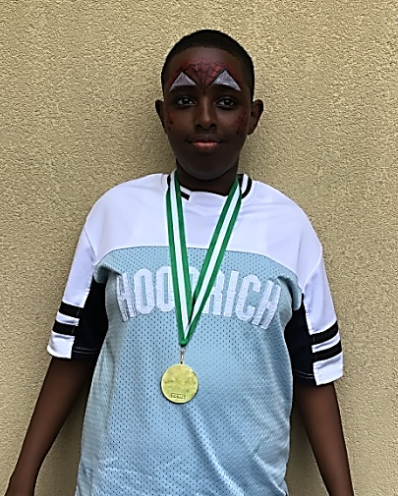
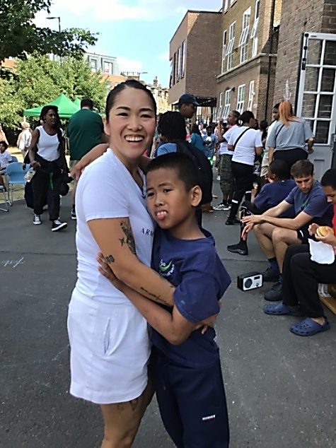


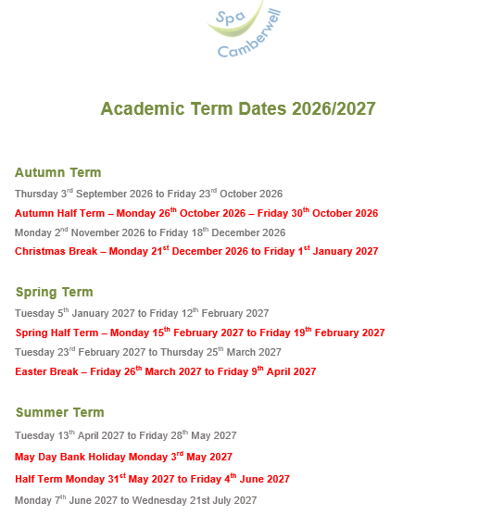

Support and activities for families
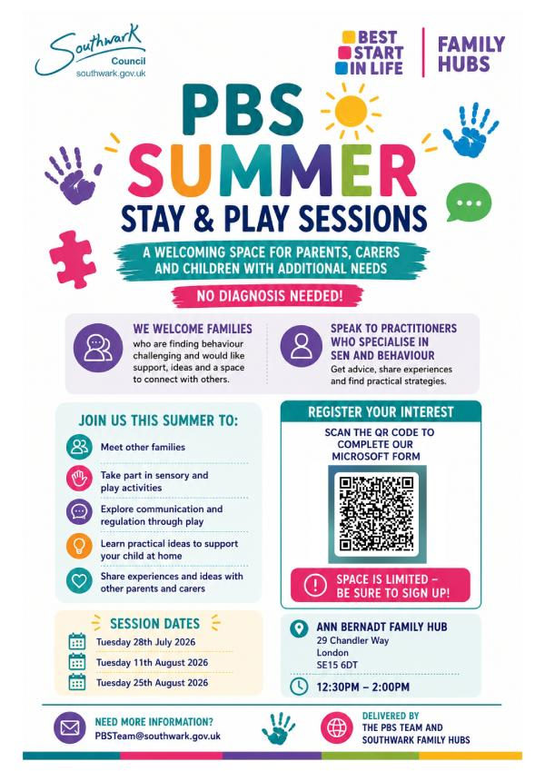

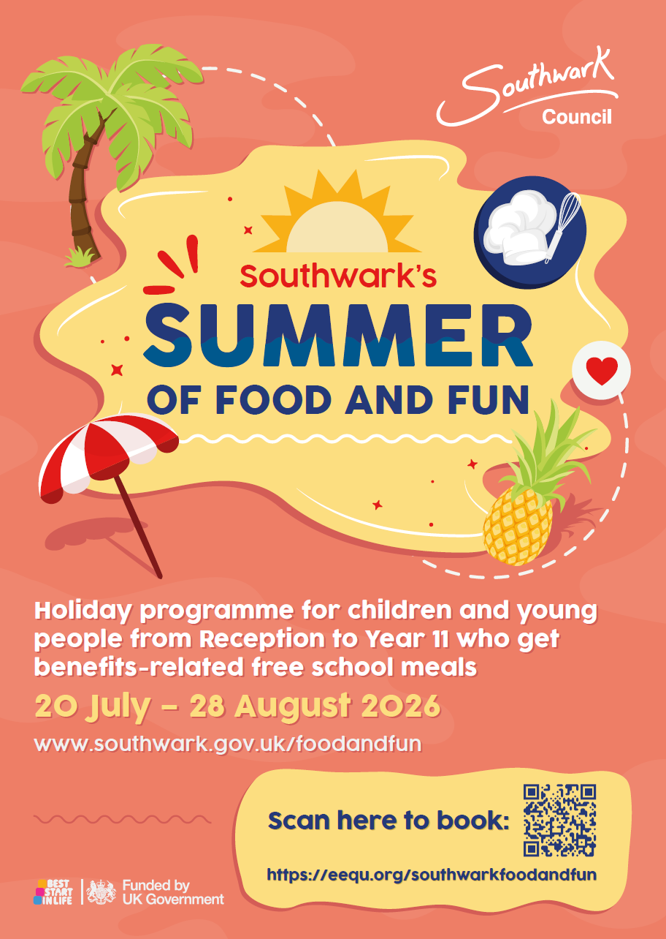

Summer holiday activities

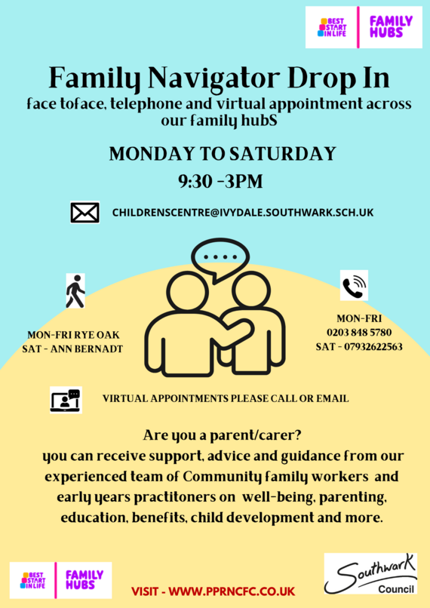

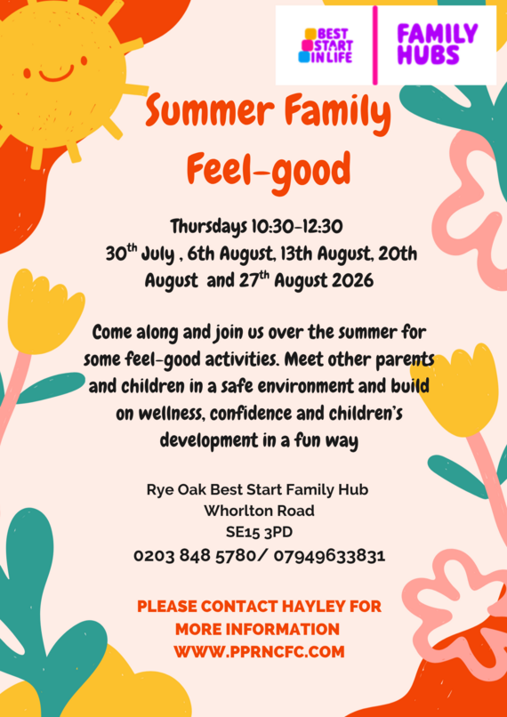

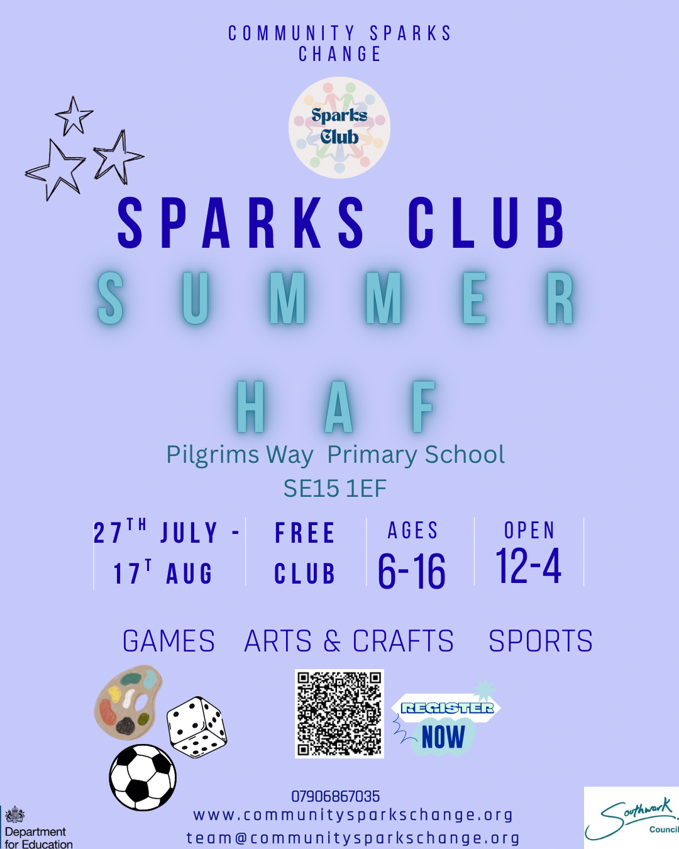


This summer, families can enjoy a free Kellogg’s breakfast at Morrisons Cafés nationwide thanks to the return of the Morrisons and Kellogg’s Breakfast Club initiative.
Available every day from 29 June to 6 September, the offer includes a free bowl of Kellogg’s cereal and a piece of fruit for both children and adults. It’s a simple way to help families access a nutritious breakfast during the school holidays and ease some of the additional costs many households face over the summer.

Great British Summer Savings
Rising prices can make life's little treats harder to afford, especially during the school holidays when costs build up for families. This Government is determined to help, and that is why last month the Chancellor announced the Great British Summer Savings scheme.
From 25 June to 1 September 2026, the Government is temporarily cutting VAT from 20% to 5% on children's meals in restaurants, children and family tickets to cinemas, theatres, concerts and exhibitions, and admission to a wide range of attractions. Combined with free bus travel during August for children aged 5 to 15 in England, families and young people will be able to enjoy experiences that make summer special, including visits to the kinds of cultural and educational attractions that enrich children's lives outside the classroom.
As part of this campaign, we have launched an attraction finder website which allows families to type in their postcode and find participating venues near them to make the most of summer savings. To use the attraction finder, please visit https://summersavings.gov.uk

-------------------------------------------------------------------------------------------------------------------------------
Tickets for Summer Holiday activities will be available
from Friday 19th June at 10am on the Short Breaks EEQU page. Book early to secure spaces!
EEQU PLATFORM
-------------------------------------------------------------------------------------------------------------------------------
The Southwark SEND and Inclusion Partnership is seeking your views on support for children and young people with SEND. Your insights will help us understand what is working well and where improvements are needed.
Click here to complete the survey: Southwark SEND and Inclusion Partnership Survey – Fill in form
The survey is open until Friday 25th September

Welcome to our Ambitious Youth Network

Our Ambitious Youth Network is an online space for autistic young people, between the ages of 13-25 to be themselves. You can share experiences, connect with others and access opportunities to advocate and improve services for autistic young people. You can join via our website or download the app on the Apple or Android store.

