26th June 2026
Dear Parents and Carers,

Thank you to all our families for your support during this week's exceptionally hot weather. A special thank you goes to our wonderful staff for their dedication and care in helping our pupils stay safe, happy and healthy throughout the extreme temperatures.
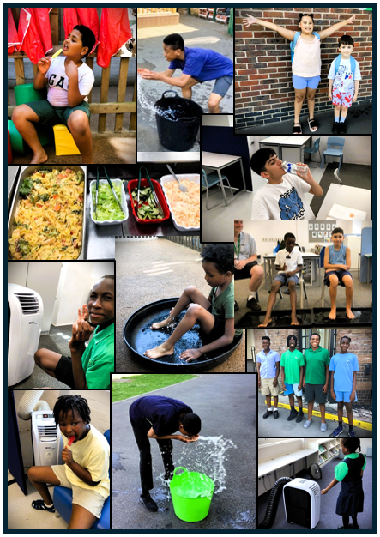
News from the week
As we approach the end of the term, we will be saying a fond farewell to Beth.
Beth has been a valued member of the Spa community for the past eight and a half years and has been an integral part of the Spa Camberwell team since we opened our doors in September 2020. Throughout her time with us, she has made an extraordinary difference to the lives of so many pupils and their families through her dedication, kindness and unwavering commitment.
Beth is moving on to an exciting new career opportunity closer to her family. While we will miss her enormously, we are delighted for her and wish her every success and happiness as she begins this new chapter.

Online Safety

Layering Up for Online safety
Protecting children and mitigating risk at home doesn't just mean applying a filter and changing a few app settings; it needs a layered approach, and this is where the Internet Matters 'Layering Up for Online Safety' comes in. This helps guide parents in setting up devices safely across networks, the devices themselves, and the apps, alongside regular conversations. There is a downloadable guide which will show you how to layer up in a simple, manageable way.
Link: Internet Matters - Layering Up for Online Safety.

Looking Ahead
- Sports Day – Thursday, 9th July
- Parents Evening – Monday, 6h July
- Spa Camberwell Carnival – Friday, 10th July
- Year 11s Leavers Event – Wednesday, 15th July
- Last Day of Term – Friday, 17th July

As always, thank you for your continued support. We hope you and your family have a restful and enjoyable weekend, with some welcome relief from the heat. We look forward to seeing everyone next week.
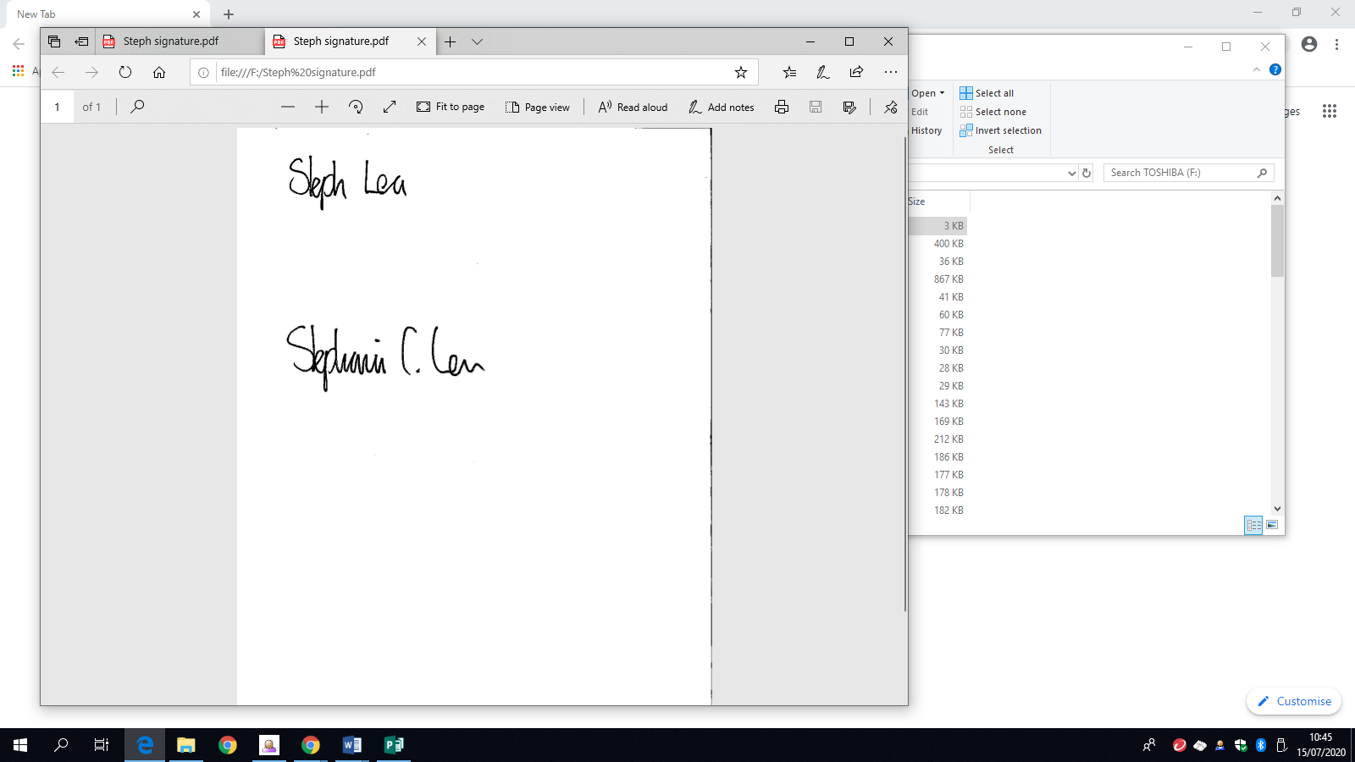

Steph Lea
Executive Headteacher

Support and activities for families






