23rd June 2026

Dear Parents and Carers,

The pupils managed as best as they could today but the building is becoming hotter as the temperature rises.

Please be aware there will be a red weather alert in place for tomorrow and Thursday. Temperatures will be even hotter and the breeze will drop.

School will remain open if you think your child will be more comfortable here and following their regular routine. If you think your child is more comfortable at home please just let us know in the morning. Families who called today don’t need to call in again unless there is a change of plan.

We will continue to monitor the situation closely, follow all relevant guidance, and update you again tomorrow.

Please do take care of yourselves and do call us if you have any queries.

Best wishes,
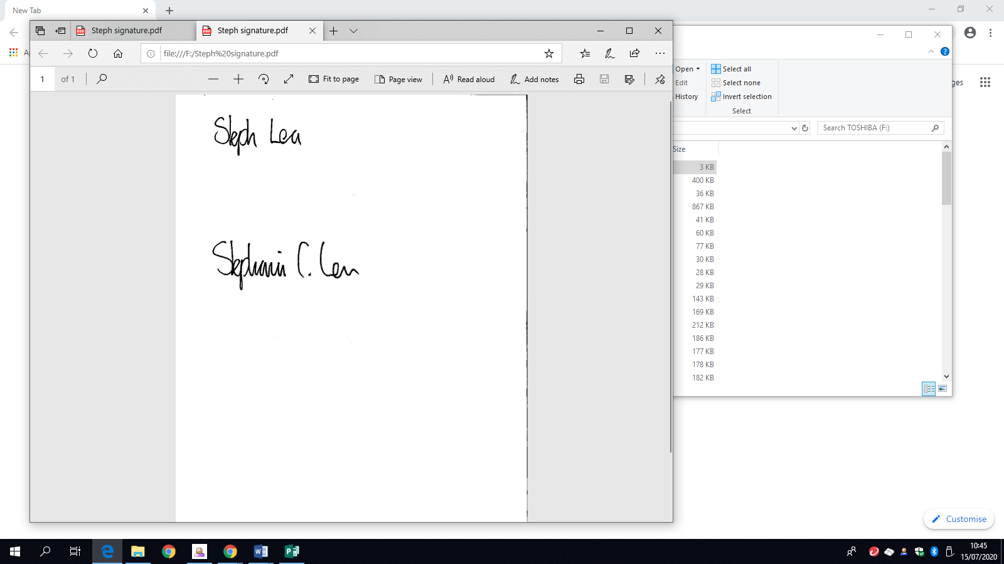
Steph Lea
Executive Headteacher

