July 6th 2026

Dear all,

As you know there is a yellow weather alert in place and the week will get hotter as it goes on.

We have decided to move the dates for our special end of term events. These will now take place in the last week of term which should be a little cooler.

Primary Sports Day: Tuesday AM July 14th
Secondary Sports Day: Thursday AM July 16th
Summer Carnival: Thursday 2PM July 16th

Some of you have already let us know you are keeping your child home due to the heat. Please keep us updated and let us know if there is anything useful we can provide for you.

Best wishes,
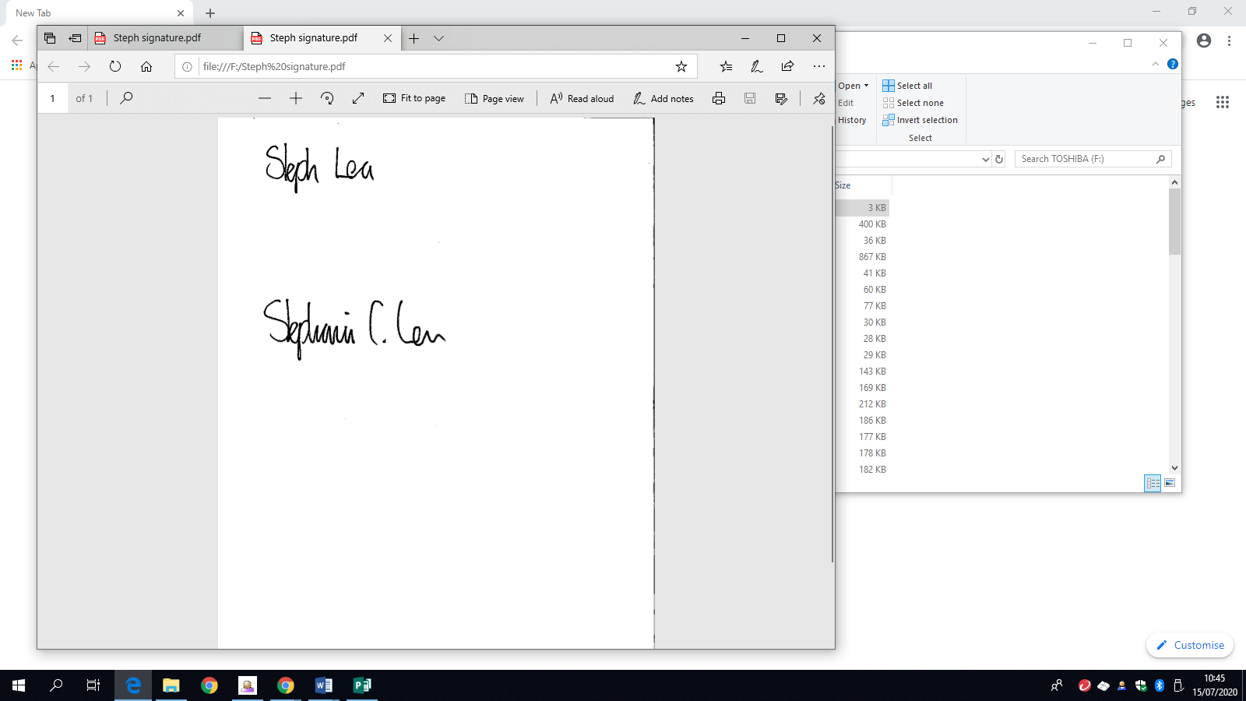
Steph Lea
Executive Headteacher

