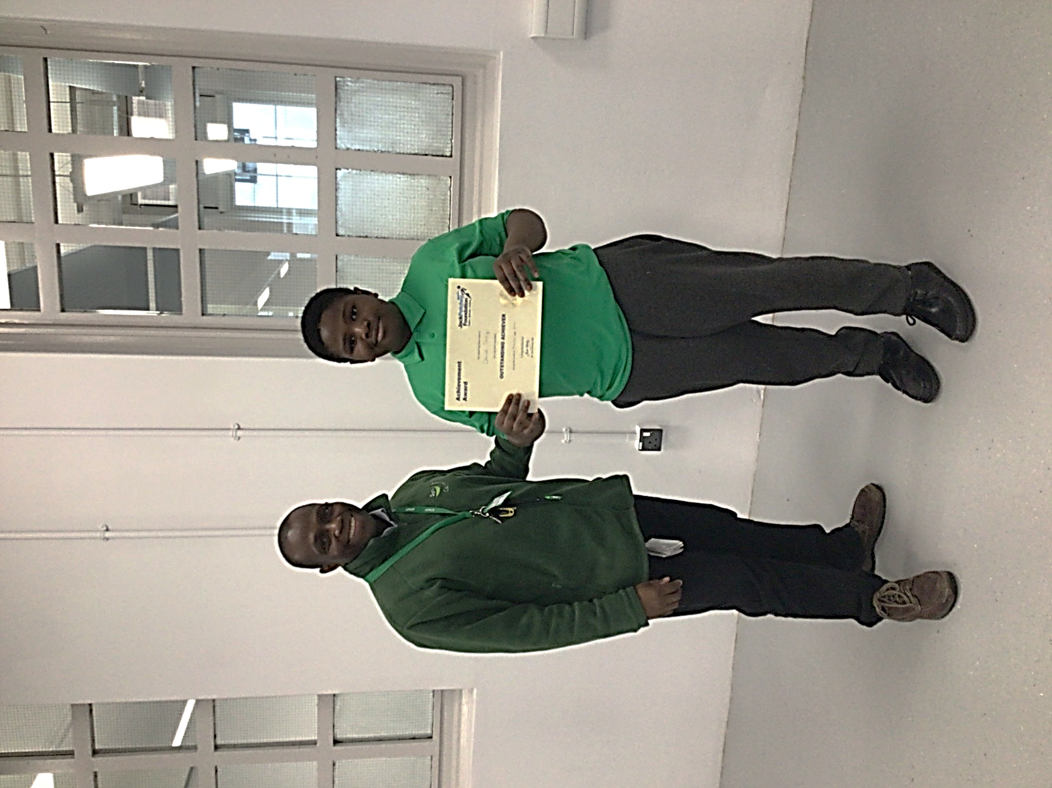

Jack Petchey Award

November 2020

Daniel Sadiq