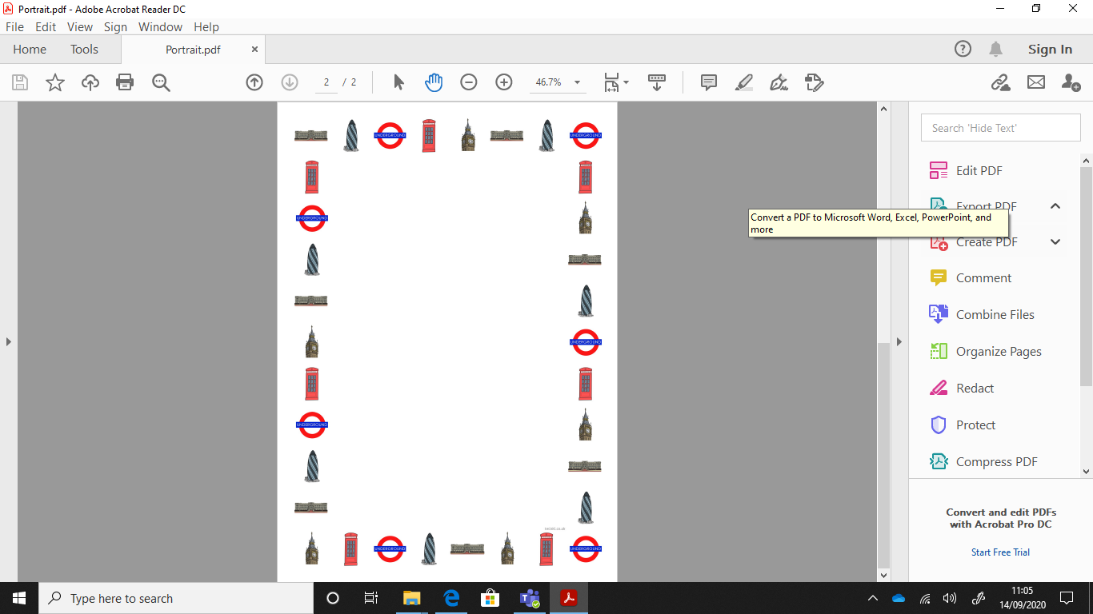

London

Your theme task for this week is to find as many facts about London!

Think about:

What is London famous for?

Are there any famous landmarks?

What is the Monarchy?

What is there to do in London?

What is the Houses of Parliament?

Are there any famous people from London?