A Different World.
Week 5, Year1.
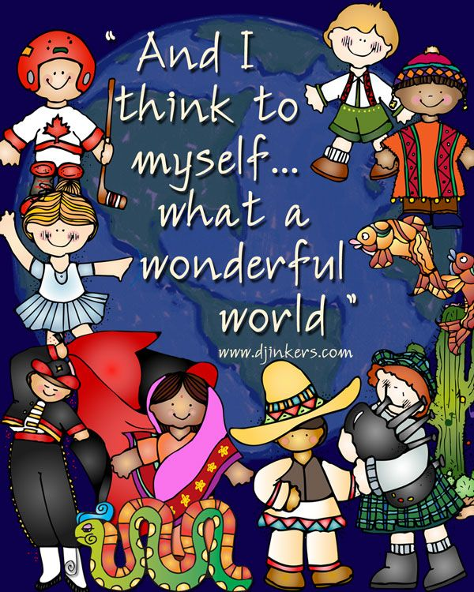 | Now we have finished reading the story ‘Man on the Moon (a day in the life of Bob)’, we think it would be great if you could write your own story about going to the moon! You will need to think about these things.  What will you take?  How will you get there?  What you will do when you get there….  Do you work on the moon?  How you will get home again…..  Remember…..  Begin every sentence with a capital letter.  End every sentence with a full stop.  Finger spaces.  Best handwriting.  Can you use exciting vocabulary?  Have you remembered how to add? Great! Now can you remember how to subtract (take away)? Can you subtract from 10? See if you can work out the pattern.  10 – 0 = 10 10 – 1 = 9 10- 2 =  Now keep thinking about how the world has changed since the corona virus?  If you were in charge what would you do to change the world? Can you write a list of all the things that you would do? Here are some ideas….  Free ice cream every day for all children.  Plant more trees.  Build a playground for every street.  Have shops which sell healthy food.  Finally….have you been doing your daily exercise? Have you been for a walk today? Can you touch your toes? Can you run on the spot for 10 minutes? Can you do 20 sit ups? Can you do 10 push ups?  Don’t forget to send a photograph of your work to the e mail address below, we love to see what you have been doing!
Please submit work by Friday 10th July 2020 and remember to ….STAY ALERT!
class1w@springhill.lancs.sch.uk
class1f@springhill.lancs.sch.uk

