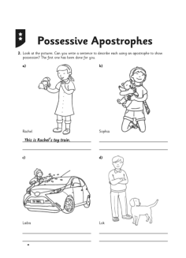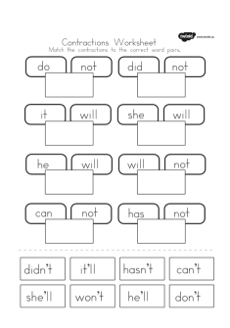Name________________________________________