**Easier option**

LC: Can I find the perimeter and area of compound shapes to solve money problems?

You work for a carpet fitting company and you have some customers have given you floor plans.
The rooms need new carpet and skirting board.
Find the area of the rooms and price up the carpet; find the perimeter and price up the skirting board.

The price of carpet and skirting board is as follows:

Flooring | Cost per m² | Flooring | Cost per m
Basic Carpet suitable for low wear and tear | £8 | Basic Skirting board suitable for low wear and tear | £4
Luxury Carpet suitable for high wear and tear | £12 | Luxury Skirting board suitable for high wear and tear | £9

Mrs. Smithson

Mrs. Harris

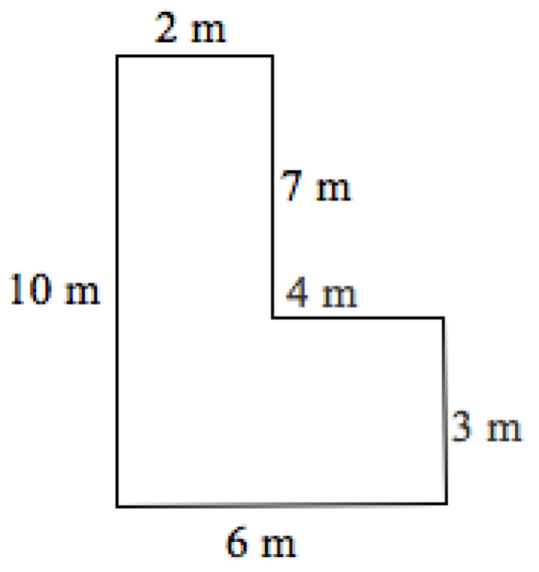
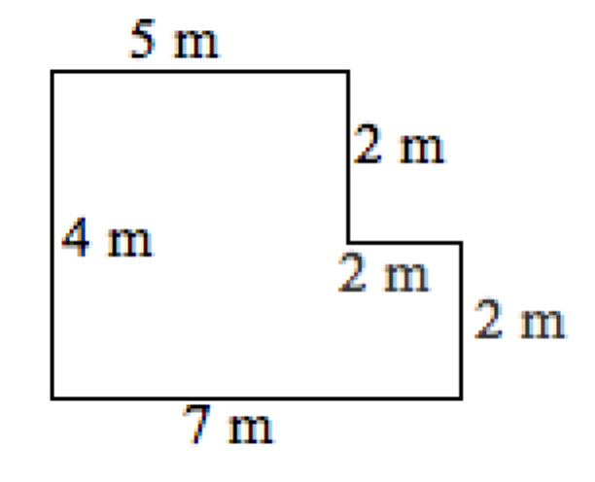

Mr. Langdon

Mrs. Pounder

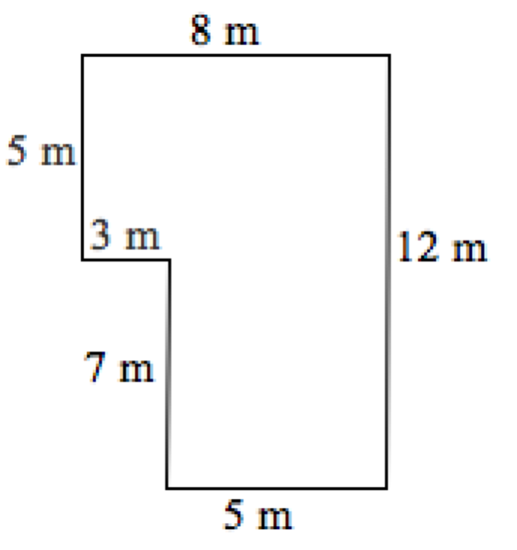
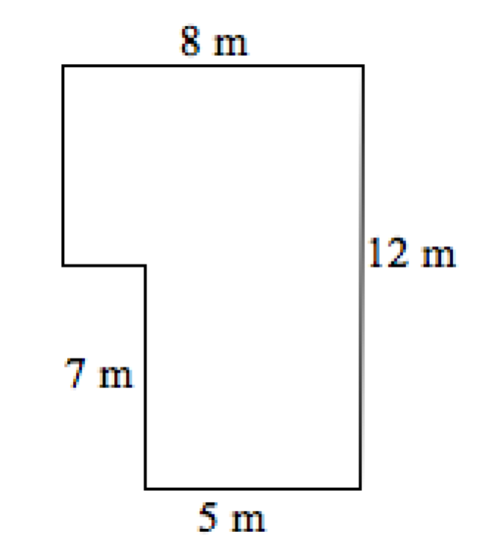

**Harder option**

You work for a carpet fitting company and you have some customers have given you floor plans.
The rooms need new carpet and skirting board.
Find the area of the rooms and price up the carpet; find the perimeter and price up the skirting board.

The price of carpet and skirting board is as follows:

Flooring | Cost per m² | Flooring | Cost per m
Basic Carpet suitable for low wear and tear | £4.50 | Basic Skirting board suitable for low wear and tear | £4.99
Luxury Carpet suitable for high wear and tear | £12.25 | Luxury Skirting board suitable for high wear and tear | £9.85

Mrs. Harris

Mrs. Smithson

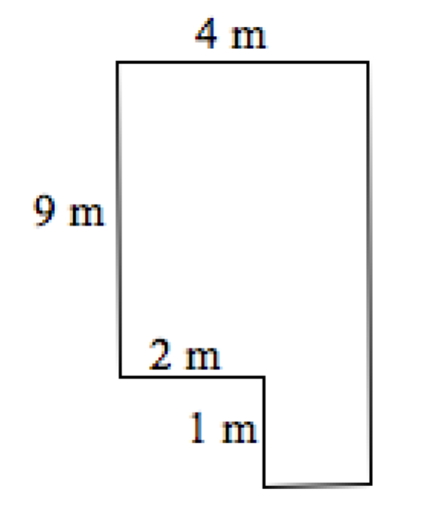
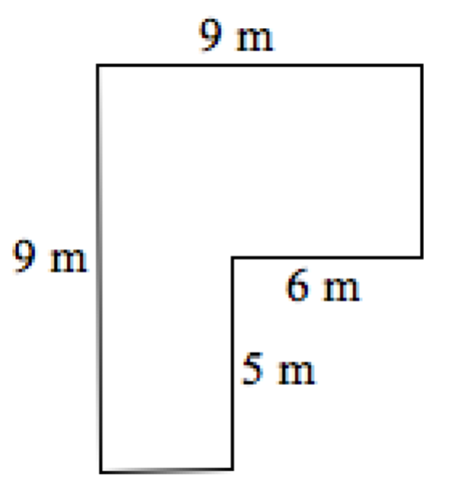
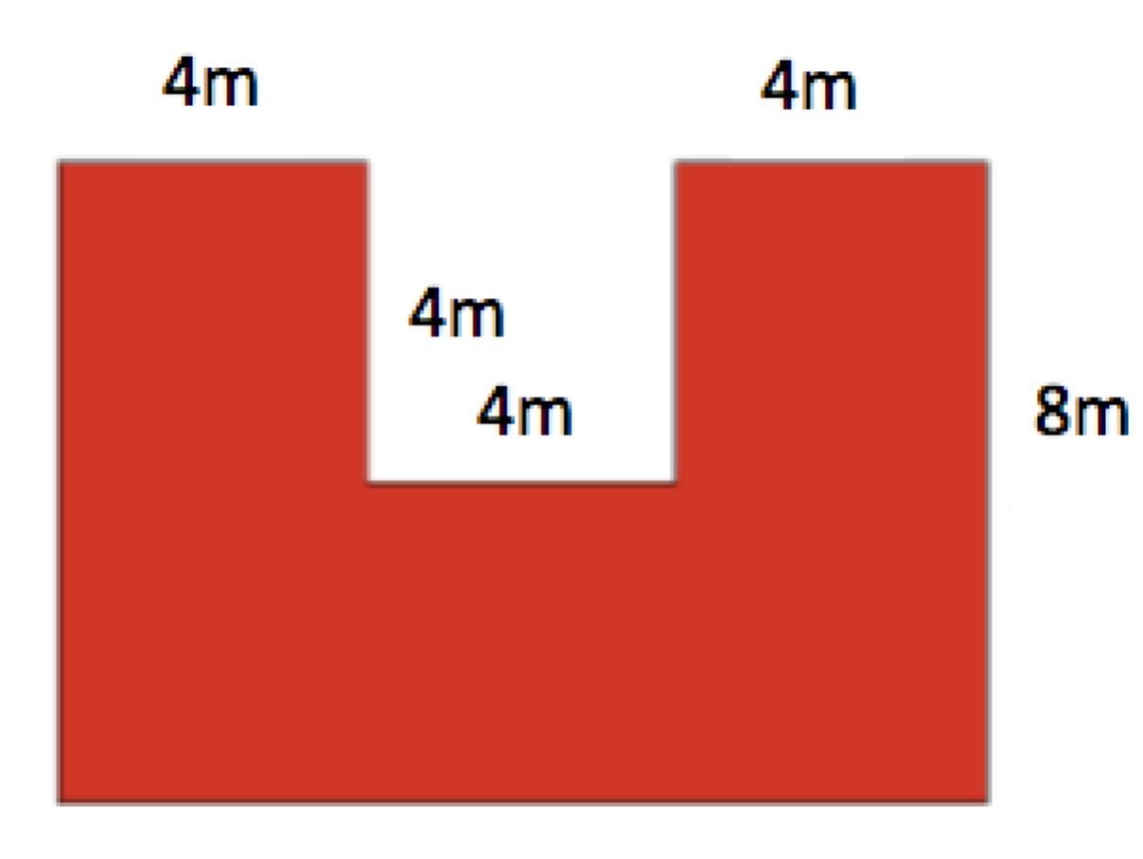
Mr. Langdon

Mrs. Pounder

