Baa Baa Black Sheep
Baa Baa Black Sheep, have you any wool?
Yes sir, yes sir, three bags full.
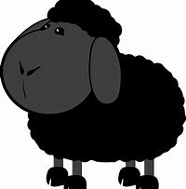
One for the master and one for the dame And one for the little boy
Who lives down the lane.

Baa Baa Red Sheep
Baa Baa Red Sheep, have you any spots?
Yes sir, yes sir, lots and lots.
Some on my back and some on my toes,
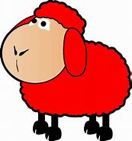
Some on my tummy
And one on my nose.

