Starting number | 10 more
198
297
490
301
294
801
606
393
+10
-10

Starting number | 10 less
198
297
490
301
294
801
606
393

Starting number | 1 more
299
400
799
399
600

Starting number | 1 less
201
400
700
399
600

50 less than 213 is ______
30 less than 405 is _____
300 less than 834 is ______
400 less than 987 is ______
_____ is 200 less than 985
______ is 50 less than 826
435 is 50 more than ______
761 is 600 more than ______

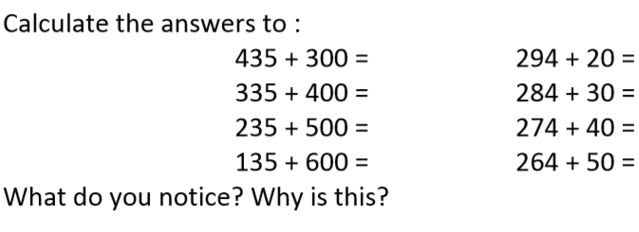

Extension!
True or False? Always explain your answer. You can use examples to help you explain.

- Whenever you add ten to a 3 digit number, only the tens column changes.
True or false? Explain.

- 10 less than 507 would only change the tens column. True or false? Explain.

