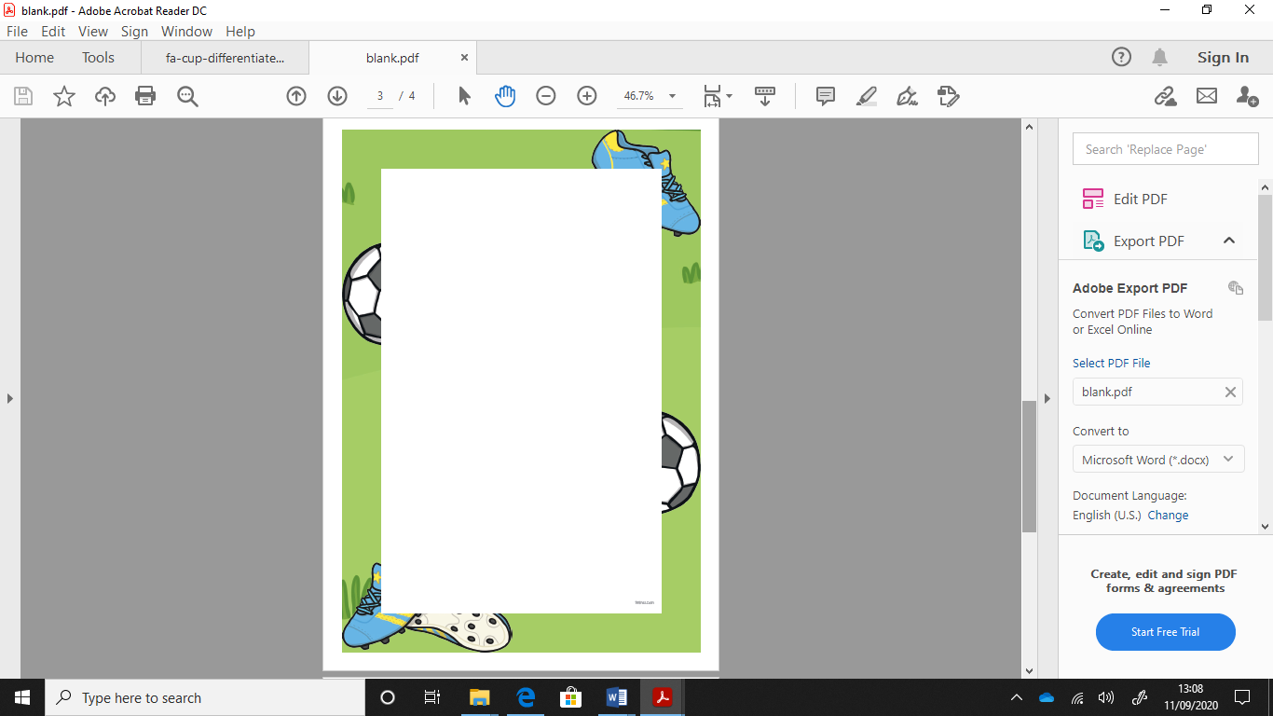

Name:

LC: Can I answer questions on a Non Chronological report?

1. What is the FA cup?

_______________________________________________________________________________________________________________

1. How does the FA cup work?

_______________________________________________________________________________________________________________

1. What does the winning team win?

_______________________________________________________________________________________________________________

1. How many people watched the final in 2016?

_______________________________________________________________________________________________________________

1. How many spectators does the FA cup have?

_______________________________________________________________________________________________________________