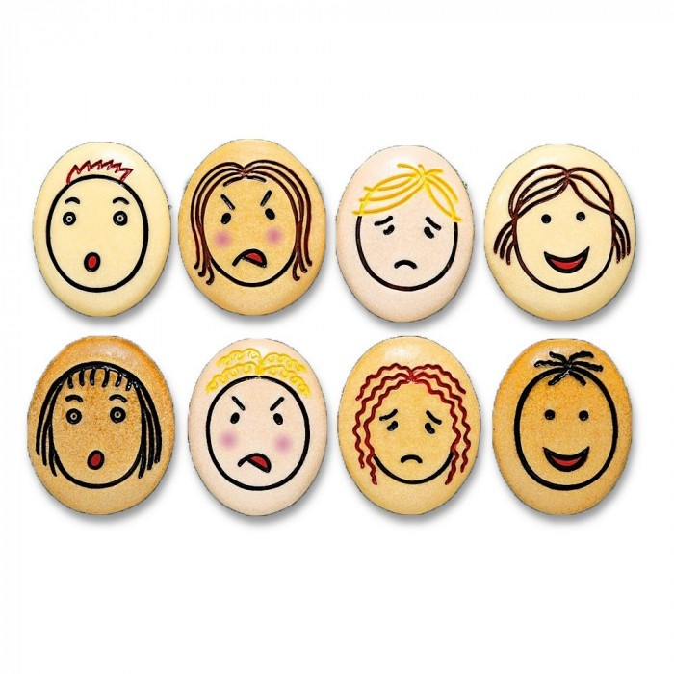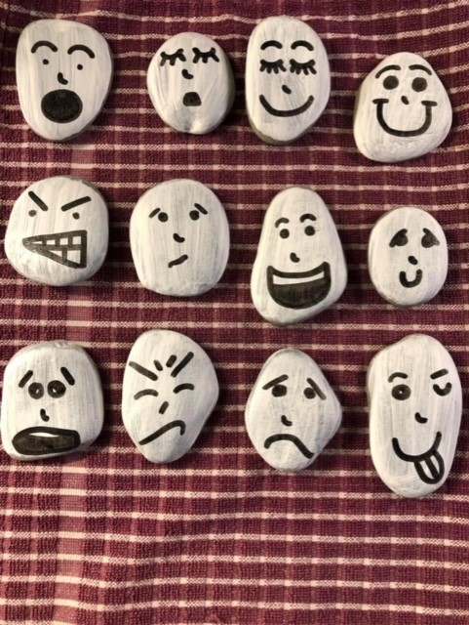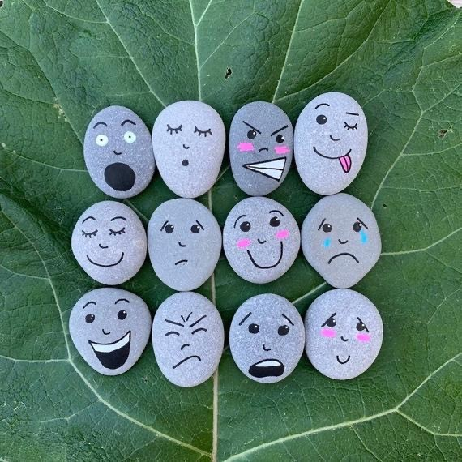

**Here are some examples for you to look at to give you some ideas for your emotion stones challenge.**

**Remember you can use paper to draw them on if you can’t find any stones or pebbles on your walk**.

Emotion Stones Challenge