Miss Brown’s Class Challenges W/B Monday 22nd June 2020

Numeracy

1. Can you order numbers cards to 10/20?

Can you count along the numbers forwards and backwards to 50 on a number square/100 square? <https://tpet.co.uk/downloads/hundred-square-posters/>

1. Can you find some bottles or containers and show full/empty/half full?
2. Can order different bottles/glasses/cups of liquid from full to empty?
3. Can you estimate (guess) how many cups to fill a bottle?

*Don’t forget to log on to Sumdog for a few minutes each day and you can also watch episodes of ‘Numberblocks’ on Youtube or on the BBC Iplayer*

Reading

1. Can you say what is in the photo, chop it up (segment) into sounds and write the word correctly? Use the green and purple sounds cards in your home learning pack.

*If you would like some new reading books you can visit…*

[*https://home.oxfordowl.co.uk/books/free-ebooks/*](https://home.oxfordowl.co.uk/books/free-ebooks/)

*(please write down any books you read in your reading journal)*

*Phonics help and videos can be found at…*

*Phase 2 sounds/tricky words* <https://www.bbc.co.uk/bitesize/topics/zf2yf4j>

*Phase 3 sounds/tricky words* <https://www.bbc.co.uk/bitesize/topics/zvq9bdm>

Book of the Week

Jasper’s Beanstalk

By Nick Butterworth

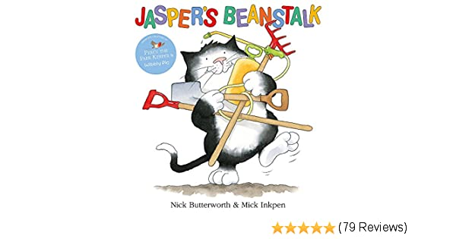

Watch it here…

<https://www.youtube.com/watch?v=Da6lxY_8jmU>

Writing

Watch the story of Jaspers Beanstalk and talk about the days of the week.

1. Can you draw a picture and write a sentence for what happened on each day in the story?

*To remember how to write letters correctly you can visit the ‘Handwriting Heroes’ and watch the videos at the bottom of the page.* [*https://appytherapy.com/handwriting-heroes/*](https://appytherapy.com/handwriting-heroes/)

Complete your challenges in any way using any items you may have at home. You can send it to me by taking a photograph of your work or the work itself at…

[FEBclass@springhill.lancs.sch.uk](mailto:FEBclass@springhill.lancs.sch.uk) (don’t forget to add your name to the email so I know whose work it is)

*You can also join Joe Wicks each day at 9am on his YouTube channel for a daily P.E. Lesson or search for ‘Boogie Beebies’ and complete simple dance routines.*

Topic

1. Can investigate the life-cycle of a bean or a plant?

Draw and write about the life-cycle and send your photos to the class email.

There are lots of photographs and videos on line to help with this task.

