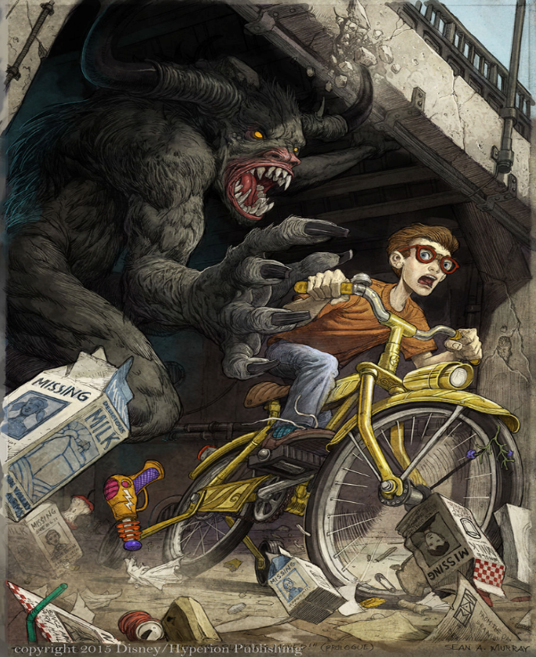

Francis by Dave Eggers
When I was a kid in the suburbs of Chicago, adventure meant Quetico Provincial Park, up on the border of Minnesota and Canada. The name implies that the place was small, but Quetico is a million acre nature preserve, so big you could go days and days without seeing another soul.
We would go on camping trips up there, weeks of canoeing and portaging, seeing bears and moose and deer, sleeping under star-soaked skies. The park was isolated and so pristine that you could actually drink the water straight from the lakes. But I won't be going back to Quetico anytime soon. Not after what happened to a girl name Francis Brandywine.
Francis was 17 at the time, black haired and with a reckless nature, determined always to leave the well-trod path, to break new ground and be alone. A few years ago, Francis was up in Quetico with her family. They were in a remote part of the park, camped on the shore of one of the deeper lakes, a lonely body of water carved millions of years ago by a passing glacier. The deep part of this particular lake was rumoured to be about 300 feet.
One night, after her family went to bed, Francis took the row boat out, planning to find a quiet spot in the middle of the lake, lay on the bench of the boat, look up at the sky, and maybe write in her journal.
So she left the shore, rowed for about 20 minutes, and when she felt satisfied that she was over the lake's deepest spot, she lay down on the bench and looked up at the night sky. The stars were very bright, and the aurora borealis was shimmering like a neon lasso. She was feeling very peaceful.
Then she heard something strange. It was like a knock. Clop, clop. She sat up, guessing that the boat had drifted to shore and run aground. But she looked around the boat, and she was still a half mile from shore. She leaned over the side to see if she'd hit anything, but she saw nothing-- no log, no rocks. She lay back down.
She told herself it could be any number of things, a fish, a turtle, a stick that had drifted under the boat. She relaxed again and soon fell into a contented reverie. She had just closed her eyes when she heard another knock. This time it was louder, a crisp plop, plop, plop, like the sound of someone knocking hard on a wooden door, except this knocking was coming from the bottom of the boat.
Now she was scared…

Continue the story from where we have left it. Use the picture for inspiration too.
Think about:
Your grammar – can you include different grammar aspects such as the dramatic dash?
How do we build suspense in a story?
How do you keep the reader interested and entertained?

