Year 4 – Autumn Term Newsletter
Welcome to the new school year. We hope the children are looking forward to it as much as we are. It promises to be a very exciting and fun year ahead.
We are hoping to introduce new topics and themes throughout the year to engage the children and inspire them to learn.
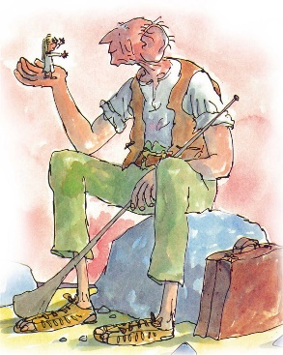
This terms topic is… Giants
In this topic we will be focusing on giants’ starting, in English, with the BFG by Roald Dahl before moving on to The Iron Man and Gulliver’s Travels. The theme will continue throughout the other subjects areas including making a dream catcher (Art and DT), learning about oceans of the world, mystery islands (Geography) and a study of times and places where fairy stories originated (history).
In Maths we will be solving problems by: Applying our knowledge of number and place value, addition and subtraction, multiplication and division and fractions. Estimating numbers and using reasoning. Comparing, describing and appropriately recording different units of measure. Describing position, direction and movement. Reading and interpreting information from a table. Any practical measuring you can do at home e.g. baking using grams and kilograms, discussing millilitres and litres and temperature etc. would be very helpful, as would telling the time and counting with money.
In science this term, we will be studying Sound and Vibrations, Materials and Their Properties and an exciting topic on Electricity.
In PE, the children will be given so many opportunities to try new sports and develop existing skills. We offer a range of before and after school clubs including Multi sports Club on a Tuesday, a Girls Football Club on a Thursday and a Sports Breakfast Club on a Wednesday.
We are sure the children are going to have a brilliant time learning.
General information:
We would be obliged if you could help and support us by making sure the children;
- Go to bed early (we recommend 8pm)
- Come to school on time, ready to learn. (8:45am )
- Read daily for at least 10 minutes
- Wear the correct school and PE uniform.
- Attend school every day.
- Complete their homework on time, taking a pride in all their work.

