Task Sheet 2
Children to complete tasks each day in small sessions lasting between 10 and 15 minutes.
Can you take pictures of your work or you doing the tasks and email me them to me as I would like to see how you are doing. classFLP@springhill.lancs,sch.uk

Letters and Sounds Video
Recap on the letters from last week s a t p i n say the sound and the name.
You will need the letter cards - m/d/g/o/c/k/ say the sound and the name.
Challenge
- Find and say the letter, write the letter correctly.
- Make as many different words that you can with the letters.
- Read and write the words.
- Can you find the ones that rhyme ( have the same ending e.g. it, kit, pit, sit)
- Read the tricky words and then try to write them
Ongoing Tasks
Watch Alphablocks on Ceebies

Story Session Video
Listen to the Hungry Caterpillar story
- Story read by the author on YouTube https://www.youtube.com/watch?v=eXHScpo_Vv8
- Animated video on YouTube https://www.youtube.com/watch?v=75NQK-Sm1YY
Challenge
- Write a diary of the foods you eat each day.
- Discuss which foods are healthy and which ones are not and why?
Ongoing tasks
Watch Handwriting Heroes to help with letter formation (the letter y is the only one in the wrong section it is a surfer not skier)
Cannon Poppers https://www.youtube.com/watch?v=ZeOOB-GVOyI
Bouncers https://www.youtube.com/watch?v=AEh4F2_TjWE
Skydivers https://www.youtube.com/watch?v=n4A23g_Jwhw
Skiers https://www.youtube.com/watch?v=x1uYdC0dQLQ
Surfers https://www.youtube.com/watch?v=zLM5Hlj5dC0

Numeracy Video
Recap on counting to 20 using Fingers
- Order the number cards 1-10 or 1-20, match objects to numbers.
- Say a number and then say what is one more (what comes after) or practically count out the objects for the number and add one to make it 1 more and say what the number is now.
- Say a number and then say what is one less (what comes before) or practically count out the objects for the number and take one away to make it 1 less and say what the number is now.

New Challenge
Sing days of the Week song - https://www.youtube.com/watch?v=HtQcnZ2JWsY
https://www.youtube.com/watch?v=Oiisv7EhG98
- Say the say of the week in order
- Say the days in order starting at different days.
- Say which day comes after Monday or Friday
- Say what day comes before Wednesday or Saturday.
Ongoing Tasks
Watch Numberblocks on BBC iplayer
Complete the Super Hero challenge on Sumdog

Topic Video
We are going to talk about the life cycle of a butterfly and know the different stages it goes through
https://www.bbc.co.uk/bitesize/clips/zxcmp39
https://www.youtube.com/watch?v=V5RSpMQQOpw
https://www.bbc.co.uk/teach/class-clips-video/how-caterpillars-change-into-butterflies-no-narration/zn4rkmn

Challenge
- Talk about the different stages of the life cycle.
- Children to make a life cycle of the butterfly using different media, painting drawing playdough, junk modelling.

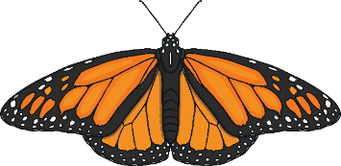
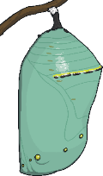
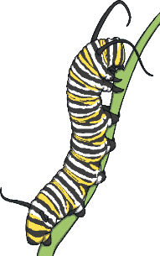
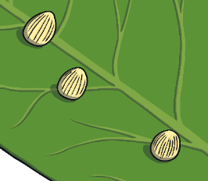
butterfly
egg
chrysalis/
pupa/cacoon
caterpillar

