Task Sheet 4
Children to complete tasks each day in small sessions lasting between 10 and 15 minutes.
Can you take pictures of your work or you doing the tasks and email me them to me as I would like to see how you are doing. classFLP@springhill.lancs.sch.uk

Letters and Sounds Video
Recap on the letters from last week s/a /t/p/i/n/m/d/g/o/c/k/ e/u/r/h/b/f/l say the sound and the name.
You will need the letter cards – ss/ll/ff/ck say the sound.
Challenge
- Find and say the letter, write the letter correctly.
- Make as many different words that you can with the letters. pass, till, huff, peck
- Read and write the words.
- Can you find the ones that rhyme ( have the same ending e.g. bell, tell, sell, dell )
- Read the tricky words and then try to write them
I/ go/ no/ the/ to /into, he/me /she/ we/ be/ was you/they/all/are/my/her
Ongoing Tasks
Watch Alphablocks on Ceebies

Story Session Video
Listen to Jasper’s Beanstalk story
- Story read on YouTube https://www.youtube.com/watch?v=Da6lxY_8jmU
https://www.youtube.com/watch?v=AN38Y4LyDOU
Challenge
- Discuss what Jasper did on each day can you remember the order.
- Draw a pictures and write about what Jasper did on each day.

Ongoing tasks
Watch Handwriting Heroes to help with letter formation (the letter y is the only one in the wrong section it is a surfer not skier)
Cannon Poppers https://www.youtube.com/watch?v=ZeOOB-GVOyI
Bouncers https://www.youtube.com/watch?v=AEh4F2_TjWE
Skydivers https://www.youtube.com/watch?v=n4A23g_Jwhw
Skiers https://www.youtube.com/watch?v=x1uYdC0dQLQ
Surfers https://www.youtube.com/watch?v=zLM5Hlj5dC0

Numeracy Video
Counting to 50 using Fingers and your head.
Recap on Count forwards and backwards to 20 using fingers and head.
Recap on the days of the week as well
New Challenge
1/ Using water can you fill containers with water saying which ones are full / empty/ half full
2/ Put water into bottles showing different amounts then order them empty to full or full to empty talking about each one.
3/ Guess then count how many small containers it will take to fill the big one
4/ Look at measuring jugs and discuss the measure litre (L) and millilitres (ml) on the side
Language to use
(measure size compare guess, estimate nearly, close to, about the same as just over, just under full, empty half full holds container how much/many… )

Ongoing Tasks
Watch Numberblocks on BBC iplayer
Complete the Super Hero challenge on Sumdog
Topic Video
We are going to look at the life cycle of a bean.
Watch the videos
https://www.youtube.com/watch?v=pg92cspLy0I
https://www.bbc.co.uk/bitesize/clips/zystsbk

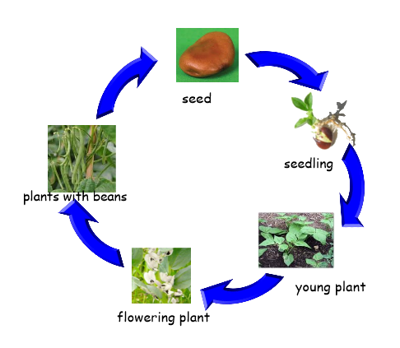
New Challenge
Can you make a draw the different stages of the life of a bean?

