The Alphabet Song
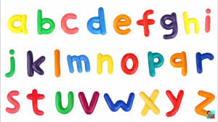
a-A b-B c-C d-D e-E f-F g-G
h-H i-I j-J k-K l-L m-M n-N o-O p-P
q-Q r-R s-S t-T u-U v-V
w-W x-X y-Y z-Z
(Repeat)
Oh it’s easy, so easy,
To learn your alphabet.
If you sing this song through every day
You simply can’t forget.
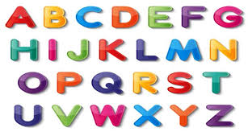
a-A b-B c-C d-D e-E f-F g-G
h-H i-I j-J k-K l-L m-M n-N o-O p-P
q-Q r-R s-S t-T u-U v-V
w-W x-X y-Y z-Z

