This persons has just started in a new school & doesn’t know anyone.  ________________ | 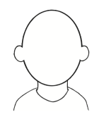 | This person has just been told they’ve won a prize in a competition.  ________________
This person is going on holiday today and is on their way to the airport.  ________________ |  | This person is sitting at a desk getting ready to do a test.  ________________
This person is standing up in assembly to receive an award for being the Star Worker.  ________________ |  | This person has just had a bad bike accident and hurt their arm and leg,  ________________

