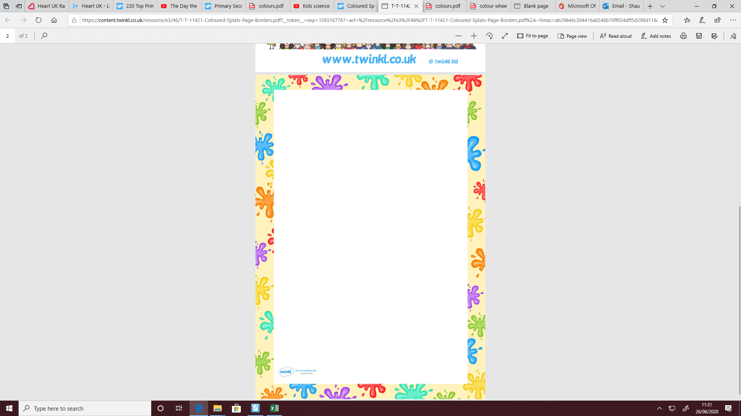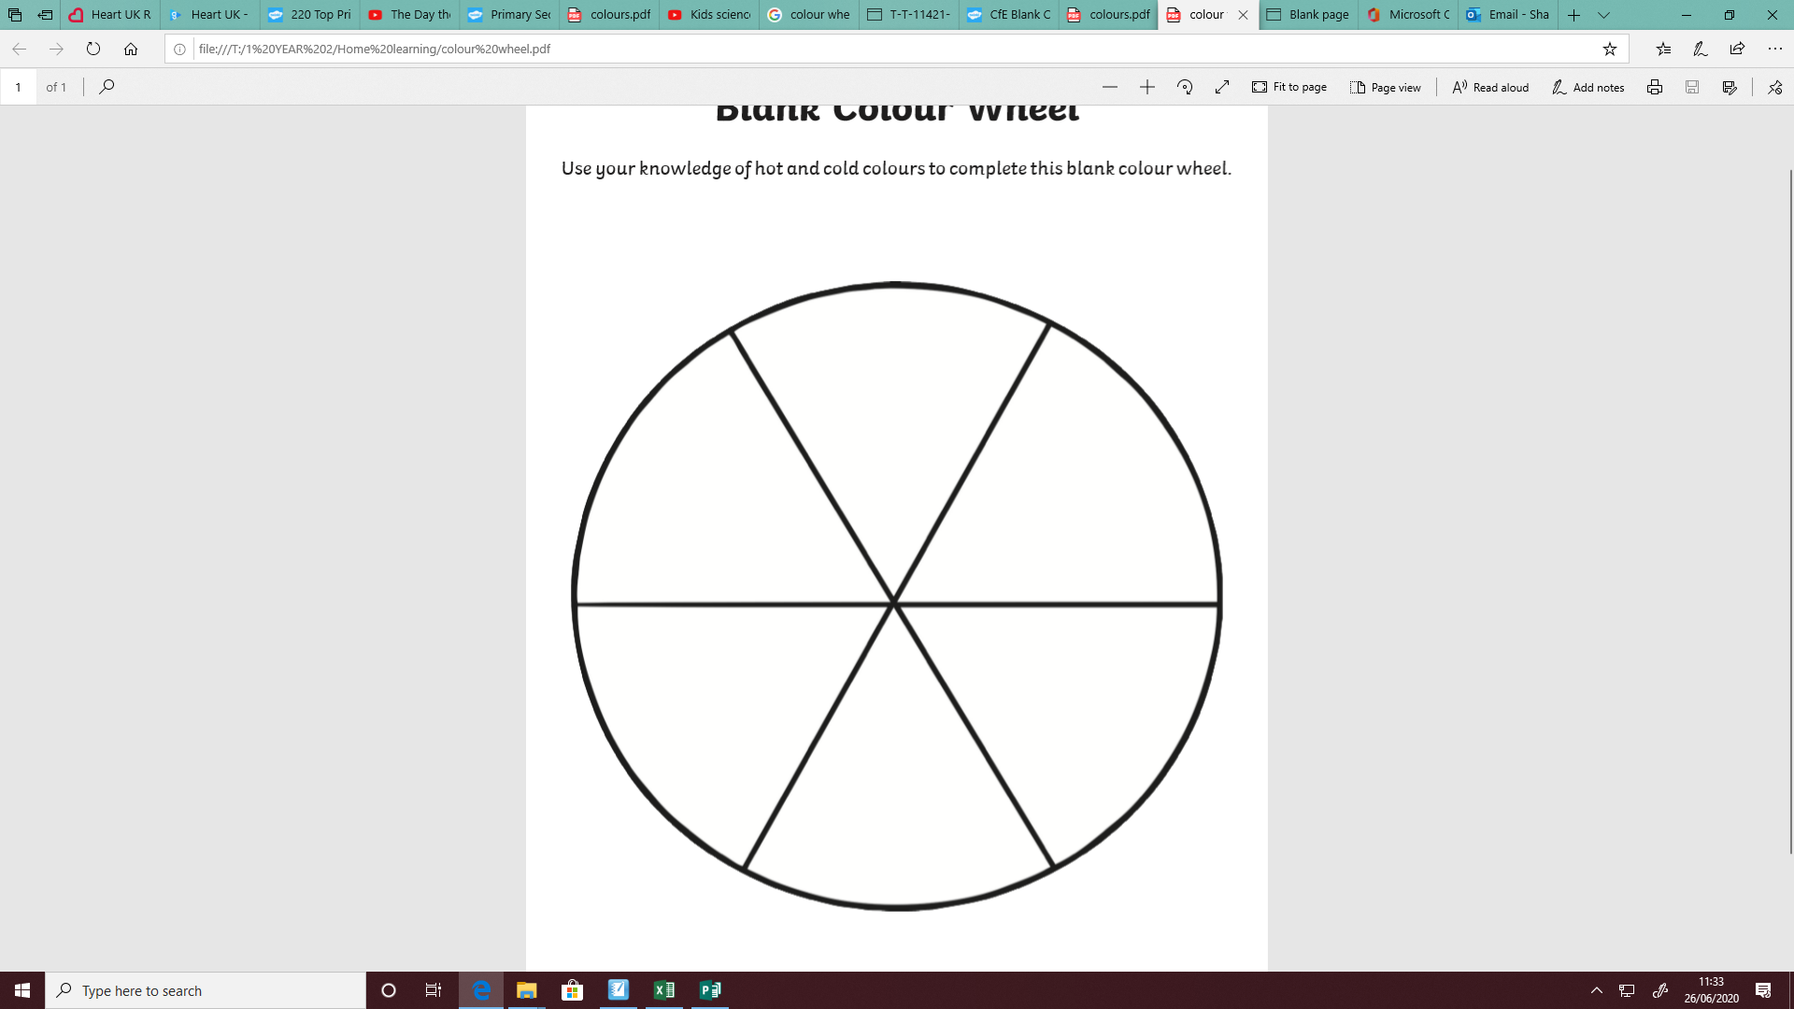

**Name _____________ Date ________________**

**LC: Can I create my own colour wheel with   
Primary and Secondary colours?**

**Remember!**

**Primary colours are red, yellow and blue.**

**Secondary colours are green, orange and purple.**