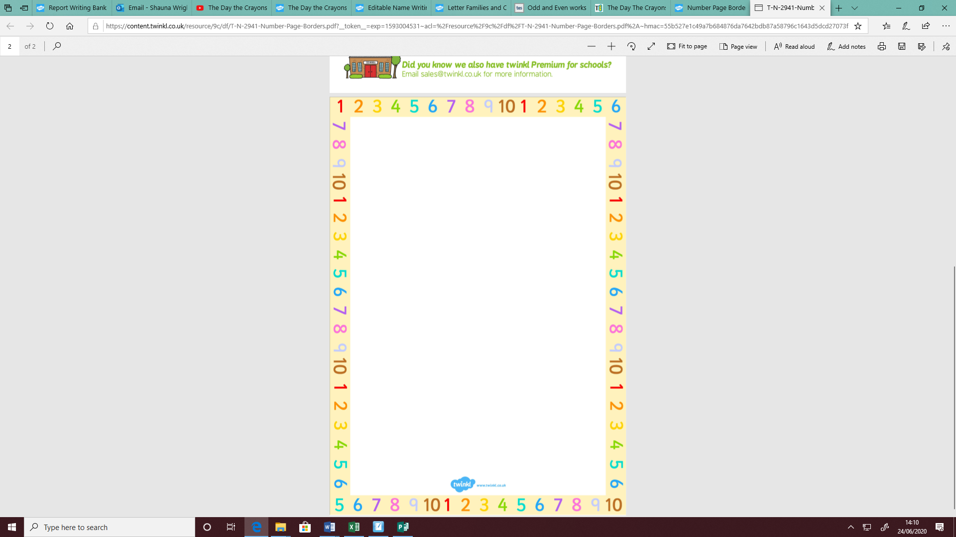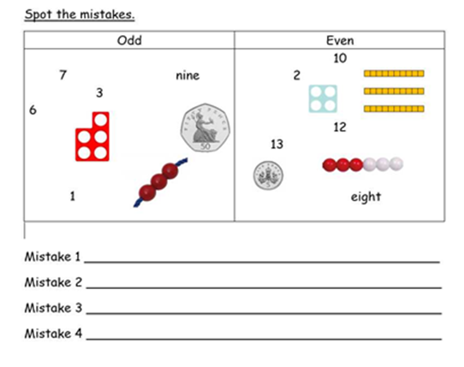

LC: Can I identify odd and even numbers?

**Are the numbers odd or even?**

**Show this in the table.**

|  |  |  |  |
| --- | --- | --- | --- |
| **6 3 20**  **18 14**  **17 9 15**  **2 11**  **7 16 5** |  | **Odd** | **Even** |
|  |  |

**Spot the mistakes**