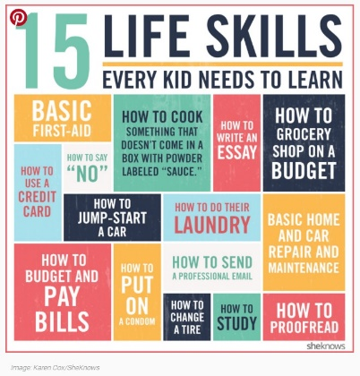Information for when you are Stuck At Home Help and support is available right now if you need it. You don't have to struggle with difficult feelings alone. For instant support, please contact:

www.healthyyoungmindslsc.co.uk Get Help now: Calm Kids, Connected Parents gives you resources on all kinds of parenting dilemmas at your fingertips — including inspirational messages, audio tracks, videos and articles to help you create a calmer, happier home.

YoungMinds Crisis Messenger text service: YOU CAN TEXT: YM to 85258 24/7 crisis support across the UK. It is free and confidential to text the service. For more information, please visit https://youngminds.org.uk

Anna Freud: National Centre for Children and Families: Corona Virus advice https://www.annafreud.org/what-we-do/anna-freud-learning-network/coronavirus/

Childline on 0800 1111. You can talk to them about anything; no problem is too big or too small. https://www.childline.org.uk

Kooth https://www.kooth.com/ Safe and anonymous online support, is available Monday-Friday 12pm-10pm and Saturday and Sunday 6pm-10pm.
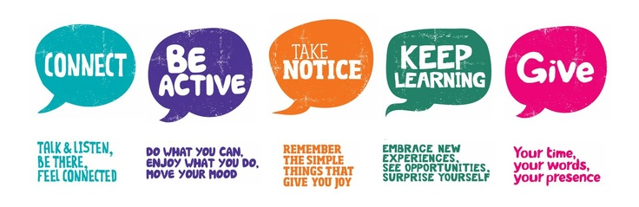
Apps for mobiles: Promoting Good Mental Health
Headspace is a personal guide to health and happiness. Designed to help you focus, breathe, stay calm, perform at your best, and get a better night’s rest through the life-changing skills of relaxation, meditation and mindfulness. Calm is an app for meditation and sleep. Designed to help lower stress, lessen anxiety, and assist in a more restful sleep with guided meditations, Sleep Stories, breathing programs, masterclasses and relaxing music. Insight Timer offer guided meditations and talks led by the world's top meditation and mindfulness experts, neuroscientists, psychologists and teachers from Stanford, Harvard, the University of Oxford and more. Sleepio is designed to teach you how to overcome even long-term poor sleep without medication. This is the companion app for the Sleepio programme. Moodometer is an interactive mood diary for monitoring and understanding emotional wellbeing. Happime a free non-profit app that helps to raise self-esteem, self-confidence and happiness levels in children young people and adults by teaching them about the power of thinking positively and how to choose a more helpful way of thinking. Smiling Mind is a web and app-based program developed by psychologists and educators to help bring balance to people’s lives. WellMind is a free NHS mental health and wellbeing app designed to help you with stress, anxiety and depression. The app includes advice, tips and tools to improve your mental health and boost your wellbeing. MindShift uses strategies based on Cognitive Behavioural Therapy (CBT) to help you learn to relax and be mindful, develop more effective ways of thinking, and use active steps to take charge of your anxiety.
Info for parents https://childmind.org/coping-during-covid-19-resources-for-parents/
Info for parents https://www.annafreud.org/what-we-do/anna-freud-learning-network/coronavirus/
