

|  |
| --- |
| Exchange Street, Accrington, Lancashire BB5 0JD |

01254 399009

Website: [www.springhillschool.co.uk](http://www.springhillschool.co.uk) E-mail: head@springhill.lancs.sch.uk

**Spring Hill Community Primary School**

**SEN Information Report & Local Offer 2017 - 2018**

SPRING HILL IS A **MAINSTREAM** PRIMARY SCHOOL WITH AN INCLUSIVE ETHOS.

1. **HOW DOES THE SCHOOL KNOW IF CHILDREN NEED EXTRA HELP?**

At Spring Hill Community Primary School, children are identified as having SEND (Special Educational Needs and Disabilities) through a variety of ways, usually a combination, which may include some of the following:

* Is the pupil significantly making slower progress than that of their peers starting from the same baseline
* Does the pupil fail to match or better the child’s previous rate of progress
* Does the pupil to fail to close the attainment gap between the pupil’s progress and their peers. The gap widens
* Liaison with previous school or pre-school setting
* Concerns raised by a parent
* Concerns raised by a teacher: for example, if behaviour or self-esteem is affecting performance
* Liaison with external agencies e.g. for a physical/ sensory issue, speech and language
* Use of tools for standardised assessment through the specialist teacher
* Children with a Statement / EHCP (Education Health and Care Plan) already have many of their needs clearly identified. Their placement at our school is a decision that is made by the Local Education Authority.
* Standardised assessments in English, Maths and social, emotional and behavioural development.
* Half termly pupil progress meetings that scrutinise the progress of all pupils between the Deputy Head Teacher and Class Teacher identifies and tracks the progress of all pupils and those who have school support, statement or EHCP.
* The SENDCo is in attendance during these meetings to be fully informed of any concerns that are raised.
* If a pupil is underperforming compared against national expectations then parents will be informed, appropriate assessments will take place if needed, appropriate targets are set.
* Before the start of each school year the next teacher will have a transition meeting with the previous teacher. Data and records are discussed about academic and social progress.
* There is a baseline assessment completed in Reception for all pupils.

1. **HOW DO I RAISE CONCERNS IF I NEED TO?**

* Talk to us – contact your child’s class teacher about your concerns initially. If you feel that you would like to speak to a senior member of staff, ask to arrange an appointment with the SENDCo. Appointments can be arranged in person, by phone or by email. Please see the school contact details at the top of this report.
* Complaints over the past 12months and outcomes of them.

1. **HOW WILL THE SCHOOL SUPPORT MY CHILD?**

3a **WHO WILL OVERSEE, PLAN AND WORK WITH MY CHILD AND HOW OFTEN?**

* The class teacher will oversee, plan and work with each child with SEND in their class to ensure that appropriate progress is made in every area
* The Key Stage 1 and Key Stage 2 Leaders, SENDCo, Deputy Head Teacher, Head Teacher will oversee the progress of any child identified as having SEND
* There may be an LSA (Learning Support Assistant) or HLTA (Higher Level Teaching Assistant) working with your child either individually or as part of a group. The content of this support will be explained to parents when support begins, as part of a child’s provision and is reviewed and updated during termly review of the targets set and the provision in place as part of the graduated response cycle of Assess, Plan, Do, Review, detailed within our SEN policy.
* How

3b **WHO WILL EXPLAIN THIS TO ME?**

* The class teacher will meet with you formally on at least a termly basis (this could be part of learning conversation meetings or separately), in order to discuss your child’s progress and the support that they are receiving
* Class teachers are always happy to discuss your child’s needs if you have questions or concerns between more formal meetings. Please speak to them directly to arrange this
* An appointment can be made with the SENDCo to discuss support in more detail if required.
* ILPs (Individual Learning Plans) will be shared with you and your child (age appropriate) termly and we will ask for you to comment on how the targets set have impacted on your child at home and at school.

**4 WHAT SUPPORT WILL THERE BE FOR MY CHILD’S OVERALL WELL BEING?**

4a **WHAT IS THE PASTORAL, MEDICAL AND SOCIAL SUPPORT AVAILABLE IN THE SCHOOL?**

* We are an inclusive school that holds a child’s emotional development as a priority
* The class teacher has overall responsibility for the pastoral, medical and social care of every child in their class
* Any additional staff working with vulnerable children requiring support during the school day, will work under the direction of the Head teacher and the SENDCo.
* How does the school ensure the safety of the children/young people?

If a

4b **HOW DOES THE SCHOOL MANAGE THE ADMINISTRATION OF MEDICINES?**

* The school has a policy regarding the administration and managing of medicines, which is available on the policy page of the school website. Parents can request a ‘hard copy’ of this policy from the school office
* Parents need to contact the school office if prescribed medication is recommended by healthcare professionals and needs to be taken during the school day. Any medication must be given to the school in the packaging that it was dispensed in by the pharmacy, with the child’s name and administration information clearly shown. A form must also be completed by the parent and medicines handed into and collected from the school office
* On a day-to-day basis, the administrative staff generally oversee the administration of any medicines. Another member of staff will always witness any administration
* As a staff, we have regular training and updates on conditions and medication affecting individual children, so that all staff are able to manage medical situations
* The vast majority of staff hold first aid qualifications, which are updated regularly.
* Further guidance is provided within our SEN policy and administering medicine policy, both available online or in hard copy on request.

4c **WHAT SUPPORT IS THERE FOR BEHAVIOUR, AVOIDING EXCLUSION AND INCREASING ATTENDANCE?**

* The school has adopted behaviour and exclusion policies available on the school website. If a child has significant behaviour difficulties, an Individual Behaviour Management Plan (IBMP) is written to identify the specific issues, put relevant support in place and set targets with a view to identifying and addressing the underlying reasons behind the behaviour. The school works closely with White Ash Specialist School and local charity organisations.

The school has an adopted attendance policy. Attendance of every child is monitored on a daily basis by the school. Lateness and absence are recorded and reported to the Headteacher who may involve the Early Help Assessment Team or Children’s Services if this becomes a concern. There is a weekly class attendance award celebrated in class.

* The school are also able to support families in making contact with other agencies that provide appropriate support.
* Pupil passports for all children who have SEN support or and EHCP/statement shows strategies, likes, dislikes, possible behaviours of a pupil to support the pupil, parent and teacher.

4d **HOW WILL MY CHILD BE ABLE TO CONTRIBUTE THEIR VIEWS?**

[**Ladder of Student Involvement**](https://soundout.org/ladder-of-student-involvement/)

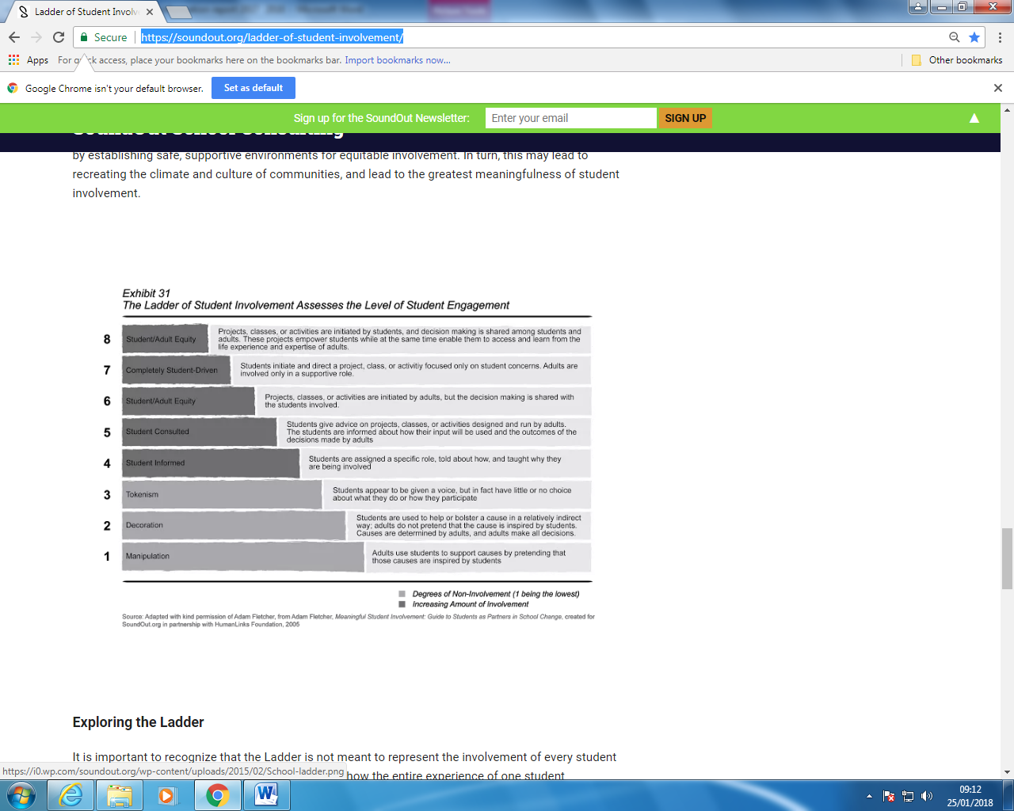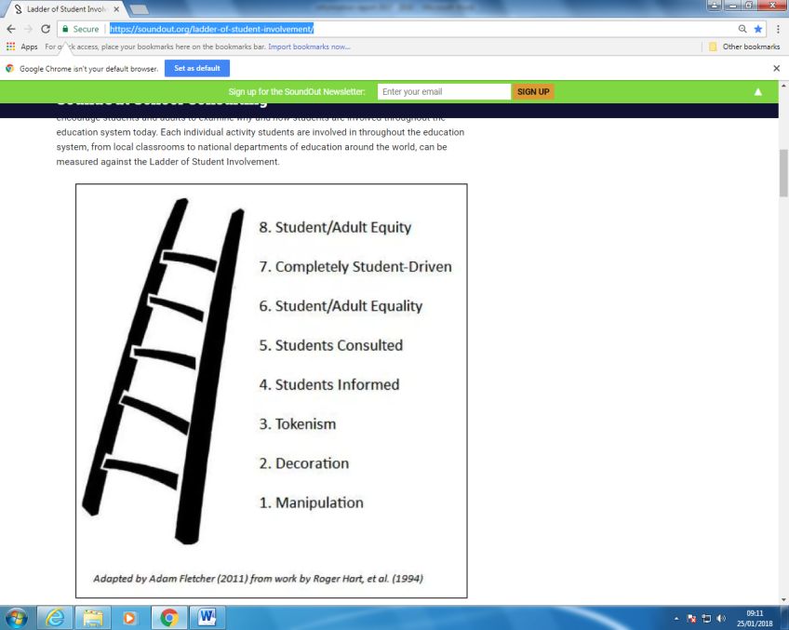

Spring Hill CP School use the ladder of student involvement to review the process of student engagement. Opportunities for different level of student involvement are important to allow pupils to feel they have control over the process. These opportunities can be given when reviewing the ILP’s for pupils throughout the school academic year.

* Children who have ILPs discuss their progress and targets when these are reviewed (age appropriate), as well as at termly learning conversation meetings
* If your child has a Statement or EHCP, their views will be sought before any review meetings (as is age appropriate)
* Children are routinely asked to reflect on their learning and share how they feel they are progressing during the course of their daily learning journey
* All children are provided with the opportunity to be voted onto the school council, as well as hold other positions of responsibility, by their class or teachers.
* During SEN Support when possible children can be given options of what type of support they need to improve an area of weakness.
* During EHCP process this is always discussed with parents and pupils during statuary meetings but also in informal meetings through the year.

1. **HOW ACCESSIBLE IS THE SCHOOL ENVIRONMENT?**

* Our school has an adopted accessibility policy, this is available on our website
* Two designated disabled parking bays,
* A ramped entrance
* Yellow lines on steps outside
* Three all access toilets
* Contrasting walls and skirting boards for the visually impaired
* An all access changing room (with shower, changing bed and additional toilet),
* Ramps at doorways
* The building is all on one level
* An induction loop system is fitted in the school hall
* All signs in school now have the equivalent braille signs underneath.
* Light switches in corridors are at wheelchair height
* There is an open access policy for speaking to the Head Teacher or SENDCo doors open to the outside which makes speaking to the classroom teacher at the start or end of the day much easier.
* If you have specific access queries or concerns please speak with us.

1. **HOW WILL THE CURRICULUM BE DIFFERENTIATED TO MATCH MY CHILD’S NEEDS?**

* The long term curriculum plans are available to parents on the school website, alongside ideas for how parents can support their child’s learning outside of school. These are updated regularly.
* All learning activities within class are planned and differentiated at an appropriate level, so that all children are able to access learning according to their specific needs. Typically, this might mean that in a lesson there would be three different levels of work set for the class, however on occasions this might be individually differentiated
* The class teacher, alongside the SENDCo will discuss a child’s needs and what support will be appropriate
* Children with SEND will have access to the appropriate resources needed in order to help them to make progress e.g.phonic mats, coloured overlays, hands on maths apparatus,
* The SENDCo reports weekly to the Head teacher and Governors are regularly informed about the progress of children with SEND and how resources are being used. Information provided will never name individual children in order to maintain confidentiality at all times
* The governor responsible for SEND also meets regularly with the SENDCo. They report on their visit to the governors to keep them all informed with school or LA (Local Authority) information
* The governors agree priorities for spending within the SEN budget, including the Pupil Premium, with the overall aim that all children receive the support that they need in order to make progress. This will include resourcing appropriate equipment and facilities.
* Staff will receive training, support and resources appropriate to the needs of the children and the expertise of the staff.

**HOW WILL WE KNOW IF THIS HAS HAD AN IMPACT?**

* Ensuring that the child is making progress academically against national/ age expected levels (or equivalents) and that the gap is narrowing between them and their peers
* If the gap is not narrowing there may be reasons for this and these must be considered. It is vital that appropriate and challenging targets are set. It may require the use of a different tracking system such as PIVOTs to track the progress of the pupils and track pupil progress against national expectations of similar pupils. At times it may be possible to moderate progress locally with other pupils from different schools that have similar needs.
* By reviewing children’s targets in ILPs and ensuring that they are being met as well as reviewing the overall provision in place for each child on the SEN register.
* Through verbal feedback from the child, the parent and teacher to build a wider picture
* Through children moving off the SEN Register when they have made sufficient progress – parents will always be informed if this has taken place.

1. **HOW WILL I KNOW HOW MY CHILD IS DOING AND HOW WILL YOU HELP ME TO SUPPORT**

**MY CHILD’S LEARNING?**

**WHAT OPPORTUNITIES WILL THERE BE FOR ME TO DISCUSS MY CHILD’S PROGRESS?**

* You are welcome to make an appointment to meet with either the class teacher or SENDCo at any time throughout the year and discuss how your child is getting on. We can offer advice and practical ways that you can help to support your child at home
* The children have reading diaries and homework books which are checked frequently.
* The school operates an open door policy for parents to come and talk about any issues.
* Your child may have an Individual Learning Plan that will have individual/group targets. This is discussed with you on at least a termly basis and parents are provided with a copy. The conversation will also provide suggestions as to how you can support your child’s learning at home. All parents are offered a termly opportunity to participate in a learning conversation
* When the child’s ILP is reviewed, comments are made against each target to show what progress the child has made
* If your child has complex SEND they may have a Statement of SEN or EHCP. In such instances a formal meeting will take place to discuss your child’s progress and a report will be written at least annually.
* Spring Hill CP School follows the principles of a structured conversation as outlined in the National Strategies Document Achievement for All The Structured Conversation. ([The Structured Conversation](http://dera.ioe.ac.uk/2418/1/afa_struct_conv_hbook_0105609bkt_en.pdf))

1. **HOW DOES THE SCHOOL KNOW HOW WELL MY CHILD IS DOING?**

* As a school we track and analyse the children’s’ progress in learning against national expectations (which still exist) and age related expectations on a half-termly basis
* The class teacher continually assesses each child and notes areas where they are improving and where further support is needed. As a school, we track children’s’ progress from entry at Year R through to Year 6, using a variety of different methods. Further information regarding the assessment of children with SEN is contained in the SEN policy. Please ask the school if you require any further details
* Pupil Progress Meetings are held each half term between each class teacher and the Deputy Head teacher with the SENDCo in attendance. In these meetings, a discussion takes place concerning children who are not making expected progress and possible actions are discussed
* Where specific needs are apparent, the school has a range of assessments which can be used to explore a child’s strengths and difficulties in more depth.
* The Headteacher and SENDCo report regularly to the Governing Body. We have a governor who is responsible for SEN, who meets regularly with the SENDCo and attends briefing sessions They also report back to the Governing Body (see section 6)
* The school is continually observing the teaching and learning that takes place through formal lesson observations and coaching from specialist advisory teachers.
* Parents are asked for feedback on the progress of the school through parent questionnaires and an open door policy between all staff and parents.

**9 HOW WILL MY CHILD BE INCLUDED IN ACTIVITIES OUTSIDE THE CLASSROOM, INCLUDING SCHOOL TRIPS?**

All pupils, regardless of any special needs, are involved in the full life of Spring Hill School:

* Homework – all pupils are given homework according to their age and ability. Pupils with special educational needs are given a relevant, differentiated version.
* If required pupils will have a home school liaison book
* Homework clubs run throughout the year
* More able pupils with SEND are included on the More Able register
* Clubs – There is a wide variety of clubs for pupils to attend. As an inclusive school, all clubs are open to all pupils and every effort is made to accommodate and include pupils with any special educational needs. Support is provided for out of school clubs if the pupil with SEND requires it.
* Assembly – All pupils attend assemblies. Those with physical difficulties are supported by their TAs to ensure their comfort and best placement within the hall – regarding visual, physical, hearing, medical, behavioural needs. Every Friday there is a Celebration Assembly, where awards are given for attainment, achievement and endeavour. Punctuality and attendance are also celebrated. Once a term, each class presents a class assembly and it is policy that every child within the class participates according to their ability.
* Plays/productions - It is school policy to include every pupil, regardless of any disability, in any productions. All children have access to any performers or theatre groups that come into the school.
* Swimming – It is school policy to include all pupils in swimming lessons in year 4 and 5 (half a year per year group). Where a pupil has a physical disability, school has bought the services of IDSS to carry out and produce a risk assessment to ensure the safety and wellbeing of the pupil. When necessary, additional TA support for changing and in-water support has been provided. When it has been beneficial to the pupil, they have received additional swimming lessons.
* Sport - All pupils participate in all sporting activities within school life. TA support is provided for any child that has a physical difficulty. Where a child follows a physiotherapy programme, aspects of this are incorporated into the warm-up sessions of the PE lesson for all children in the class. Sports day is arranged so that each child is competing against their own individual challenge but an element of competition has also been introduced. All children are considered equally for school teams and selection is not always based on the strongest members, other factors are considered, such as regular attendance, commitment and effort.
* Children with SEN physical needs will participate in regional SEN competitions that are appropriate.
* Pupil parliament/School Council – children with SEND have equal entitlement to be a member of the school council and be involved in planning and decision making within the school.
* Trips – All pupils are included on school trips. Risk assessments (in line with the school’s Educational Visits Policy) are undertaken to ensure the safety and wellbeing of all pupils and those with disabilities. If after a risk assessment has been completed, it is found to be unsuitable for a member of the party with a disability, then an alternative trip is arranged. Again, individual TA support is provided for these children as necessary. If a child takes regular medication in school, appropriate plans are put into place for administration of the medication during the visit. Personnel providing the support for SEND are in addition to the required pupil: adult ratio.
* School teams - All children are considered equally for school teams which are not sport related, such as the Maths Challenge and Library Competitions. Selection in not always based on the strongest members, other factors are considered to be more important, such as regular attendance, commitment and effort.
* The Learning Mentor works with pupils with Social, Emotional and Mental Health difficulties (SEMH) and Social skills groups are in place to help the children to interact better in the playground. Whole group circle time sessions also take place to address social skills. When necessary the Learning Mentor works 1:1 with children who need a higher level of input. She also works with the families of the target children and supports them in matters that improve the well being of their children.

1. **HOW WILL THE SCHOOL PREPARE AND SUPPORT MY CHILD WHEN JOINING THE SCHOOL OR TRANSFERRING TO A NEW SCHOOL?**

* We encourage all new children to visit the school prior to starting
* We can create ‘social stories’ with/for the children if transition is likely to prove challenging
* For children starting in Reception, the Headteacher holds a meeting for parents in addition to planning a series of visits for children throughout the second half of the Summer Term, in order to help children, parents and staff get to know each other
* Reception Teachers aim to visit all parents at home before they start at Spring Hill CP School.
* A transition form is sent to all pre-schools and other schools prior to children transferring to Spring Hill. A teacher or member of the Senior Leadership Team will visit settings where it is felt there is a need.
* We liaise closely with the staff when receiving and transferring children to and from different schools, ensuring all relevant paperwork is passed on and all needs are discussed and understood
* If your child has complex needs then a Statement or EHCP review will be used as a transition planning meeting to which we will invite staff from both schools
* Transition between year groups and key stages within the school will be dealt with as part of our annual programme of transition and handover to the next class teacher
* At any point where a child with SEND is preparing to leave our school, we would seek to arrange additional visits for the child in question to support smooth transition. Many secondary schools also run programmes specifically tailored to aid transition for the more vulnerable pupils at the end of the primary stage of education.

1. **WHAT SPECIALIST SERVICES AND EXPERTISE ARE AVAILABLE AT OR ACCESSED BY THE SCHOOL?**

* Within the school we have a culture of sharing good practise and expertise; this enables us to ensure our staff have as much knowledge as possible within the field of supporting children with SEND
* The environment is designed to support children with individual needs e.g. visual timetables, individual workstations etc as required
* As a school we work closely with any external agencies that we feel are relevant to supporting individual children’s’ needs within our school including: Health services including: GPs, school nurse, CAMHS (Child and Adolescent Mental Health Service), clinical psychologist, paediatricians, speech and language therapists, occupational and physiotherapists; Children’s Services including: Early Help locality teams, social workers; educational psychologists and specialist advisory teachers.
* Starting from September 2017 Spring Hill CP School has employed a full time permanent member of staff as a class teacher and SENDCo. Mr Blower has 70% of his time to focus on the SEN of Spring Hill CP School.
* Mr Blower is a qualified teacher who has worked as a primary teacher in a mainstream setting for over 5 years and has over 10 years’ experience of working in SEN schools in a number of roles as a Class Teacher, Assistant Headteacher and Deputy Headteacher.
* From November 2017 Spring Hill CP School employs a private Speech and Language Therapist (SALT). The SALT provides assessment of pupils needs then arranges a package of support for the pupil.
* The SALT liaises through weekly written and oral discussion with the SENDCo.
* The SALT will support a pupil when the pupil has been identified as having language difficulties in speaking, listening, reading and writing by the school staff, the pupil or parents. The SALT will create a fully rounded picture of the pupils needs through assessment and evidence gathering from the pupil. School staff and the parents. The SALT will plan, monitor and provide training for staff and parents to help the pupil with their language needs.

1. HOW ARE THE SCHOO RESOURCES ALLOCATED AND MATCHED TO CHILDREN/YOUNG PEOPLE’S SPECIAL EDUCATIONAL NEEDS AND DISABILITIES? HOW IS THE DECISIONS MADE ABOUT THE TYPE AND QUANTITIY OF SUPPORT MY CHILD/YOUNG PERSON RECEIVES?

* Spring Hill CP School follows the graduated response as outlined in the in “Schools Guide to the 0 to 25 SEND code of practice September 2014”. The graduated response means that you follow the process of assess, plan, do and review. As shown on the next page.

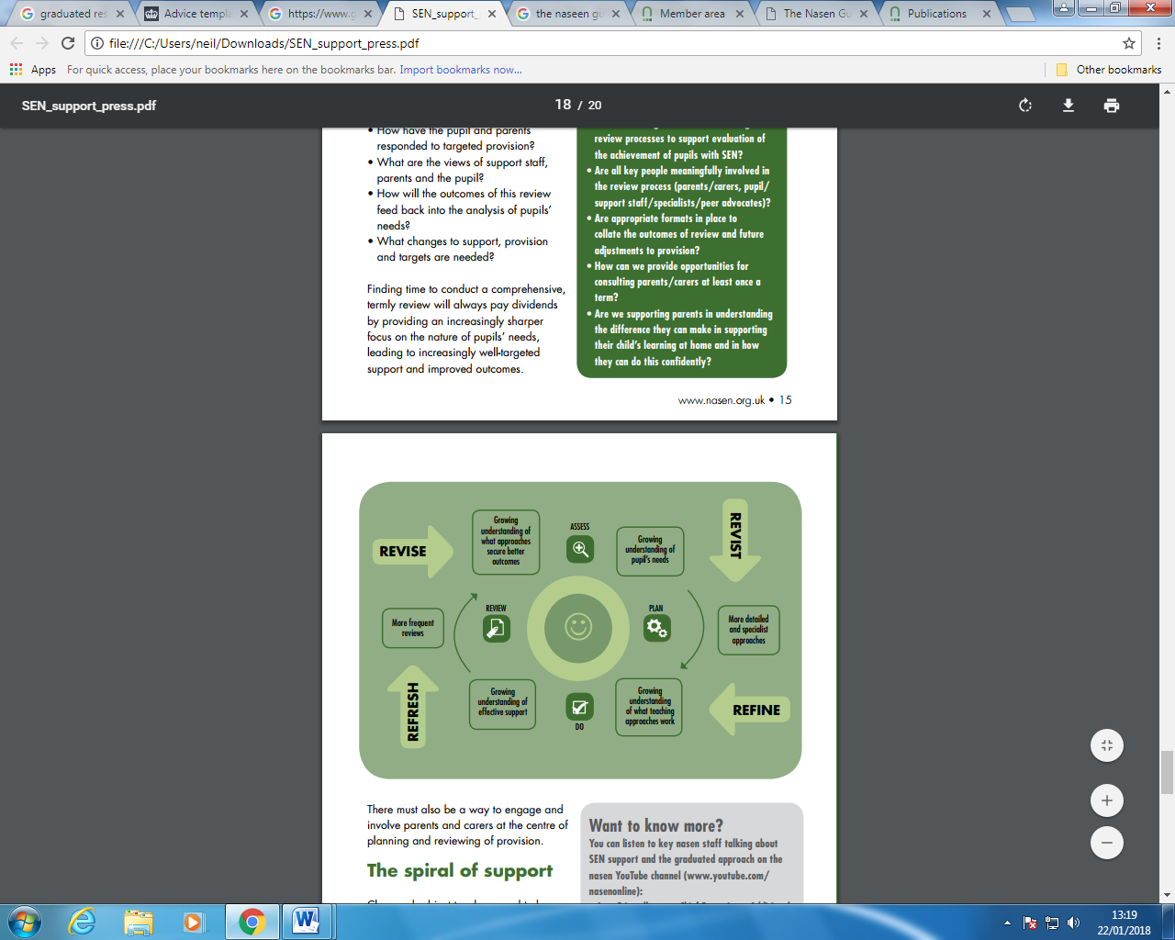

* During the graduated response cycle discussions will take place about what the pupil needs to achieve regarding staffing, resources and specialist advice. These costs are shown on a class provision map.
* Each child will receive a budget and these costs are tracked to ensure that the pupils are receiving the support that they need.
* Each child will have an Individual Learning Plan who are on SEN Support or EHCP/Statement this helps to keep track the provision and costs for each pupil.

1. **WHAT TRAINING HAVE THE STAFF SUPPORTING CHILDREN WITH SEND HAD OR ARE CURRENTLY HAVING?**

* We look to ensure that we have a variety of skills among our staff body, in order to enable us to support children in the best possible way
* The school also operates an internal training programme for support staff and teaching staff, facilitated by the SEN consultant/specialist teacher. Whole group sessions or bespoke support based upon the needs of both children and staff, are timetabled.
* TA Training
* SENDCO and SEN specialist teacher training
* Opportunities for SEN Governor training
* Regular meetings between SEN Governor and SENDCo to update and inform on any relevant information
* Staff SEN training when necessary
* Induction meeting for all new staff (teachers and TAs) with the Inclusion to explain the systems and structures in place in the school
* Relevant SEN publications (Special Children, SEN Magazine).
* Inclusion Leader’s termly attendance of the SENDCO Cluster meetings for local and national updates and guidance on SEND.
* This academic year there has been medical training for pupils who have health care plans to help with administering medicines and physical difficulties.
* There has been training on ASD for all staff and specific training for Down Syndrome for specific teachers and teaching assistants.
* Specific staff and parents have received training on support packages in using IDL Cloud an English Intervention program.
* Specific staff has received training on WELCOMM a speaking and listening program aimed at Key Stage 1 and children who are operating well below their age expectations.
* Specific staff has received training on using Boxall Profile online to help with assessing pupil’s emotional needs.
* Specific staff have received training on using PIVATs to assess the needs of pupils in English, Maths and PSHE

1. WHAT ARRANGEMENTS DOES THE SCHOOL MAKE IN RELATION TO THE TREATMENT OF COMPLAINTS FROM PARENTS OF CHILDREN WITH SEND CONCERNING THE PROVISION AT SPING HILL CP SCHOOL?

* At Spring Hill CP School we understand that parents can feel concerned about the provision their child is receiving in school. We feel it is necessary to listen to, understand and act upon any concerns and complaints that parents have. We want to provide an open, honest and fair approach to when discussing concerns and complaints with parents.

1. **WHO CAN I CONTACT FOR FURTHER INFORMATION?**

* Please speak to the class teacher in the first instance
* General information relating to SEND can be found on the school website, including within the SEND policy. This can be found on the policy page of the school website
* Further information is available from the SENDCo and Head teacher or, in exceptional circumstances, the SEN Governor.
* The school has a complaints policy, which is available on the policy page of the school website
* You might also wish to visit the following websites:
  + Lancashire County Council’s Local Offer, outlining services available for children and young people who have SEND, can be found at:

<http://www.lancashire.gov.uk/children-education-families/special-educational-needs-and-disabilities/about-lancashires-local-offer.aspx> *.*

* + Contact Parent Partnership Service:

<http://www.lancashire.gov.uk/children-education-families/special-educational-needs-and-disabilities/help-for-parents-and-carers/information-advice-and-support.aspx>

* + Contact IPSEA (Independent Parental Special Education Advice)

[www.ipsea.org.uk/](http://www.ipsea.org.uk/)

1. **WHO SHOULD I CONTACT IF I AM CONSIDERING WHETHER MY CHILD SHOULD JOIN THE SCHOOL?**

Please contact the office staff for further information about the school and to arrange a meeting with the head teacher, in the first instance.

Tel:

|  |
| --- |
| 01254 399009 |
|  |

Email:

[head@springhill.lancs.sch.uk](mailto:head@springhill.lancs.sch.uk)