Imagine, Believe, Achieve
Springdale First School
Key Concepts and components - Reading


Key concepts
Concepts | Components
  Discussing & Questioning | Asking questions | Answering questions  Listening to others | Clarifying
Making Links   | Familiarity  Connections | Similarities  Differences | Experiences  Unfamiliarity  Themes
Vocabulary  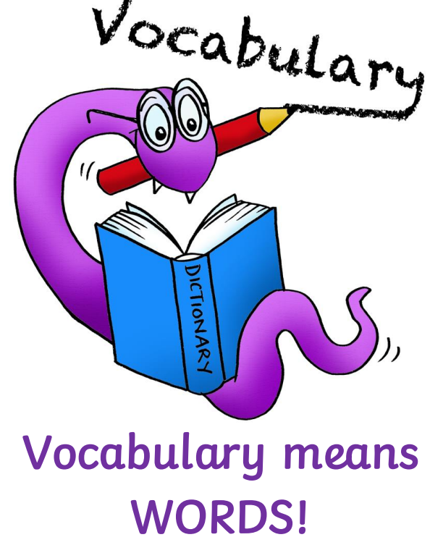 | Known vocabulary  New vocabulary  Synonyms/antonyms | Dictionaries  Repeated phrases | Predictable phrases  Contexts  Idioms
Inference   | Characters’ thoughts, feelings and motivations  Make deductions | Link to own experiences  Draw conclusions | Characters’ personality  Look for clues
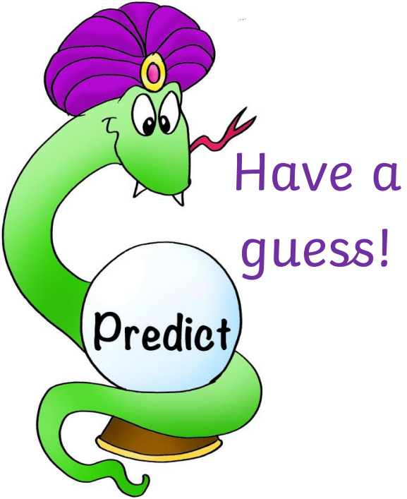  Prediction | What has been said | Story development  Events | Content
Explain  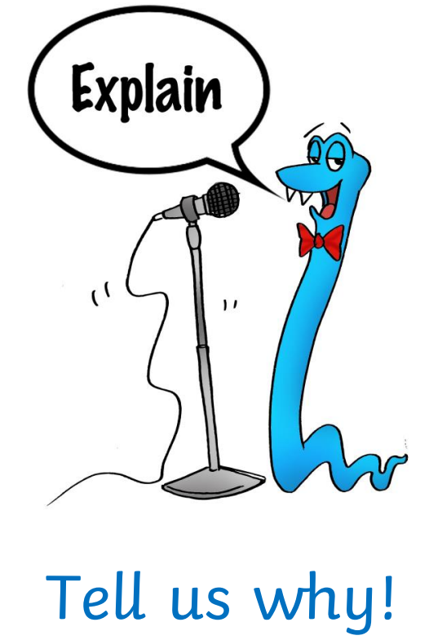 | Layout | Justifying | Word choices
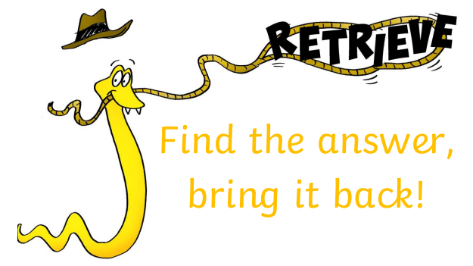  Retrieve | Information in the text  Synonyms | Background information  Main events | Skimming  Scanning
Sequencing/Summarising  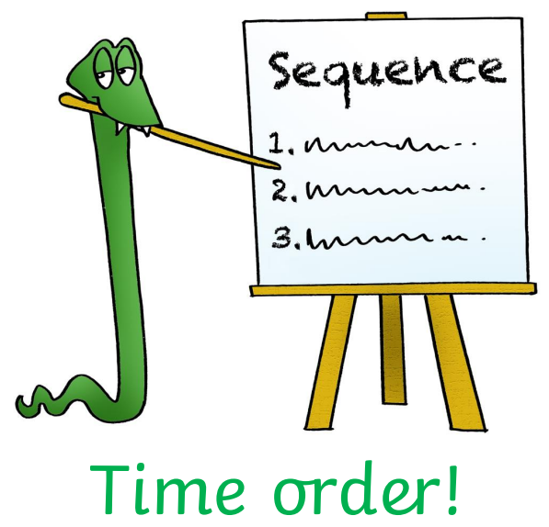 | Time order  Key events  Ordering | Headings  Sub-headings | Re-enact  Retell  Summarising
Decoding  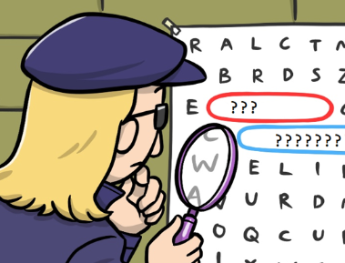 | Phonics | Word reading  Accuracy | Blending
Fluency  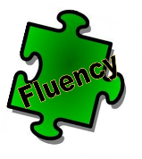 | Echo reading  Prosody | Automaticity  Read aloud | Confidence
Oracy   | Physical  Thoughts and Feelings | Linguistic  Cognitive  Social & Emotional | Discussion  Analysing

