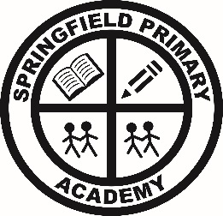
Springfield Primary Academy
Springwood Crescent, Grimsby, N E Lincolnshire, DN33 3HG
Tel: 01472 230260
Email: office@springfieldacademy.net
Website: www.springfieldprimaryacademy.net
Principal: Mrs T Storr
Care, Collaboration, Challenge
______________________________________________________________________________________________________
Friday 20th September 2024

Dear Parent/Carer,

Parents’ Evenings

The children have settled back into school and are getting back into routine. On Wednesday 18th October you will have an opportunity to meet with your child’s class teacher to discuss how the first half term has gone. You will be able to book these appointments on MCaS from Monday 30th September, so please ensure you have access to MCaS. If you have any concerns about your child, please do not hesitate to get in touch with your child’s class teacher.

Census Day

Thursday 3rd October is our Superhero Lunch. All children staying for school lunch will be entered into a draw to win some Smyth Toy store gift vouchers.
The money the school receives from the Government to pay for infant school meals is generated by the average number of meals taken on this day in October and a day in January 2025, so we are very keen for the maximum number of lunch orders! This funding directly benefits all pupils. Reception, Year 1 and Year 2 are all eligible for Universal Infant Free School Meals so please can all these children order a meal to try? (A packed lunch can also be brought from home if they prefer as backup!) Meals need to be booked on MCaS by midnight on Monday, 23rd September. Thank you for your support.

Bringing balls to school

Can I please remind you that the children should not bring footballs to school. We have plenty of balls for them to use during breaks and lunches and we would not want any child to lose their favourite ball!

Diary Dates

24th September Year 5/6 visit to Tealby
30th– 4th October Year 5 visit to Whitby
7th– 9th October Year 3/4 basketball festivals
16th October Individual school photos
16th October Parents evening
18th October Close for Half term

As always, thank you for your continued support.

Thank you
T Storr
Principal

